Annual Report 2017
HIGHLIGHTS AND STATISTICS FOR 2016 -2017 (12 months)

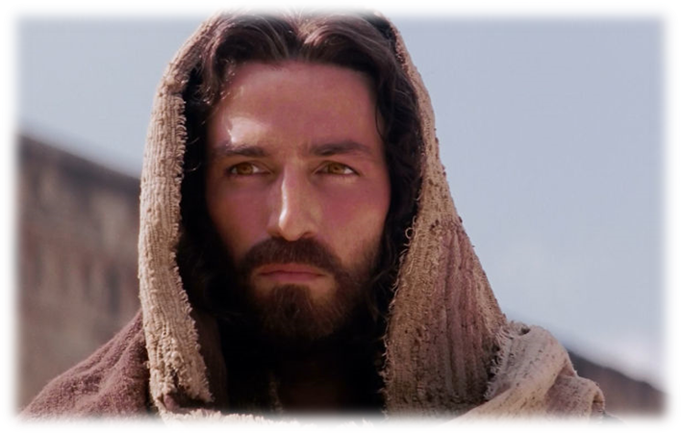

Healed Forever by Our Savior’s Resurrection

Our Savior Ev. Lutheran
Church & School
Grafton, Wisconsin

2017 Annual Report
TABLE OF CONTENTS

VOTER’S MEETING PAGE

Agenda……………………………………….…………………………………………………………… 5

Devotion & Prayer 6

MINISTRY
Our Purpose/Mission 7
Staff & Elected Leaders 9
Highlights of our Ministry in 2016 10
Pastoral Ministry 11
Pastor’s Report 13
Staff Minister’s Report 14

STATISTICS
Baptisms, Confirmations, Marriages, Funerals 17
New Members in 2016 17

MINISTRY REPORTS (Overview) 18

EDUCATION
Principal’s Report 19
K.M.L. Report 28
Teen Ministry 32
Sunday School 33

BOARDS & COMMITTEES
Board of Christian Education 34
Board of Elders 35
Spiritual Growth Committee 36
Evangelism Committee 38
Board of Stewardship 39
Board of Trustees 40
Budget & Finance Report 41
Long Range Planning Committee “LRP” 42

FINANCE
Treasurer’s Report 43
Proposed Budget………………………………………………………………………….. 47
Monthly Contribution Totals…………………………………………………………. 49

MISCELLANEOUS
Altar Guild 50
Missions 51
Visitation Ministry 52

Our Savior Ev. Lutheran Church 2017 Annual Report

ANNUAL VOTERS’ MEETING

June 25, 2017

Agenda

Opening Devotion & Prayer Pastor Wagner
Secretary’s Report (April Voters’ Meeting Minutes) Doug Schnell

Overview of Annual Report Pastor Wagner

Pastor’s Report Pastor Wagner
Membership Update
Church Discipline
Staff Minister’s Report Tom Hering
Visitation Ministry Report Pastor Wagner
Principal’s Report Joel Grulke
KML Report Joel Grulke

Ministry Reports (as time is allotted)
Board of Elders’ Report Marty Dierker
Board of Education Report Jamie Luehring
Board of Stewardship Report Dayton Behnke
Board of Trustee Report George Edwards
Evangelism Committee Report Jon Hahm
Spiritual Growth Committee Report Len Collyard
Long Range Planning Committee Report Pastor Wagner

Other Reports
Teen Ministry Tom Hering
Sunday School Tom Hering
Missions Pastor Wagner

Financial Secretary’s Year-End Report Andrew Koffman
Treasurer’s Year-End Report Chad Thistle
Budget & Finance Report Todd Schneider
President’s Report Russell Miller

Old Business:
- Thanking Prof. Tom Kock for his service Pastor Wagner
- Call updates Russell Miller
- Budget Presentation, Discussion & Approval Todd Schneider

New Business:
- Roof Repair Decisions Marty Dierker, Russ Miller
- LRP Vision Plan Russell Miller

Adjournment and Closing with Prayer Pastor Wagner

2017 Annual Report

DEVOTION: Alive within Us

“Why do you seek the living One among the dead? He is not here, but He has risen just as He said.”
Luke 24:5-6

For the followers of the Lord Jesus Christ, the resurrection is THE most powerful event in history. All that we believe and ascribe to, all that our life and worship is about, has it’s foundation on this single reality - that Jesus Christ rose from the dead.

Nothing short of God provides power like that.

Does your life lack power? Is there much you would like to accomplish but you don’t have the capacity and strength to do it? Maybe you can’t break the chain of a sinful habit or overcome fear or anxiety or be the man or woman that God created you to be. Whatever it is—habit, circumstance, or need for growth . . . Jesus Christ can change your life. His resurrection is evidence of the power to prove that.

Let’s make it personal. Luke 24 gives us a glimpse into the lives of three women who were the first to hear of the Easter miracle. Jesus died late on a Friday afternoon and we join them early Sunday morning while it was still dark. As their final act of devotion, the grief-stricken ladies made their way to Jesus’ tomb to prepare His body for burial. They were shocked to find the stone rolled away from the entrance and His body gone. All their emotions crashed around them. They didn’t know what to do. Suddenly two angels stood before them, asking, “Why do you seek the living among the dead? He is not here, but has risen” (v. 5).

I can imagine these ladies kneeling, trembling, and then being asked such a pointed question. Can you imagine how their hope began to rise as the angels said, “He is not here but He is risen. Remember how he told you . . .” (Luke 24:6). They had watched him die as the Lamb, slain for the sin of the world. They knew why he came, but they had forgotten who he was. Overwhelmed by their circumstances they had forgotten what Jesus had promised—the three most powerful words ever spoken: I will rise.

All it took for their confusion to lift was to remember His Word (v. 8).

To you who are suffering under the weight of a difficult situation, I write with this same message: Jesus has risen and He wants to bring the power of His resurrection to bear upon whatever you’re facing. Do what these ladies did: believe what He said. Take Him at His Word. Remember His promises.

The resurrection of Jesus Christ is proof that God will do what He said. Rehearse God’s faithfulness in what He did on that pivotal, powerful morning and be filled with faith at how He is still at work today in your life.

In Awe of Him who Lives,

Pastor Wagner

Our Vision Statement
Heaven is my home
because Jesus is my Savior!
God guides me on the journey through to my destiny;
by faith in the forgiveness and acceptance of Christ
I can enjoy peace, rest and confidence right now
because I know that he lives and …
He loves me!

Heaven is my home because Jesus is my Savior!
Do not let your hearts be troubled. Trust in God; trust also in me.
In my Father’s house are many rooms; if it were not so, I would have told you.
I am going there to prepare a place for you. And if I go and prepare a place for you,
I will come back and take you to be with me that you also may be where I am.
You know the way to the place where I am going.”

God guides me on the journey through to my destiny;
“Surely I am with you always, to the very end of the age.”

By faith in the forgiveness and acceptance of Christ
In him we have redemption through his blood, the forgiveness of sins, in accordance with the riches of God’s grace that he lavished on us with all wisdom and understanding.

I can enjoy peace, rest and confidence right now
Let the peace of Christ rule in your hearts, since as members of one body
you were called to peace. And be thankful.

Because I know that he lives and …
I know that my Redeemer lives,
and that in the end he will stand upon the earth

He loves me!
This is love: not that we loved God, but that he loved us
and sent his Son as an atoning sacrifice for our sins.

Note: This Vision Statement is an attempt to capture the essence of what we want each person to know mentally and spiritually. God wants each of us to “know Christ and be found in him” now and for eternity, as the Apostle Paul says in Philippians 3. We want every person trained through our ministry to be able to express this simple truth when they’re asked about their faith, their Lord, or their church. You see, heaven is where we belong and are going. All the rest are simply details of the journey.
2017 Annual Report

Our Savior Evangelical Lutheran

Church & School

Our Purpose

To give glory, honor, praise and worship to our Triune God -- Father, Son and Holy Spirit -- in all
that we say and do. (1 Corinthians 10:10-31)

Our Mission

As men, women and children united by the Word of God into the community of Christ,
Our Savior Ev. Lutheran Church of Grafton, Wisconsin exists to:

...KNOW Jesus Christ as Savior,
...GROW in loving service to God and each other,
...GO into our community and the world with the
good news of Christ’s forgiveness.

We carry out our Mission by...

- proclaiming faithfully God’s inerrant Word (Law/Gospel) to lead people to repentance and faith in Jesus Christ (2 Timothy 4:2).
- gathering regularly to worship (Hebrews 10:25) and celebrate the sacraments
(Luke 22:19-20 & 1 Cor. 11:24).
- practicing fellowship with one another (Acts 2:42-47).
- sharing the Gospel with all people (Mark 16:15).
- actively pursuing the lost and straying (Luke 15).
- growing in God’s Word (ourselves, our children and others) (2 Peter 3:18).
- strengthening our families and homes (Psalm 128).
- equipping Christians for works of service in Christ’s kingdom (Ephesians 4:11-16).
- living in unity and peace with our fellow believers (Ephesians 4:3).
- loving one another with an unconditional, self-sacrificing love as Christ himself loved us
(John 13:34-35).
- encouraging and building each other up (1 Thessalonians 5:11).
- serving the needs of all people, as we are able (Galatians 6:10).
- supporting our church and school with our prayers, time and talents and our financial
- offerings (2 Corinthians 8 & 9).
- joining others in sending the Gospel world-wide through the Home and World Mission programs of the WELS (Romans 10:10-15).

2017 Annual Report

Staff & Elected Leaders

Pastors | Mark C. Wagner | Principal | Joel Grulke, Principal
Staff Minister  Pastoral Asst | Thomas P. Hering  Jeremiah Backhaus | Office Staff | Jill Klug
Pulpit Asst Office Staff | Vacant  Sarah Smith | Maint. Staff | Gary & Cheryl Suckow, Lucas Grulke,  Caleb Grulke
EFT Students | Andrew Nemmers  Thomas Neider | Teachers | Joel Grulke (6-8)  Emily Rodrigue (3-5)  Annette Diener (Kindergarten-2)  Amy Grulke (PreSchool)  Amanda Hering (Assistant)  Monica Dierker (Assistant)
Library | Alison Wolf
Officers | Russell Miller President  Steve Wolf Vice-President  Doug Schnell Secretary  Chad Thistle Treasurer  Andrew Koffman Financial Sec. | Board  Chairmen | Bob Klug Elders  Nick Matter Christian Education  Dayton Behnke Stewardship  George Edwards Trustees  John Hahm Evangelism  Len Collyard Spiritual Growth  Todd Schneider Budget & Finance

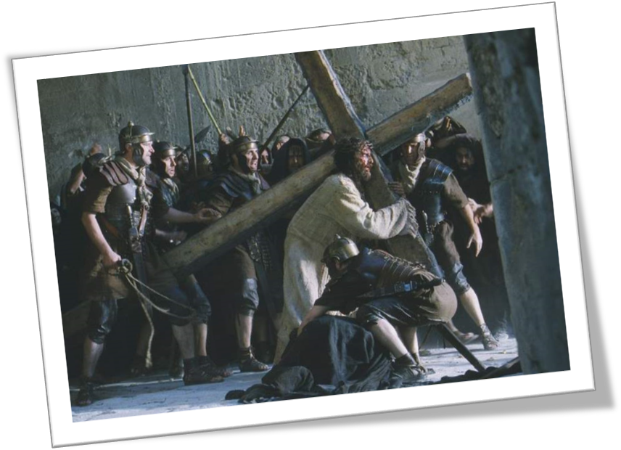

Highlights of our Ministry in 2016-2017

“Now is the time of God’s favor, now is the day of salvation.” We cannot rest on the laurels of our previous work or history. We still have work to do “while it is day.”

The apostle who wrote these words was Paul, originally the enemy of Christ who sought to teach his followers a “lesson.” On the way to Damascus to put them in jail or see them stoned to death he was confronted by Jesus (Acts 9), blinded and told to wait for assignment. In a remarkable turn-around he was converted to the very faith he had tried to destroy. (1 Tim 1:12-17) He was shown mercy so that the Lord’s grace might be on display in his life. That’s why he would say, “Christ’s love compels us.” (2 Cor. 5:14-15) He learned first-hand what it meant to be forgiven and how the cross of Jesus had rescued him from sin, from himself. (1 Cor 2:1-5) We too have been persuaded to KNOW him more, to GROW in serving him gladly and serving each other, to GO into all the world with the offer of free and full forgiveness. At Our Savior, we plan time for building relationship with the Lord Jesus, spending time in his Word, seeking salvation in his Sacraments. We pray for his guidance and support. We desire to be participants in the sublime calling of making disciples. We, like Paul, share the message of Christ and him crucified (1 Cor. 2:1ff) with a world that is perishing. God has poured out his grace and love for over fifty years to the family of faith at OSLC. We were blessed with a strong commitment to build upon that heritage. Last year we sought to re-position our finances by paying down the mortgage. This year we’re challenged by repairs, yet the Lord promises to provide for us. Our prayer remains this: Lord, what would you do through us to accomplish your vision for Our Savior? Help us, every day and every week, to find our calling in Christ to be meaningful. What a joyful privilege to be a part of the family of faith!

Some of our local blessings include...
- Stabilization: our first step forward (this last year) was to secure our finances for the upcoming years. The Lord has accomplished that among us through the Capital Appeal “Hope for Years to Come” which brought the highest level of commitment of any of our appeals. As our lay leadership team continues to pull together, our intent is to expand opportunities for people to connect with Word & Sacrament as well as with each other. We are now also securing our facility with a special Repair Project.
- Long Range Plan – we’re ready this summer to formulate our five year plan and identify our distinctive path forward, based on input from our members and analysis of our communities.
- Calls: to seek the Spirit’s guidance and support in replacing teachers Ben & Katie Raddatz as well as our pulpit assistant, Pastor Tom Kock.
- To KNOW: offering several different types of Bible Study and levels of challenge
- Our Back Door: intentional and aggressive Elder & Shepherd emphasis on our straying and seeking opportunities for outreach, developing an expanded and committed visitation team
- To GROW: so many growing families! Lots of baptisms, youngsters, Pre-K mothers meeting… all with a potential for ministry, through school and Sunday School
- Volunteers! We continue to employ joyful, willing members and friends who share their resources and talents generously. For example, this past summer we built a new garage with the aid of 40 volunteers.
- To GO: Our Front Door: ongoing Outreach efforts, through the support of lay leaders, with new emphasis on prospect follow up, using a more modern tracking system called "Salesforce." New Members both through instruction and through transfers! We continue to make efforts to integrate them as part of our inner circle of servants.
- Attend to our Work-at-Large commitments, support synod, KML and other agencies
- Manage our beautiful sanctuary for inviting worship; an exceptional, committed “Grateful Hearts” group and well-attended contemporary service
- Our dedicated and determined staff: Pastor Wagner, Mr. Hering, Pastor Kock, Jeremiah Backhaus, Mr. Grulke, Mr. Ben Raddatz, Mrs. Dierker, Mrs. Diener, Mrs. Grulke, Mrs. Collyard, Sarah Smith, Jill Klug, Jon Grulke, Caleb Grulke, Gary & Cheryl Suckow. This fall we’ll welcome Mrs. Amanda Hering and Mrs. Emily Rodrigue as the newest members of our teaching team. All are dedicated, skilled, passionately-invested servants of our loving Savior.
2017 Annual Report
Page 1 of 2

P A S T O R A L M I N I S T R Y

M
inistry means service. We are all in the ministry together serving our gracious God by serving one another. This is a beautiful concept derived from the unconditional love of our Lord Jesus Himself, which translates into a different worldview. All around us are selfish, uncaring people who look out only for themselves. But “we” live with His unique point of view. Love comes down to us from above and so we begin to love others because of the love we ourselves have received (1 John 4:19). Love becomes our identifying mark (John 13:35) as we build the community of Christ together. “Our Savior” came down from heaven not to be served, but to serve and give His life as a ransom for others (Mk 10:45) To prove that this was his motto He washed the feet of his disciples and then gave them the New Command, “Love one another as I have loved you.” (John 13:34). This full extent of his love carried him to the cross under and with our sin. In awe we watch our Lord serve us in life and in death. In greater awe we watch Him arise to lead and love again. In response we serve one another in our family of faith and for the good of those yet outside.

When we finally grasp how rich His grace is, (2 Cor. 8:9 evokes 9:11 & 1 Tim. 6:17-18) we live to build His kingdom. It is not a burden, but a privilege. To live is Christ and to die is gain (Phil. 1:21). Or as Paul put it in another passage,

For this reason I kneel before the Father, from whom his whole family in heaven and on earth derives its name. I pray that out of his glorious riches he may strengthen you with power through his Spirit in your inner being, so that Christ may dwell in your hearts through faith. And I pray that you, being rooted and established in love, may have power, together with all the saints, to grasp how wide and long and high and deep is the love of Christ, and to know this love that surpasses knowledge—that you may be filled to the measure of all the fullness of God. Now to him who is able to do immeasurably more than all we ask or imagine, according to his power that is at work within us, to him be glory in the church and in Christ Jesus throughout all generations, for ever and ever! Amen. (Ephesians 3:14-21)

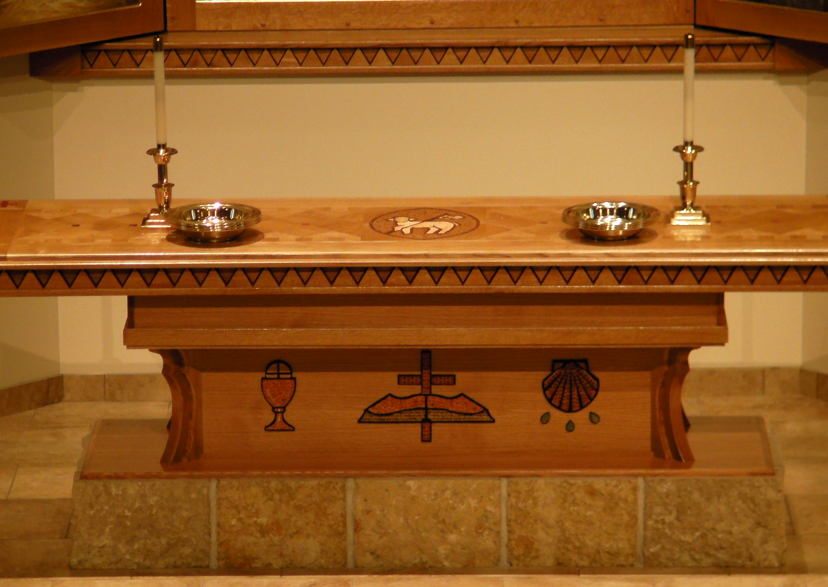
Therefore, let us learn to honor our God and our Lord (John 20:28) in our own lives individually and together in as we love others with the same love He has shown us. (John 3:16)

Our ministry is a labor of love… His love working in and through us together!

At this beautiful “Altar of Great Love”
we hear and receive his good news!
2017 Annual Report
Page 2 of 2

Through your pastor and teachers you supported our vision: "Heaven is my Home because Jesus is my Savior." We need to be ever more diligent to train and equip others for their ministry. During the past year we ministered to the following who either joined or left our fellowship, one step closer to God and eternal joy in heaven with Him.

Those who joined our Christian family in 2016-2017:

Communicants Souls (members incl. children)

Baptisms 1 14
Adult Confirmations 6 6
Youth Confirmations 3 00
Professions of Faith 5 5
Transferred In (WELS or ELS) 15 23
Totals 30 48

Those who left us in 2016-2017:

Death 2 2
Transferred to other WELS/ELS 23 25
Released (or moved away) 4 6
Removed/Excommunicated 13 17
Totals 42 50

Year End Totals - Current (last yr)
Members as of 06/25/2017 - 590 (602) (audited) 788 (790) (audited)
Attendance – Regular Weekly Services - 331 (336,335,332,334,368)
Special Services - 160 (165.161,162,159,160)

Bible Class Attendance – Adults Average Sun AM 50 (54)
Mon PM na (na)
Tues PM 10 (10)
Wed AM na (na)
Sat AM 09 (08)
AIC 07 (05)
GW/Kelm 00 (49)
Seniors 25 (18)

Adults 98 (144)

Confirmation Class Tue-Thu 18 (18)
Confirmation Class Wed. 07 (09)
Teens Sun AM 07 (07)
Sunday School Sun AM 53 (45)

Children 85 (79)

They include the teachers, who are part of the study.
Also note that we have included the nursery with the Sunday School at this time.

2017 Annual Report
Page 1
P A S T O R ‘ S R E P O R T
C
hange and challenge seem to be the constant of life – as we have again experienced at Our Savior this past year. The Lord reached out through the call system to Ben & Katie Raddatz, and they are now on their way to New Mexico. He shifted the proclamation of the gospel through Prof. Kock over to another congregation. He allowed leaks in both parts of our building to command attention and repair. Yet we see his promises fulfilled and his presence beside us through all the different weather patterns of life. We know that he will provide – for our children in school, for our preaching and for our buildings which house the worship and work of his kingdom. Already we have s plan for school and we’re seeking a replacement for Pulpit Assistant. We have begun to get answers for the repair of the facility. And we have been blessed to see an abundance of baptisms despite the mobility of God’s people, as new families arrive to take the place of those called away. Our leadership is strong and our mission is the same - to GO with the Gospel into our communities.

Regular areas of pastoral responsibility include:

- Worship planning, including creation of various services, coordinating music and maturing our contemporary service as part of a balanced, blended approach. To God be the glory! (Pastors Wagner, Kock, Backhaus, Kelm, Mr. Hering)
- Regular Bible Study planning, coordination, preparation and instruction (Pastors Wagner, Kock, Backhaus, Mr. Hering)
- Catechism instruction (3 times a week which includes the Public School Class) (Mr. Hering)
- Bible Information Classes (Fall, Spring, Summer) and Lutheran Survey classes as needed (Pastor W)
- Leadership, prayer and support for the elected leaders and their teams (Pastor W, Mr. Hering)
- Staff and Lay leadership, training and coordinating (Pastors W, Mr. Hering)
- Prospect calls and Encouragement calls, Counseling the Troubled and Straying (Pastor W)
- Leading, Coordinating, and Training our Southeastern Wisconsin District Mission Board and mentoring Hispanic pastors (Pastor W)
- Supervising, Coordinating, and Distributing gifts for our WELS Committee on Aid & Relief throughout the world (Mr. Hering)
- Assisting, encouraging presentations by laymen about ministry & management of our gifts (Pastors W, Mr. Hering)
- Administration of the church office, Overseeing Record keeping, Managing Business systems, Historical archives etc. (Pastor W, Mr. Hering)
- Supervising EFT students for liturgy and calls; supervising the Ozaukee Jail schedule and Sem students (Pastor W)
- Supervising EFT students for confirmation class (Mr. Hering)
- Pre-marriage meetings, arrangements and conducting of weddings (Pastor W)
- Funeral visitations and arrangements, along with prayer and ministry to the grieving (Pastor W, Mr. Hering)
- Adding to and managing computer networks, machinery, communication tools, updating classrooms & church (Pastor W)
- Visitation ministry to care for souls unable to come to worship; Oz Jail ministry and bible study (Pastor W, Mr. Hering)

Goals for the new year:
- We will review, revise and communicate a new Long Range Plan to keep our vision/goals clearly identified and in sight.
- We plan on teaching and explaining our Vision Statement, biblically connecting the Christian family to their roles at home and in their community of Christ.
- We will again assess the priorities of our positions, streamlining, transferring or dropping responsibilities in order to conduct a more focused, intensive search for the lost.
- We will assess our Visitation Team results, free up Pastor W. for a personal & intensive effort to reach out to the wandering and disillusioned members of the congregation (revamping team this summer).
- We will, through lay leadership, train and equip others who can help us maintain close contact with our prospects, manage our data base and recruit for Bible Information and Lutheran Survey classes.
- We will together take the resources which he assembles for us and through us to expand his ministry of the gospel. We will continue our contact and communication among members, including more fellowship and service through CONNECT ambassadors
- We will continue to prioritize personal study of the Word and time with our spouses, children and their families. We will seek to know Christ and his grace more fully this year that we may serve others with his heart of compassion and love.
2017 Annual Report

STAFF MINISTER REPORT

Our Savior Lutheran Church and School Annual Voters’ Meeting

June 25, 2017

A FEW HIGHLIGHTS

- Our Sunday School staff faithfully served our children and families during the 2016-2017 year. We thank God for our teachers and helpers, who weekly share the saving news of Jesus. This year we will complete a 3-year curriculum update for most of our classes.

- Three teachers rotated throughout the year to teach our Sunday teen class.

- Planning has begun for our annual church/school picnic to be held on August 27, 2017. Please note that we will again hold the picnic on the last weekend of the month. We will have regular Thursday worship that week, but only a single 10 am service on Sunday. There is a need for helpers on Saturday, August 26, at 3 pm to assist with the set-up for the picnic.

- College Roll continues to serve some of our collegiate youth through emails, prayers, mailings and care packages. Number of collegians served:
2016-17 = 13 2015-16 = 17 2014-15 = 24
2013-14 = 16 2012-13 = 17 2011-12 = 18
2010-11 = 13 2009-10 = 16 2008-09 = 15
2007-08 = 17 2006-07 = 17 2005-06 = 24
2004-05 = 29 (13-year average = 18)

- Christian Aid and Relief (synod work). I continue to serve our synod as the secretary of WELS Christian Aid and Relief. We regularly make decisions to bring physical relief to victims of natural disasters or personal tragedies in the form of cash grants, food, clothing, and medical supplies. We also partner with WELS missionaries to support humanitarian aid projects that can help build bridges to proclaim the gospel.

- KML Board of Directors. I continue to serve our KML High School Federation as a member of the Board of Directors, including on its Executive Committee.

- We are truly blessed to have several individuals who faithfully teach Bible classes for adults, teens, Sunday School and Lutheran elementary school.

- I continue to supervise Wisconsin Lutheran Seminary students who assist in teaching our students Confirmation classes during our first semester. I will begin to serve the Seminary this fall on a very limited basis as I oversee several additional students who will teach Confirmation classes at a few other locations.

- We continue to use Facebook to share congregational and school information with our members and others. Around the time of major worship services and other events of interest, we see high activity and engagement.

- Connect Ministry exists to help new members become comfortable in their new church home as well as help new and current members connect through experiences such as hobbies, life circumstances and other activities. This effort is proceeding with a very non-programmatic emphasis.
- Our Tuesday Senior Bible study has grown to a steady and energetic group of between 20 and 30 regular attendees. It is a joy to witness the growing closeness and support that has developed among the members of the group.

- Fellowship Activities This Past Year

School Work Days (July-August)
Church Softball Games (May-August)
Church and School Picnic (August)
Golf Outing (September)
Hearts to Hands – Knitting, Crafting… (2x per month)
Fall Family Trunk or Treat Night (October)
Chili Contest (November)
Pizza making event (November)
Advent by Candlelight (December)
Christmas caroling and chili lunch (December)
Church and tree Christmas decorating (December)
Our Savior Night (February)
Easter Breakfast (April)
Church Work Day (April)
Pizza making event (April)
School Awards Picnic (May)
School Sports Post-season Parties

Regular Bible Studies-last semester

- Sunday
  - Adults
  - Teens
  - Children
  - Child care
  - Women’s evening class

- Tuesday
  - LES Confirmation classes
  - Senior study - Galatians
  - Adult study – 1 Samuel
  - Adult Bible Information Classes
- Wednesday
  - Public school Confirmation class
- Thursday
  - LES Confirmation classes
- Saturday
  - Men’s Bible breakfast the first and third weeks
- Other special studies

Bible Topics Offered

- Following is a listing of many of the Bible classes that were offered at church in 2016-2017. Be sure to plan to study God’s Word here at church with your brothers and sisters in Christ throughout the year.

Divine Treasure Hunt  Patient Parenting – Raising Your Kids in the Shadow  of the Cross  The Book of 1 Samuel  The Book of 1 Corinthians  The Book of 2 Corinthians  The Book of 1 Timothy  Miracles Point to God  Our Bible Sisters  The Book of Ruth  The Book of Galatians | The Book of 1 Peter  In the Fullness of Time  Make a Fresh Start  Walk with Jesus – His Last Week on Earth  A Planetary Abolition  *Life with God  *Many and varied teen studies  *Weekly Sunday School classes

Sunday Bible Study/Sunday School attendance update

Year Nurs. PreK K-2 3-4 5-7 Teens Adult 1 Adult 2 Total
Student number + staff workers

16-17 4+3 9+2 8+1 6+1 4+1 4+1 49+1 (9 wks incl) 94

15-16 4+3 9+2 11+1 4+1 3+1 5+1 54+1 (9 wks incl) 100

14-15 6+2 9+3 10+2 4+1 6+1 6+1 48+1 (6 wks incl) 100

13-14 3+2 11+3 13+2 3+1 7+1 7+1 47+1 na 103

12-13 2+2 12+3 8+2 5+1 9+1 7+1 45+1 10+1 110

11-12 5+3 10+3 10+2 5+1 10+1 9+1 45+1 18+1 111

10-11 4+2 8+3 11+2 8+1 10+1 9+1 50+1 11+1 115

09-10 4+2 5+2 10+2 9+1 8+1 8+1 41+1 20+1 101

08-09 4+2 10+2 15+2 7+1 12+1 11+1 43+1 20+1 119

07-08 5+2 12+2 14+2 6+1 10+1 13+1 42+1 13+1 117

06-07 4+2 7+2 12+2 6+1 8+1 11+1 36+1 13+1 96

05-06 4+2 7+2 12+2 8+1 14+1 14+1 33+1 16+1 103

Some Summer and Future Highlights

  - Sat/Sun, June 24-25 Strawberry Festival volunteer event
  - Sun., June 25 Annual Voters' Meeting
  - Mon., June 26 School work day 6 pm
  - Sat., July 15 Church softball all-star day
  - Mon., July 17 KML Golf outing & dinner in West Bend
  - Tues., July 18 School work day 6 pm
  - Sat., July 22 School work day 8 am
  - Wed., July 26 School work day 6 pm
  - Fri., Aug 4 Ozaukee County Fair volunteer event
  - Mon., Aug. 7 OSLS Registration Night
  - Sat., Aug. 12 OSLS River Edge volunteer event
  - Sat., Aug. 19 School work day 8 am
  - Mon., Aug. 21 KML First class day
  - Wed., Aug. 23 OSLS First class day for K-8
  - Sat., Aug 26 Set up for Picnic Sunday
  - Sun., Aug. 27 10 am Worship and picnic
  - Tues., Sept. 5 OSLS First class day for 3K
  - Wed., Sept. 6 OSLS First class day for 4K
  - Sat/Sun, Sept. 9-10 Racing Hearts 5K volunteer event
  - Sun., Sept. 10 Christian Education Sunday
  - Sat., Sept. 23 OSLC Golf Outing

2017 Annual Report
Statistics for 2016 & 2017

B

B
aptisms: (14) – Logan Thomas Soldner, Leroy John Norton, Aidan Alexander Neuworth, Malachi Charles Curtis, Graham William Liesner, Chas McComas Custer, Lincoln Lawrence Gerner, Caisen Matthew Weidner, Jax Wilder Fabitz, Adreana Luna Abts, Cora Marie Pautz, Evelynn Edith Geis, Shawn James Geis, Kylie Noelle Wagner.

C

onfirmations: (3) Youth – Jacob Hoevker, Eric Land, Emma Thistle; (6) Adult – Ken Krueger, Paul Clements, Candi Speitz, Chas Custer, Casie Duemke, Gina Anderson.

By Profession of faith: (5) – Harvey & Donna Hammond, Cindy Flood, Don & Ruth Kienau.

M
arriages: (1) – Greg DuCharme* & Terese Gapuz*.
(*=non-member)

F

unerals: (3) – Rebekah Gall, Carol Ebert, Doris Netz.

N
ew Members this year: (23) Billy & Roxanne Griffin (RJ, Rayandre, Rayjaun), Steve & Leah Sanfilippo (Sam & Lola), Tom & Heather Harwood (Olivia, Hunter, Holden), Linda Benner, Tate & Courtney Plath, Pam Vromon, Larry & Anne Krueger, Mark Mandler, Sam & Lydia Wallace.

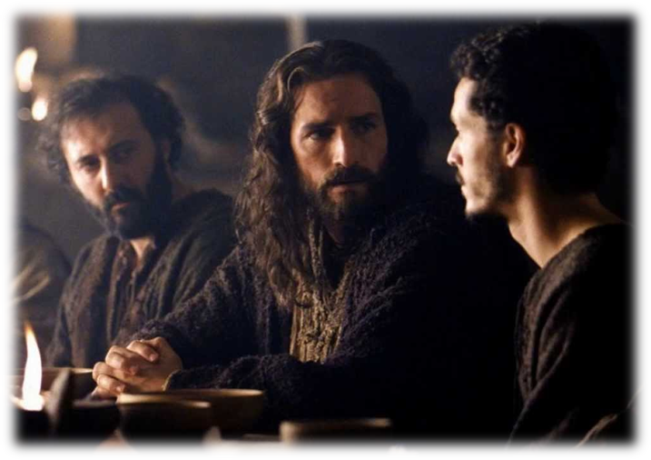



2017 Annual Report

M I N I S T R Y R E P O R T S

Grace and peace to you…! These words capture the eternal assurance which we have in Christ. Both words were used as the introductory and concluding framework by the apostles in their letters to remind God’s people that we are citizens of a higher kingdom (Phil 3:20). We belong above, so we live our lives with that focus, on spiritual, eternal heavenly matters. (Col 3:1-4) Regardless of politics, the economy, the everyday ups and downs, illnesses, losses and disappointments in life, we already stand on solid ground. Our foundation is built on THE spiritual rock, which is one of the descriptions in Scripture for Jesus Christ. Again this year in so many ways we have experienced his strengthening through Word and Sacraments. Let us continue to seek His kingdom and righteousness (Mt. 6:33), sharing and serving with one another. Let us rejoice to be part of the community, the body of Christ. We do that as we accept ourselves before the Lord, aware that God has gifted each of us in a special way to serve him. We do that also as we applaud when He uses others to serve alongside of us with their gifts. Together we gladly serve Him.

The reports which follow are cited on the contents page and summarized here. We are continuing to standardize the reports and planning mechanisms. Some areas of ministry are more active than others, and some more visible than others, but none more important than any other. So in looking over our areas of ministry we continue to see God’s gracious hand at work with us and through us.

The following reports are currently available in print.

Report Title

Principal’s Report
KML Report
Teen Ministry
Sunday School
Board of Christian Education
Board of Elders
Spiritual Growth Committee
Evangelism Committee
Board of Stewardship
Board of Trustees
Budget & Finance Committee
Long Range Planning Committee “LRP”
Financial Secretary’s Report
Treasurer’s Report
Proposed Budget (Addendum)
Altar Guild
Missions
Visitation Ministry


2016-2017 Principal’s Annual Report

Looking Forward to Heaven

“For he was looking forward to the city with foundations,
whose architect and builder is God.” Heb. 11:10

Here are some of the highlights of Our Savior Lutheran School’s 50th year of educating our Savior’s lambs as we look forward with God’s continued blessing to another 50 years and at His timing to a life in heaven by our Savior’s side.

2016
July:
- Transition meetings were held with Mrs. Katherine Raddatz as she began to become familiar with school procedures and the school materials she would be using to teach grades 1&2 Christ-Light, language arts (reading, phonics, penmanship, writing) and social studies, grade 2 math, and grades 3-8 music and choir. Mrs. Raddatz would be taking the place of Mrs. Kathy Collyard who retired at the end of the 2015-16 school year.
- Parents volunteered time and energy on six different days through the summer to thoroughly clean various parts of the school that typically do not get that much attention through the year. We thank the Parent-Teacher-Friends group for all their efforts in organizing this as well as the support of Thrivent through their Thrivent Action Event which enabled us to get many of the supplies that were needed to get the cleaning accomplished.
- The teachers were assigned different storage areas of the school to go through and determine if any of the stored items were still usable or should be discarded. While this may seem like unnecessary busy work, it is not. First and foremost, it helps each of our teachers know or be reacquainted with what is in our building that can be used for instruction purposes. Second, it helps keep us from getting cluttered and having to find more storage space for things we may never use. Lastly, it also helps us to help each other on staff or other members like Sunday school teachers who may need materials to help them with their work and role that they have in our ministry at Our Savior. While we do not do this every year, it is good to do periodically. A large dumpster was brought on the property to help us dispose of the broken and obsolete equipment.
- Jill Klug completed her first full year of serving as our administrative assistant in the school office. We thank the Lord for providing us with such a dedicated and faithful servant who meets and greets all who enter with a warm smile and positive Christian spirit, ready to help and serve wherever she is needed.
- Gary Suckow carpet cleaned each of the classrooms, hallways, church entryway, and a few other carpets during the summer. We greatly appreciate his volunteered time and effort to help our facility stay clean and presentable for those who visit and our students who walk these carpets throughout the school year.
- Approval to increase the size and types of equipment on our lower playground was given by the Board of Christian Education and Church Council. Our playground had a couple pieces of equipment that were either broken or not appropriate for early childhood students. Our goal was to have a playground that would serve not only our early childhood students, but also our students in the lower elementary grades. Installation was scheduled for the last week of September. Monies were raised through the Our Savior golf outing and some other generous donations.
- Also donated to the school was a large plant-growing stand on wheels that can be used for life science classes. This donation came through a memorial gift given in memory of a grandmother of one of our students. We are very thankful for this gift that enables us to enrich and make practical our teaching of God’s amazing creation.
- As a result of a recent fire inspection in May of 2016, we were required to upgrade our fire alarm system in the original school building and church. This work was completed during summer and effectively ties all buildings, with the exception of the church office building, into one system that is monitored 24/7.

August:
- Faculty meetings were held throughout the summer and more frequently in August to grow professionally and prepare for the upcoming school year. I am thankful for the various God-given educational insights and talents that each of our teachers bring to our meetings as we seek to enrich the lives of our students throughout the school year.
- Mrs. Diener and Mrs Raddatz attended the Early Childhood Literacy Conference held at Concordia University on August 5th. This is a good conference for teachers to take a look at some of the best ways to help young students learn to read, write, and express themselves through use of high quality literature.
- Registration night was held on August 8^{h}, and families received information about the classroom schedules, sports and other activities that were part of the school year. Mr. Jamie Luehring conducted the meeting as Mr. Grulke was away on a family emergency. Thank you Mr. Luehring for stepping in!
- The school year began with a half-day on August 24th for grades K-8. Pastor Wagner led us in an Opening Service. 3K began after Labor Day on September 6th and 4K began on September 7th. The school day ran from 8:15 a.m. to 3:15 p.m. for grades K-8.
- 2016-2017 Enrollment
3K=2 4K=6 K=9 1st=10 2nd=7
3rd=8 4th=8 5th=5 6th=7 7th=3 8th=4

3K&4K=8* K-2=26 3-5=21 6-8=14

K-8=61 PreK-8=69

- The following is the breakdown of students church membership for the beginning of the 2016-2017 school year:
Unchurched 0
Prospect seeking membership 0
St. Matthew’s, Port Wash. 8
St. John, Mequon 1
St. Marcus, Milwaukee 1
Our Savior 59
Total: 69
- Eight families (11 students) were new to our school, in grades 3K, 4K, kindergarten, first, second, fourth and eighth grades. Five families are from Our Savior, one is from St. Matthew, Port Washington, one is from St. John’s, Mequon, and one is from St. Marcus, Milwaukee.
- Board of Christian Education Members for 2016-2017 School Year:
Jamie Luehring (Chairman)
Mike Smith (Secretary)
Kent Russell (Treasurer)
Philip Babler
Nick Matter
Michael Braatz (St. Matthew’s Representative)
Joel Grulke, Principal (ex officio)

- The staff for our 2016-2017 school year was as follows:
Mr. Joel Grulke – Principal and Gr. 6-8; Gr. 3-8 Science, Math Courses 2 & 3;
Algebra 1 & 2
Mr. Ben Raddatz – Gr. 3-5; Gr. 3-8 History, Technology; Intermediate Math 3-5
Mrs, Monica Dierker – Gr. 3-8 Literature, Gr. 1 Math; Math Course 1, Assist
with Technology, Student testing and tutoring
Mrs. Katherine Raddatz – Gr. 1-2 Christ-Light, Language Arts & Social Studies;
Gr. 2 Math; Gr. 3-8 Music & Choir
Mrs. Annette Diener – Kindergarten; Gr. 1-2 Christ-Light, Science, Music & Art
Mrs. Amy Grulke – 3K; 4K; Gr. 6-8 Art, World Languages, Writing, Vocabulary

- 2016-2017 Mission Offerings
- Quarter 1 (July – September) – Haiti – Joint Project with KML Federation
- Quarter 2 (October – December) – Cross Trainer Mission Projects - KML
- Special Christmas Offering – Haven Project
- Quarter 3 (January – March) – LWMS – Family Ministry for Outreach
- Quarter 4 (April – June) – LPS 150th Anniversary
(Offerings collected in our weekly Wednesday Chapel Services are sent to these missions throughout the year.)
- Weekly Wednesday morning chapel services were conducted through the school year. Pastor Wagner, Mr. Hering, Mr. Raddatz, Pastor Wildauer, and Mr. Grulke each took turns leading staff and students in worship, helping students to grow in their understanding of worship and bringing to them a message from God’s Word for their life. Mrs. Dierker and Mrs. Raddatz served as our accompanists for these times of worship.
- PTF – Parent-Teacher-Friends held a meeting each month from August to May to help support various school activities and give a way for participants to become involved in these school events.

September:
- The school children sang “We Thank You Dearest Father” for Christian Education Sunday on September 11th .
- We had 15 students in piano and/or instrument lessons, and 1 student participating in KML band lessons. We are thankful that this fine arts activity is available to our students to explore and develop the musical gifts God has given them. We thank Mr. Nate Amundson (KML Band Instructor), Mrs. Kari Brich (piano and other instruments teacher), and Mrs. Teri Wildauer (piano teacher) for their time and commitment to the musical interests of their students.
- A classroom breakfast was held for each classroom. This was sponsored by the PTF. Students, their family, and the teacher enjoyed a prepared breakfast prior to the start of a school day on designated Fridays. This provided an opportunity for families, new and old, to get to know the other children and their families at the start of the school year. After students and teacher returned to the classroom, parents were able to spend more time becoming acquainted. Thanks to the PTF and volunteers who prepared and served the meals and did the clean up afterwards.
- Cross Country had 17 students participating this year. It was coached by Mr. Chad Anhalt and Mrs. Andrea Semmann with Mr. Bill Mathiak assisting. They participated in a number of different meets through the fall, and they ended with two girls and two boys qualifying for the national meet on Oct. 22nd at Concordia University.
- Volleyball was coached by Mrs. Kaite Raddatz and Mrs. Kyla Rath assisting. Six girls participated this year for a B team. They had a great year building their skill level and team play considering the few players they had.
- On September 21st a vision screening for our students was conducted by volunteers from the Cedarburg Lion’s Club. We appreciate their time in helping us to help identify students who may be in need of corrective eye glasses which can impact their learning.
- Terra Nova Achievement Testing Week was held during the last week of September. Our students continue to use God’s gifts to His glory. These tests also help our staff identify strengths and weaknesses in our curriculum.
- On Sept. 27th new equipment was installed on the lower playground with the help of a number of volunteers and guidance from a team from which we purchased the equipment. The following Saturday, Oct. 1, another large team of volunteers was organized to move a “mountain” of playground chips from the lower parking lot to the new playground as well as some left overs to the upper playground. Many thanks for all who helped bring this project to completion.

October:
- Top spelling students in Gr. 5-8 participated in the KML Grade School Spelling Bee on October 11th . Congratulations to Trey Luehring (6th gr.) for taking third place.
- Grades 3-8 sang at St. Mathew’s, Port Washington on October 9th.
- Gr. K-8 took a field trip to Old World Wisconsin located in Eagle, Wisconsin on Oct. 19th.
- A parent meeting was held on Oct. 19th for all those students who would be participating in the winter sports of basketball and dance. We appreciate the opportunities we have to work with parents and families in areas other than academics so that we can strive to be on the same page when it comes to carrying out the purpose of our extra-curricular programs and promoting Christ in all we do.
- Career Day was held at Our Savior on October 21st. We thank those who came and shared their careers with our students as a way to help teach our students about the many and varied gifts that God gives to His people and how they can use those gifts in service to Him and their fellowman. We had a dairy farmer, engineer, deputy sheriff and a building & construction person share their occupations with the students in K-8.
- October 21st was the PTF Family Fun Night with a “Trunk or Treat” activity followed by a movie. Over 100 adults and children participated in this fun family event.
- Red Ribbon Week was celebrated with the theme “Start the Trend: Drug Free with a Friend” was held the week of Oct. 24 - 26. This theme was created by Kathryn Grulke who graduated from Our Savior in May 2016. Posters distributed and displayed all over Ozaukee County had the school and Kathryn acknowledged. Exciting news for the year ahead, Emma Thistle (graduated June 2017) had her theme chosen for 2017-2018, “Be Bright, Live Right – Stay Drug Free!. Not only that, but we also had the 2nd and 3rd runner-up themes submitted by Grace Gahan “Staying Drug Free Lights Up Your Life” and Michael Braatz “Go Do Your Thing, But Make It Drug Free” respectively. Their three entries were chosen out of 150 entries submitted by students throughout all Ozaukee County Schools. All three students received a gift card and public recognition in local newspapers and events.
- 4K-8th grades attend the KML musical “Miss Nelson Is Missing” on October 26th.
- Teachers attended the Wisconsin State Teachers’ Conference at Wisconsin Lutheran High School on Oct. 27 -28.

November:
- Our Savior Dance Team began their practices with Mrs. Hilde Miller and Mrs. Amy Grulke coaching. Eight girls participated in this activity and performed their routines at selected basketball games during the season.
- Parent Teacher Conferences were held on Nov. 3-4. These conferences give the teachers an opportunity to discuss a student’s academic progress and an opportunity to discuss how we can better assist our parents in the training of their children.
- 8th graders participated in the annual “8th Grade Charger-for-a Day” event held at KML. This gave them a little taste of what student life will be like as they shadowed high school students through their morning classes.
- Basketball season got underway with the boys being coached by Mr. Tom Hering, Mr. Jamie Leuhring, and Pastor Martin Wildauer. The girls were coached by Mrs. Kimberly Thistle and Mr. Ben Raddatz. This year we had two girls from 7th & 8th grades combine together with two other schools who had low numbers in the upper grades to from one girls’ A team. This worked out very well and gave the added benefit of forming new friendships that may likely carry on into high school when they are classmates at KML.
- K-8 had their annual Thanksgiving meal in the Family Life Center gym on November 19th. It was a special day to thank God for all of His blessings to our school and its families!
- A pizza-making event occurred on November 19th. We had a great turnout of helping hands to get the work done!

December:
- On December 1st, students in grades K-8 attended a performance of the “Nutcracker” at the Cedarburg Performing Arts Center.
- The students practiced and participated in the Children’s Christmas Service that was held on Sunday, December 18th at 4:00 p.m. in the Family Life Center gym. The Children’s Christmas Service was entitled “From Heaven Above to Earth I Come”. Attendance was about 325 – this is 80 less than the previous year. All students were in attendance, however, snowy and cold weather may have played a role in keeping some away from a beautiful service. A free-will offering of $250 was received for the Haven Project that helps families that have been relocated for their safety and purchases basic need items for their use.
2017
January:
- The PTF sponsored a winter cleaning day on Saturday, January 7th, to take care of some mid-year cleaning and a couple repair and improvement projects.
- Paul Spaude, a senior at Wisconsin Lutheran Seminary, visited on Friday, Feb 10 to give a pastor/teacher recruitment presentation. He did a great job of engaging students and encouraging them to think about full time ministry.
- Grades 3-8 sang in church on January 22nd.
- Our Early Childhood Education night was held on January 30. We had thirteen parents which represented nine families attend to hear information about our 3K, 4K and Kindergarten programs. The weather was not very favorable for attendance at this event. Also, a number of families did not attend due to another commitment or illness.
- With the beginning of the 2nd semester of the school year, we added one more student in 7th grade which brought our enrollment total to 68 after two students’ enrollment was withdrawn the past September in order to be home-schooled by their parents.

February:
    - January 30 – February 3 was our school spirit week with various dress-up days and culminating with a pep rally at week’s end – all in preparation for our KML Basketball A-Team Tournament on February 3rd – 5th.
    - New website for church and school was launched at the beginning of February.
    - Mr. Benjamin Raddatz announced his decision to accept a Call which he had received in early January to Shepherd Lutheran School in Albuquerque, New Mexico. With this announcement, the Board of Christian Education requested a Call meeting to be held on February 26th in order to seek the Lord’s direction for a called worker to fill our need for a 3rd-5th grade teacher and athletic director for the 2017-2018 school year. Mr. Ryan Loberger of Doral, Florida was Called.
- Teachers went through AED/First Aid training on Feb. 20. Jill Klug, Tom Hering and Sarah Smith also participated.
    - 3K – Grade 2 sang in church on February 26th.
    - Our Savior’s Warrior Basketball teams have concluded their season. Both teams played hard and represented Our Savior well.
    - Thanks to all the parents who helped with the home basketball games, concessions, scorer’s table and clean-up.
- Our Savior Family Fun Night was held on February 26th. It was great to see familiar and new faces enjoying the games and fellowship.

March:
    - Nine students in grades 6-8 will participate in the Luther Prep Co-ed Basketball Tournament on March 10 & 11.
- K-Gr. 2 sang at St. Matthew Church in Port Washington on March 12th.
- KML Grade School Forensics competition was held on March 14. This year we had a larger turnout of participants (180) from our federation schools. Five of Our Savior students in grades 5 & 6 used their speaking gifts well and either captured a 1st or 2nd place for their piece. This was the first year since I have been here that we did not have any 7th or 8th grade students participate, however, we had a highly interested group of current 4th grade students who did participate in the Our Savior forensics competition held earlier, and I look forward to seeing them, along with the current 5th & 6th graders come through the ranks in the years ahead.
- On March 19th another Call meeting was held as Mr. Ryan Loberger was led to return the Call we extended to him. God through the Voters of Our Savior then Called Mr. Darren Vogt of East Fork Lutheran School on the Apache Reservation in Whiteriver, Arizona to consider the 3rd - 5th grade Call.
- The children sang in church on March 20th.
- On March 22, Jerry Zeamer, recruitment director for KML, led our Wednesday morning chapel service and afterwards presented some information to our students about KML.
- 3rd quarter Parent-Teacher Conferences were held March 23rd & 24th. Academic and behavior progress reports were discussed with parents as well as Terra Nova testing scores for students in gr. 3-8. Parents continue to be positive, supportive and complimentary of our Christian education program. It is a blessing to be able to work together as a team (Church, School & Family) centered on Christ.
- On March 31st Kohl’s Wild Theater visited Our Savior to give an educational presentation to our 4K-8th grade students on healthy habits.

April:
- Softball practice began with Mr. & Mrs. Raddatz coaching.
- On Tuesday, April 4, Pastor and Recruitment Director Evan Chartrand from Luther Preparatory School in Watertown visited Our Savior and gave a recruitment presentation to grades 3-8. He and his wife, Joanna, were members at Our Savior, and she taught for a year here a few years ago when Evan was a senior at the seminary.
- On Tuesday, April 4 Our Savior participated in the annual KML Grade School Math Meet competition. Our 7th & 8th grade team did a commendable job with their efforts, taking 10th place out of 14 schools. Our 5th & 6th grade team took 1st place out of the 14 teams and showed true team effort as there were no individual places awarded to Our Savior 5th & 6th grade team members.
- On Friday, April 7 students from 3K-gr.8 could enter an art project in the annual KML Grade School Art Fair. Projects from grades 3-8 were selected to go to KML and were then judged and displayed during the KML Music Fest. Our students’ artistic talent and their awards were able to be seen in Our Savior’s mezzanine through Easter Sunday.
- All four 7th grade students attended the KML Charger-for-a-Day event held Tuesday, April 10. Also, all four current 8th grade students are registered to enroll at KML.
- Pizzas were made for the PTF fundraiser on April 22nd.
- On April 23rd another Call meeting was held as Mr. Darren Vogt was led to return the Call we extended to him. God through the Voters of Our Savior then Called Mr. Brian Papenfuss of St. John’s, Lomira, Wisconsin, to consider the 3rd - 5th grade Call.
- Our Kindergarten participated in a “Fun & Fitness Day” at KML on April 28.
- On April 28th & 29th Our Savior students in grades 3K&4K performed their songs in action “Sixteen Dances” and “May There Always Be Sunshine” and students in grades K-8 performed the play “The Granny Awards”. A good turnout of over 200 people not including students and teachers attended each night to be entertained and have their hearts warmed by the God-given talents of their children and grandchildren. This continues to be a great avenue for students to discover talents and participate in something that does not involve athletic ability.
- On April 30th, God, through the Voters of Our Savior, extended a Call to Mrs. Amanda Hering to teach grades 1&2 and also take grades 3-8 music. This was a one-year, part-time Call to fill Mrs. Raddatz’s position. Also Called for a one-year part-time Call was Mrs. Monica Dierker to continue the position in which she has been serving at Our Savior. The Lord led both ladies to accept the Calls extended to them. We are thankful to God for filling the needs of these two positions with capable and qualified servants of the Word.
May:
- On May 4th, staff and students participated in the National Day of Prayer led by Staff Minister Hering.
- On Monday, May 8th, grades PreK-2 went on a field trip to the Clausing Farm in Mequon.
- Grades 3-8 went on a field trip to the Wisconsin Maritime Museum in Manitowoc on Wednesday, May 10.
- PTF has been looking at a variety of ways to get our families involved in the community. One such was with the “Keep Grafton Clean Day” on Saturday, May 13. A few families helped gathered at Our Savior for some doughnuts and fellowship before going to Lime Kiln Park to receive their cleanup assignments.
- Our KML Track Meet was held on May 17th. It was a beautiful day to be outside and watch 9 students participate.
- Our KML Grade School Softball Tournament was held on May 20th in rainy and cold weather. After one win and one loss the tournament was called.
- On May 21st another Call meeting was held as Mr. Brian Papenfuss was led to return the Call we extended to him. God through the Voters of Our Savior then Called Mr. Timothy Hochmuth of Good Shepherd’s Lutheran School in West Allis, Wisconsin, to consider the 3rd - 5th grade Call.
- May 23rd was the Our Savior Music Recital with 14 students performing a variety of instrumental music pieces.
- On May 25th Grades 6-8 took a field trip with Pastor Wagner and Mr. Hering to a local funeral home to help them better understand how God takes those who are His from mortality on earth to eternity in heaven earned by Christ.
- Our End-of-the-School Year Picnic was held on May 31st. Thanks “Chef Polheber” for preparing a wonderful meal. Also, thanks to the parents who assisted.
- Students in grades K-8 participated in a whole-school kickball game in the afternoon of May 30th. Much fun was had along with great sportsmanship and encouragement!

June:
- Graduation night was held on June 1st. Four students graduated from Our Savior. Each of these students has enrolled at KML for their freshman year of high school. They are:
Michael Braatz
Cody Golownia
Eric Land (Salutatorian and Class Speaker)
Emma Thistle (Valedictorian and Class Speaker)
- After the graduation service, Mr. Jamie Luehring recognized Mrs. Annette Diener for 25 years of service at OSLS and 35 years in the ministry; Pastor Wagner was recognized for 20 years of service at OSLC and 35 years in the ministry, and Mr. Joel Grulke was recognized for 10 years of service at OSLS.
- In addition to our monthly meetings held by faculty to coordinate, plan, and carry out numerous activities that occur throughout the school year, we met on June 2nd at the end of the year to review, assess, and begin planning how to improve our classes and activities for the next school year. It is a great opportunity to be able to collaborate and grow with each other as we consider new ideas to help our students grow their God-given talents.
- On June 3rd we held our Volunteer & Award’s Picnic with a meal and awards at Mequon Rotary Park. We had about 112 in attendance. We just made it into some dry weather in the afternoon, and it was good to return to the park after a two-year absence due to inclement weather.
- On Sunday, June 4th, Our Savior Lutheran Church recognized the three years of Called service to Our Savior Lutheran Church & School by Mr. Benjamin Raddatz and the one year of Called service by Mrs. Katherine Raddatz after services with a presentation of a gift from the congregation. Mr. Russell Miller, Congregation Chairman, presented the gift. A reception was held between services in the lower lobby of the Family Life Center in their honor. Their last Sunday with us was June 18th. We wish them the Lord’s richest blessings as they move with their children Ellyanna and Titus to Albuquerque to begin Mr. Raddatz’s new Call to teach and to be part of our synod’s Principal Apprentice Program. God’s peace and love be with them always!
- Our Savior teachers attended the KML Educator’s Conference on June 5th.
- Mr. Grulke attended the Southeast Wisconsin District Pastor-Teacher Convention along with Pastor Wagner on June 6th & 7th.
- On June 15th, God, through the Voters of Our Savior, Called by way of the synod’s Assignment Committee, Mrs. Emily Rodrigue. We praise God for again answering our Call with a gifted servant to teach our children for the 2017-2018 school year. We pray that her transition to Our Savior will be a blessing for her and students in her classroom. We are also thankful that we now have a full staff for the new school year. To God be the glory as He directs His church in ways that are best!

- Tuition for the 2017-2018 School Year
Educational Member Tuition; $1500
Total Non-Member Tuition: $5,200
3K Tuition: $1250
4K Tuition: $1780
- Our milk cooler stopped working the last week of school. After almost thirteen years of working, it will need to be replaced. The school does have monies set aside for this purchase.
- Our faculty continues on a rotational basis to have summer hours (8:00 a.m. – 12:00 p.m. Monday - Thursday) in the school and school office to assist families during these non-regular school months. They also meet every couple of weeks through the summer to prepare for the new school year.

In Closing:

As we look ahead to the 2017-2018 school year, I ask that you keep in your prayers Mrs. Amanda Hering and Mrs. Emily Rodrigue as they transition to teaching at Our Savior and serving in our midst during the 2017-2018 school year. Also, continue to pray that we would be able to reach more and more families and children with the good news of Christ, the Savior. Finally, pray for our staff and our congregational leaders as they seek to carry out this important work of ministry in which we are all important participants.

In Christ’s Service,

Joel Grulke, Principal

2017 Annual Report
KML Annual Report 2016
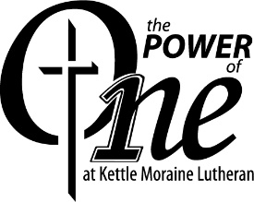
For: KML Federation of Churches
From: Superintendent David W. Bartelt

Devotional thought
2 Corinthians 12:9 But he said to me, “My grace is sufficient for you, for my power is made perfect in weakness.” Therefore I will boast all the more gladly about my weaknesses, so that Christ’s power may rest on me. (NIV ®)

We are KML. This is a victory battle cry! When we say it...we say it boastfully. It is not the fiscal strength or the enrollment growth that feeds a boastful attitude. KML is a school that does and always will rely on the power that comes from Jesus. He is the ONE who gives us eternal victory. He is the ONE who gives us strength to serve. Jesus is the ONE that gives us a mission and purpose.

We live by the Power of ONE! Think of what that power does for each individual. Each one of us is strengthened by the Word. The Word is taught, preached, and practiced at KML. We are one school that is strong because of the grace of God. We are one federation of many churches, schools, and individuals who rely on the all-sufficient and free grace of God. The Power of ONE unites us. We are KML!

2015-16 ACT Test comparisons

 |  | English | Math | Reading | Science | Composite
National |  | 20.1 | 20.6 | 20.8 | 21.3 | 20.8
State |  | 19.7 | 20.4 | 20.7 | 20.7 | 20.5
KML |  | 24.7 | 24.3 | 25.2 | 23.9 | 24.7

Enrollment – The enrollment (426) increased by 23 students at the beginning of the school year. We are anticipating another increase of 40 in the fall of 2017. Programming and staffing are being studied by the committees of the Board. KML is part of the Wisconsin and Milwaukee Choice Program- In our second year the eighty-six students received voucher dollars to pay for the full cost of tuition. The majority of those students are currently members of our KML Federation. The tuition assistance dollars that would have gone to them were dispersed to more families who did not qualify for the program. This program will allow more people to enjoy the blessings of Christian education at KML!

Vision 2021- The Board of Directors has approved some significant initiatives that will be the catalyst of school improvement over the next seven years. Some key components of that vision are:
- Reduced or eliminate the $7 million debt
- Increase the value of the high school ministry to the 28 churches of the federation
- Evaluate and reshape the curriculum and faculty towards a sustainable and more powerful impact on future graduates
- Manage increased enrollment from 400 to 500 students over the next three years
- Our third round of a Self-Study will provide a detailed school improvement plan over the next 7 years.

Facilities
- The Building & Grounds Committee has completed several campus improvement projects in 2016. Projects include:
  - The oldest roof section has been replaced
  - driveway improvements
  - construction of concession stand
  - maintenance shed roof
  - outside camera system
  - increased door security

Faculty and Staff
- In September we installed two new teachers into our KML ministry. Mr. Dan Hubert is our new Band teacher. Mr. Dan Albrecht is our new Computer Apps teacher. Mr. James Livingston is our new Geometry teacher.
- Mr. Len Collyard and Pastor Ron Mehlberg have announce their retirement at the end of the 2016-17 school year.
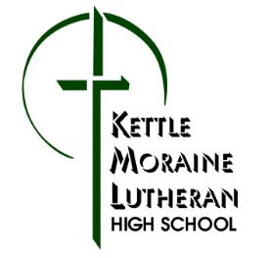
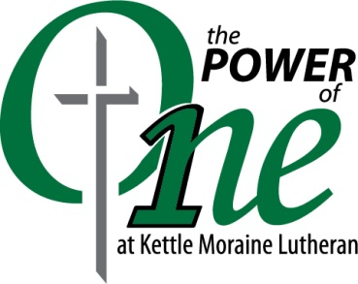

Blessings of 2016

January
- The Lord continued to bless our Builders campaign as we started the year with gifts totaling $9,360 per month from 315 Builders (134 to capital/debt reduction) who support KMLHS through auto deposits!
February
- KML presented the drama Larceny and Old Lace on February 19-21. The many attendees enjoyed the hard work and exceptional talents of the play’s cast and crew.
- The KML Foundation awarded over $31,000 to KML for student tuition assistance.
March
- The Charger Boys Varsity team finished the season with a 16-8 overall record and finished 3rd in the East Central Conference with a record of 10-4.
- The Charger Girls Varsity team finished their season with an amazing 21-4 overall record and a 14-0 conference record, earning the team the East Central Conference Championship and their 5th straight 20 win season, their 5th straight conference championship, and their 4th straight Regional Championship.
- For the fourteenth year in a row, the Varsity Cheer team brought home a Regional Championship and earned a State Runner-up finish in their division.
- Twenty-two KML band members as well as 18 solos and ensembles qualified as WSMA state instrumentalists.
- WSMA vocal state qualifiers this year included the Echoes Show Choir, Echoes Jazz Choir, and individuals with 10 solos and two duets.
- A Community Electronics Recycling Event was held at KML under the direction of Mr. Joshua Schoeneck. Approximately 30,000 pounds of electronics were collected for recycling.
- KML hosted a Thriving Families in Challenging Times parenting seminar on March 22. The presentations were given by counselors from WLCFS. The KML Foundation sponsored the event.
April
- The KML Cross Trainers completed their 8th year of going on mission trips across the US. The Cross Trainers and their chaperones shared the message of Jesus in Alabama, Alaska, Florida, South Carolina, Tennessee, Texas, and St. Lucia.
- The annual Family Music Fest event took place on April 8 with the theme of A Night at the Movies.
- The Annual Dinner Auction was held April 15 at the River Club of Mequon. Under the theme of Friday Night Lights, more than $82,000 (gross) was raised to benefit KML with the net proceeds going toward fulfillment of the Auction Committee’s pledge to the stadium lights fund as well as to the tuition assistance program.
- Over the Easter break, 31 KML students and five parents joined KML instructor, Mr. Jerry Zeamer, on a ten day journey of our country's rich history to the East Coast.
- The KML Forensics team earned two bronze, seven silver, and five gold medals at the State Forensics Tournament at UW-Madison on April 16.
- A total of 27 students wrote 38 Advanced Placement tests in the following areas: Chemistry, Psychology, Spanish Language, Calculus AB, Calculus BC, English Language and Composition, Statistics, U.S. Government, and German Language and Culture.
- Of our 107 seniors, 59 received scholarships for the college of their choice. For the first year of college our departing seniors received more than $824,000. If all their renewable scholarships are used, the total will exceed $2.7 million!
May
- Nine KML students were chosen to have their work published in the East Central Conference High Schools magazine Perspectives which celebrates the creative writing of students from each school in the conference.
- The 107 members of the KML Class of 2016 graduated on May 28.
- We bid farewell to many KML faculty and staff at the end of the school year and praised God for their faithful service:
  - Mrs. Jane Boettcher – main office (5 years)
  - Mrs. Jean Kowalski – fiscal office (8 years)
  - Mrs. Christin Leckwee – study hall / commons supervisor (1 year)
  - Mrs. Sarah Mayer – instructor (16 years in the ministry, 13 at KML)
  - Mrs. Bonnie Schramm – retiring instructor (28 years in the ministry, 26 at KML)
  - Mr. Darwin Schramm – retiring instructor (41 ½ years in the ministry, 37 ½ at KML)
- The KMLES Band Program marched in its first parade ever at the West Bend Memorial Day Parade.
June
- This was the 6th year of KML’s E³ (E-cubed) summer classes, with a wide selection of camps offered for our elementary students – sports, cooking, Spanish, music, chess, computer programming, and much more!
- KML German instructor, Mr. Wes Schmandt, led a group of 18 KML students and parents on a 14-day trip to Austria, Switzerland, and Germany.
July
- The 27th Annual Kettle Golf Open was held on July 28 to support the KML golf team and athletic department and to honor retiring instructor and golf coach, Mr. Darwin Schramm.
August
- KML welcomed new staff members Mrs. Amy Hubert (main office) and Mrs. Angie Livingston (Learning Center).
- The 5th annual Kettle Klomp was held August 13. This event consisted of a 5K race and two-mile walk. Proceeds were used to benefit KML.
- With the 2016-2017 school theme of The Power of ONE, KML began its 43rd year of serving our Lord with an enrollment of 427, including 13 international students from China and South Korea.
- With the start of the 2016-2017 school year, KML began its second year of participation in the Wisconsin Parental Choice Program and its first year taking part in the Milwaukee Choice Program. Eighty-six KML students have been blessed to receive Choice funds to pay for their tuition at KML (78 WPCP, 8 MPCP). As a result, tuition assistance dollars from KML were reallocated to other KML students who applied for financial aid.
September
- KML’s annual Celebration of Ministry was held in the PAC Auditorium on September 18. Installed during this service were Mr. Dan Albrecht (computer instructor), Mr. Dan Hubert (band instructor), and Mr. James Livingston (math instructor). Twenty-five years in the ministry were also celebrated by Mr. Jonathan Pasbrig.
- Recently retired KML instructor, Mr. Darwin Schramm, was inducted into the Wisconsin Basketball Coaches Association Hall of Fame on September 24.
- The KML Foundation hosted the Annual Charity Golf and Dinner Outing at the West Bend Country Club on September 12. The event raised more than $34,000 for the KML Foundation, student assistance, and toward the purchase of a marimba.
October
- The KML Foundation sponsored a Sport Clay Shooting Event at the Highlands in Cascade on October 2 which raised more than $2700 for the Foundation.
- On October 13-14, KML hosted 327 grandparents for Grandparents’ Days. They enjoyed refreshments and presentations by Mr. Luehring and Mr. Snamiska and were entertained with a preview of the Children’s Theatre production, Miss Nelson is Missing! After worshipping with their grandchildren at chapel, they accompanied them to classes and were treated to lunch on campus.
- Volunteers from the KMLES Band Program participated as student musicians in Spotlight Productions’ performances of The Music Man in West Bend on October 14-15.
- KML students performed the Children’s Theatre production of Miss Nelson is Missing! for six enthusiastic audiences with matinee performances on October 25-26 and public performances on October 28-30.
November
- Our annual Veterans Day program was presented on November 3 to an audience which included over 325 veterans and guests. This year’s focus was POW/MIA. Rev. Mark Wagner of Our Savior, Grafton, was our guest preacher. We thank all those who participated, and we thank those who serve us – and who have served – in the armed forces, and their families.
- KML students in the Echoes choir participated in the WELS East Regional Choral Festival at Luther Preparatory School in Watertown, WI, on November 11-13.
- KML welcomed Mrs. Dawn Farley as the new International Student Program Coordinator, replacing Mrs. Becky Kemnitz who accepted a full-time position elsewhere.
- Friends of KML showed overwhelming support of our ministry when KML participated in its 2nd #GivingTuesday on November 29. Matching donors’ gifts of $50,000 were surpassed in ONE day with generous donations of over $85,000! The total support given to KML on #GivingTuesday with the match was over $135,000! All praise to our Heavenly Father who blessed us through these generous friends!
December
- The KML Foundation sponsored the concert, A Son Illuminated, by the popular contemporary Christian group Koiné for the general public on December 13.

To God be all praise and thanks!

2017 Annual Report
Board, Committee or Group Reporting | Teen Bible Study
Trends affecting our ministry: | We have a small core of teens participating in Sunday Bible study at Our Savior. The overall attendance has decreased the past few years. The teen class ten-year average is just below 10, with this past year’s average attendance at 5.  The strongest trend continues to be the clear correlation between the parents that attend Sunday morning adult Bible study and the teens that attend teen Bible study on Sunday morning…similarly parents that do not attend Bible study and the teens that do not attend teen Bible study.  Our attendance is weighed on the side of early teens vs. late teens.  Our current 8th grade graduating classes are smaller than previous years.
Accomplishments in 2016 | A relatively small core group of teens attend Teen Bible Study on a regular basis with a few more who attend on an occasional basis. God continues to bless our Teen Bible Study!  We primarily used a video based curriculum that focused on teen topics: “Everyday Videos and Bible Studies for Teens.”
Asking the Lord to  bless our efforts, we have made the following goals for 2017 | With the Lord’s blessing, we hope to increase our number of core teens who attend Bible study on a regular basis.  More effectively reach out to those teens that are not attending regularly or at all.  Continue to create a greater understanding within the congregation and the teens themselves of the importance of teen involvement and regular study of God’s Word.  Continue to encourage our teens to become more involved in service opportunities within the church.  We would like to see the teens (and their parents) organize and enjoy a greater number of Christian fellowship events.  Continue to encourage, support, and pray for our teen leaders.
The congregation can aid us in achieving our goals by: | This ministry to teens would benefit having additional people from the congregation willing to coordinate a few outings…  ENCOURAGE OUR TEENS TO ATTEND/PARTICIPATE IN TEEN BIBLE STUDY, and to be an example and a model for them as we regularly attend some of the many Bible study opportunities that are offered within the church. Continue to pray for the teens and leaders asking God to bless the teen ministry program here at Our Savior.  These teens, Lord willing, will be the future leaders of the church. We ask that more of our adult membership encourage them by looking for opportunities to chat with them, and express thankfulness to them for their involvement and contributions, and to look for opportunities to include our teens in congregational ministry.
Reporter Name or any other person to be acknowledged for this area of ministry: | In His service: Scott Martens, Jimmy Pautz, Tom Hering

2017 Annual Report

Board, Committee or Group Reporting | Sunday School
Trends affecting our ministry: | - Sunday School enrollment (nursery – gr. 7) had a slight drop this past year. (39 in 2016-2017, 44 in 2015-16)  - Stable population of young children within the congregation.  - We continue to enjoy a core of parents who are committed to Christian Education for their children.  - Enrollment trends continue to show a slight decrease after the Christmas season.  - Dedicated and committed staff that faithfully carries out their teaching and administrative responsibilities.
Accomplishments in 2016/17 | - Continued to offer Preschool Sunday School for 3 and 4 year olds and classes for Kindergartners through 7th grade.  - Continued the “team teaching approach” where more than one teacher teaches in a couple of our classrooms.  - Welcomed back a returning teacher.  - Prepared and offered a Christmas Eve Service.  - Sang in both services on the last day of Sunday School in May.  - Met for devotion and planning with staff.  - Made recruitment contacts with families.  - Continued outreach to members whose children are in public school and don’t attend Sunday School.  - Invited the parents to meet the teachers and see the classrooms on Christian Education Sunday.  - Continued to offer a snack program where the parents help provide treats.  - Continued a three year phase-in of an updated ChristLight curriculum for Kindergarten through 7th grade.
Asking the Lord to bless our efforts, we have made the following goals for 2017-18 | - Encourage students to bring friends.  - Continue a “parent meet the teacher” Sunday.  - Prepare for the Christmas Eve Service.  - Encourage additional SS attendance through a mid-year recruitment effort.  - Continue to monitor enrollment trends and grade splits for future years.  - Recruit, as needed, for our Sunday School teaching staff.
The congregation can aid us in achieving our goals by: | - Praying for our teachers and students.  - Volunteering to teach, be an aide, lead music, etc…  - Sending your children to Sunday School.
Reporter Name or any other person to be acknowledged for this area of ministry: | Deanna Edwards, Coordinator  Tom Hering, Superintendent

2017 Annual Report

Board, Committee or Group Reporting: | Board of Christian Education
Trends affecting our ministry: | - Increasing costs associated with education  - Positive trend in parent involvement and growth in PTF group  - Increased community use of facilities  - Marketing our school in a community with quality educational choices  - Good potential to see growth in enrollment over the next several years  - Increasing amount of administration work needed to adequately cover all aspects  of maintaining and improving our Christian education program.
Accomplishments in 2016/2017 | - Thankful for Mr. Ben Raddatz’s three years of service as our 3rd-5th grade teacher  - and athletic director  - Thankful for Mrs. Katherine Raddatz’s three years of coaching volleyball and softball and one year of part-time teaching various classes in 1st-8th grades  - Thankful that the Lord called and led Mrs. Amanda Hering to accept the one-year teaching position that opened with Mrs. Raddatz moving to Albuquerque, New Mexico  - Thankful that the Lord called through a one-year assignment Mrs. Emily Roderigue to the teaching position that opened with Mr. Raddatz accepting a new called position for next year in Albuquerque, New Mexico.  - Progress continues in Accreditation process  - Parent survey brought valuable insights and ideas to implement to strengthen Our Savior.
Asking the Lord to bless our efforts, we have made the following goals for 2017-18 | • Continue to develop necessary programs and procedures to meet any deficiencies  so as to achieve accreditation in fall of 2017  • Continue to increase parent involvement  • Revisit in fall of 2017 the staffing needs for the 2018-2019 school year and  recommend calls to be issued when the synod’s calling window reopens in  November 2017.
The congregation can aid us in achieving our goals by: | • Praying for our school, students, faculty, and staff  • Continue to support our program of Christian education through participating in  special projects or events  • Communicating the benefits and blessings of OSLS to families and friends  • Volunteering in classrooms, hot lunch, coaching, field trips, etc.
Reporter Name or any other person to be acknowledged for this area of ministry: | Jamie Luehring, Joel Grulke, Nick Matter, Phil Babler, Mike Smith, Kent Russell, Michael Braatz - St. Matt's Rep

2017 Annual Report
Board, Committee or Group Reporting: | Elders
Trends affecting our ministry: | - Membership increasing (new members joining), but still losing members leaving via the back door  - Church service & bible class attendance is down over years past  - Increasing demands for Pastor’s & Staff Minister’s time  - How people see the church fitting into their lives  - Spending time on discipline issues  - Government limiting/interfering religious activity
Accomplishments in 2016/17: | - Membership Issues – continued working with Pastor & Visitation Team  - Worked on worship issues (i.e.: midweek Advent & Lent services, special services, weekly services, etc) Standardized worship times for special & holiday services  - Cleaned up membership roster of inactive members and members with whom we have lost contact  - Restarted the Care Committee for Call Workers (CCCW)  - Looked into safety concerns for persons on church property  - Formed subcommittee to look into Organ replacement/upgrade
Asking the Lord to bless our efforts, we have made the following goals for 2017/18: | - Worship & Bible Study attendance  - Visitor & Worship issues  - Reduce members leaving via the back door  - Support the Pastoral team  - Move forward with the congregations long range plan  - Vision of the congregation  - Personal & Family plan for growth in the word  - Meet our member need’s & want’s from the Church
The congregation can aid us in achieving our goals by: | With your Prayers & Support  - Contacting Elders when members notice that members are drifting away from the Lord.  - Contract an Elder with any worship and Church policy issues
Reporter Name or any other person to be acknowledged for this area of ministry: | Pastor Wagner  Bob Klug (Worship Elder)  Jeremiah Backhaus (CCCW)  Dale Meyer (Visiting Elder)  Steve Wolf (Cong VP)  Doug Schnell (Cong Sec)  Russ Miller (Cong President)  Marty Dierker (Chairman)

2017 Annual Report
Board, Committee or Group Reporting | Spiritual Growth Committee
Trends affecting our ministry: | - Sunday School attendance remained fairly steady during the past ten years, with a slight decrease the past couple years.  - Adult Bible class attendance has remained stable, with Sunday’s class remaining ahead of the ten year average.  - Faithful Bible study leaders.  - Faithful core of Bible study attendees. There have also been a significant number of new attendees for our Bible studies.
Accomplishments in 2016/17 | - Supported the effort of Advent Family Activities and Devotions.  - Encouraged attendance at Sunday School and Bible class through post-service presentations.  - Ongoing use of our congregational Facebook page.  - Provided verbal encouragements to our Bible studies, asking those who currently attend to consider inviting others to the class.  - Provided the congregation with a brochure to encourage attendance during Lenten services.  - Distributing a “new member” Bible class brochure, with a welcome note on the front, which lists the various Bible classes throughout the week, and invites new member participation. These are given to new members as they join.  - Planned and facilitated the men of our congregation to attend the annual “Men of His Word” conference that was held in February in Oshkosh.  - Developed, distributed and encouraged congregational usage of a Spiritual Growth Plan as a tool for both family and individual efforts toward spiritual growth.
Asking the Lord to bless our efforts, we have made the following goals for 2017-18 | - Continue to encourage a greater understanding in our membership as to what spiritual growth means, why it is important, and how to achieve spiritual growth on a personal, family and corporate level.  - Encourage greater in-home personal Bible reading/devotional life.  - Encourage greater attendance by our membership at church offered Bible classes.  - Ongoing use of our Facebook page as a means for connection and encouragement among our membership.  - Provide periodic “Words of Encouragement” testimonials by committee members and other congregational members in order to encourage others in personal Bible reading, devotional life and corporate Bible study.  - Encourage the men of our congregation to attend the annual “Men of His Word” conference in Oshkosh on Feb. 24, 2018.  - An annual ongoing effort to focus the newly implemented Spiritual Growth Plan toward specific areas of growth in the coming years.
The congregation can aid us in achieving our goals by: | - Increased use of Word and Sacrament by all our membership.  - Attending Bible classes and other spiritual growth activities.  - Praying that more would spend regular time with God’s Word.  - Increasing the time spent with God’s Word in your home.  - Showing love and concern for the spiritual growth of others. We believe members inviting other members to Bible studies is the best line of recruitment, including talking up special events like the women’s Camp Phillip outing and the men’s Men of His Word Conference.  - Not only personally using the Spiritual Growth Plan, but also sparking conversation with others about the blessings and benefits of such a tool.
Reporter Name or any other person to be acknowledged for this area of ministry: | Len Collyard, Stu Stein, Andy Vatter, Tom Hering

2017 Annual Report
Board, Committee or Group  Reporting | Evangelism Committee
Trends affecting our ministry: | - Growing neighborhoods & businesses nearby; steady number of visitors; increased interest among area congregations to work cooperatively; strong lay leadership; enthusiastic Outreach leadership Team.  - Better Data Tracking Systems: We are excited to be able to use our data tools like PowerChurch & SalesForce to help keep track of prospective members, and will continue to grow our outreach efforts through gift bags, door visits and more personal communications.  - Challenge: Many of us are hesitant to accept the reality that we all are gifted with opportunities to share Jesus in our day to day lives.
Accomplishments in 2016/2017 | - Continued use of SalesForce software and volunteer assistance with data entry continues to help us track member and visitor worship attendance.  - Presentation September, 2016 “Healing the Heart” workshop focusing on addiction and its effect on individuals and families.  - Congregation volunteer involvement setting up, participation in, and taking down joint area WELS churches' Christmas Living Nativity at Cedar Creek Farms.  - Efforts to coordinate our school outreach efforts and with church: participation in Grafton Christmas parade, Cedarburg Strawberry Fest Shortcake booth.  - Identifying the role of our school and its programs as opportunities for outreach.
Asking the Lord to bless our efforts, we have made the following goals for 2017- 2018 | - To encourage/train our people to Build Better Relationships for inviting their FRANS To continue to make the visitors experience warm and welcoming, and to use our gifts as a congregation to spread the Word of The Lord.  - To continue supporting our Christian day school's outreach efforts.  - Continue to romote member involvement and church/school in community events.  - To host a Wellness Event as a community outreach effort that would include spiritual, emotional, and physical health.  - To explore the feasibility of sharing Jesus with communities north of us with no WELS congregations.  - To increase Bible Information Class attendance.
The congregation can aid us in achieving our goals by: | - Remembering that we all are members of the Outreach Committee, as Christians, and have a duty as such to spread The Word.  - Becoming a truly friendly, inviting congregation at worship and in our service to our community.  - Remembering we all must do our part to spread The Word and use our gifts to their greatest good.  - Praying for more outreach opportunities.  - Continue to recruit and bring FRANS to our Bible Information Class.  - Utilize the materials and opportunities the Evangelism committee provides.
Reporter Name or any other person to be acknowledged for this area of ministry: | Thanks to Calvin Gall, Becky Sander, Holly Schneider, Sarah Smith, larger events team, and many others. (Jon Hahm, Chairman)

2017 Annual Report
Board, Committee or Group Reporting | Board of Stewardship
Trends affecting our ministry: | Desire to expand ministry with greater member involvement.  Ongoing “Hope for Years to Come” campaign
Accomplishments in 2016/17 | Monthly encouragements in the News & Notes.  Quarterly Stewardship Updates to the congregation which include written educational and financial material, followed up with a verbal Powerpoint presentation to the congregation.  Hosted Our Savior Family Night in February, with attendance at about 170 in 2017. The five-year average is 137.  - Hosted a Chili Contest event in November, with about 65 attending; and an average of about 80 over the last several years.  - 279 Commitment Forms were distributed during the annual spring congregational commitment intent appeal. 73 were returned (26%). This information helps establish a budget based on the projected offerings. The appeals continue to emphasize a response motivated by the Good News we have through Jesus.  Assisted with the annual church picnic in August, which was changed from the traditional 2nd weekend of August to the last weekend of August. Attendance was significantly increased at 180, compared to the average over the previous five years of about 125-130.
Asking the Lord to bless our efforts, we have made the following goals for 2017-18 | Organize and conduct fellowship events, including the Our Savior Fun Nights, annual picnic, chili contest...  Encourage our membership to prayerfully practice their stewardship of time, talents and treasures through monthly and quarterly updates and presentations.  Continue to evaluate and encourage our membership to assist in our ministry plan by responding to the spring annual appeal; and provide Scriptural encouragement for our members to reflect their love for Jesus in how they respond with their time, talent, treasures and worship.
The congregation can aid us in achieving our goals by: | More boards/committees/groups using the Service Survey information that is easily accessible through Sarah in the church office.  Our entire membership prayerfully using their time, talents and treasures to the glory of God and to serve one another.  Involvement: 1. Attending worship regularly  2. Attending Bible Study(ies)  3. Attending fellowship events  4. Participating in various service opportunities
Reporter Name or any other person to be acknowledged for this area of ministry: | Dayton Behnke, Chad Bloedel, Mark Boeckman, Scott Martens, Matt Schiller, Tom Hering

2017 Annual Report
Board, Committee or Group Reporting | Board of Trustees
Trends affecting our ministry: | - Weather for some outside projects.  - Out-pouring of volunteers for work days and special projects.  - We have been blessed with more help, sometimes than work that can be accomplished at any one time.  - Donations of time and material has been amazing.
Accomplishments in 2016/2017 | - Completion of the new garage to replace our aging shed.  - Re-lamping of the Life Center.  - Removal of some trees and shrubs during the spring work day.
Asking the Lord to bless our efforts, we have made the following goals for 2017-18 | - Re-roofing the Life Center and Church  - Sealing of the parking lot.  - Refinish the Life Center floor. (Basketball Court)
The congregation can aid us in achieving our goals by: | - Continue with volunteer and stewardship support.  - Prayers for Our Savior staff, board and committee members.
Reporter Name or any other person to be acknowledged for this area of ministry: | - Bob Duckart for his time and effort in calling, recruitment of additional volunteers for special projects, and his ushering thru the permitting process for the garage.  - Joe Weiss for his tackling of the "fallen" sign.  - Dan Sauer for his work with electrifying the garage.  - Various other volunteers who are working hard on our property and grounds – mowing, trimming, building, cleaning, spraying etc.

2017 Annual Report
Board, Committee or Group Reporting | Budget and Finance
Trends affecting our ministry: | - Mortgage & Interest costs in current budget  - Building repairs are needed  - Rising health care costs  - High concentration of giving by small number of families
Accomplishments in 2016/17 | - Present a balanced budget for FY2018  - Developed cash reporting with the goal of highlighting our true cash position on a monthly basis
Asking the Lord to bless our efforts, we have made the following goals for 2017-18 | - Meet our capital appeal commitments  - Achieve a balanced budget (or surplus) in FY2019  - Fund building improvements without taking on more long-term debt
The congregation can aid us in achieving our goals by: | - Pray for the stewardship efforts for both our church and school  - Submit commitment cards for annual giving and capital appeal
Reporter Name or any other person to be acknowledged for this area of ministry: | Todd Schneider, Chad Thistle, Philip Babler, Joel Grulke, Tom Hering, Andy Koffman, Pastor Wagner

2017 Annual Report

Board, Committee or Group Reporting | Long Range Planning
Trends affecting our ministry: | - Greater awareness of our ministry and facility in the Grafton community  - Ongoing growth in our nearby communities and immediate area  - The need to expand member volunteerism towards ministry goals  - Political/Economic challenges impacting our members and communities
Accomplishments in 2016/2017 | - Completed the Capital Appeal successfully, already seeing positive results  - Assessed primary functions and ministry needs  - Addressed staff and building needs as critical priority
Asking the Lord to bless our efforts, we have made the following goals for 2017-18 | - Complete the Accreditation process for our LES  - Revise the congregation’s long-range plan – involving all leaders and focus groups of our membership to get a broad spectrum of input  - Support and provide recommendations to the various committees that make ministry, finance and campus/facility decisions  - Communicate effectively what the congregation’s long-range plan is and how each member can contribute to its achievement  - Facilitate an increased level of participation by the congregation in the various ministry opportunities available to our members
The congregation can aid us in achieving our goals by: | - Encourage each other to maintain or increase involvement in the various ministry opportunities available  - Offer input and advice regarding opportunities for our congregation to expand internal and external ministry efforts  - Take an interest in our Long Range efforts, read and listen thoughtfully as we attempt to communicate with the congregation so that we can make informed and mutually satisfying decisions  - Pray for God’s continued blessings among us, pray that the work being done is within His will and to the glory and honor of His holy name  - Continue to give generously of your time, talents and treasures
Reporter Name or any other person to be acknowledged for this area of ministry:
  Ministry | Finance | Campus/Facility
  Jamie Luehring | Todd Schneider | Marty Dierker
  Pastor Wagner | Craig Shanks | Rick Land
  Joel Grulke | Chad Thistle | Steve Wolf
  Tom Hering |  | George Edwards
  Bob Duckart
  Scott Martens

2017 Annual Report

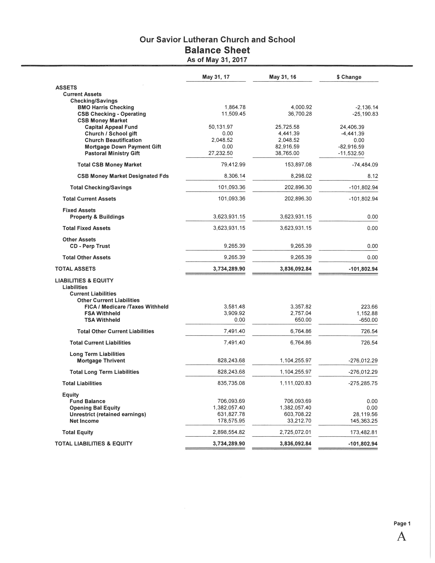

2017 Annual Report

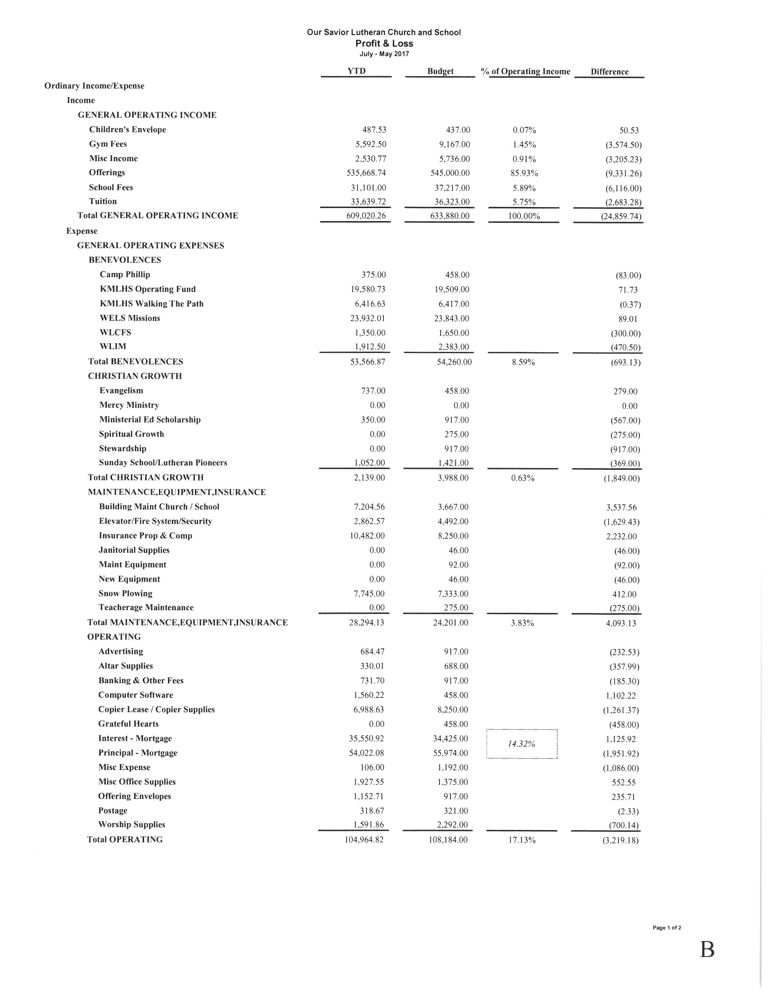

2017 Annual Report
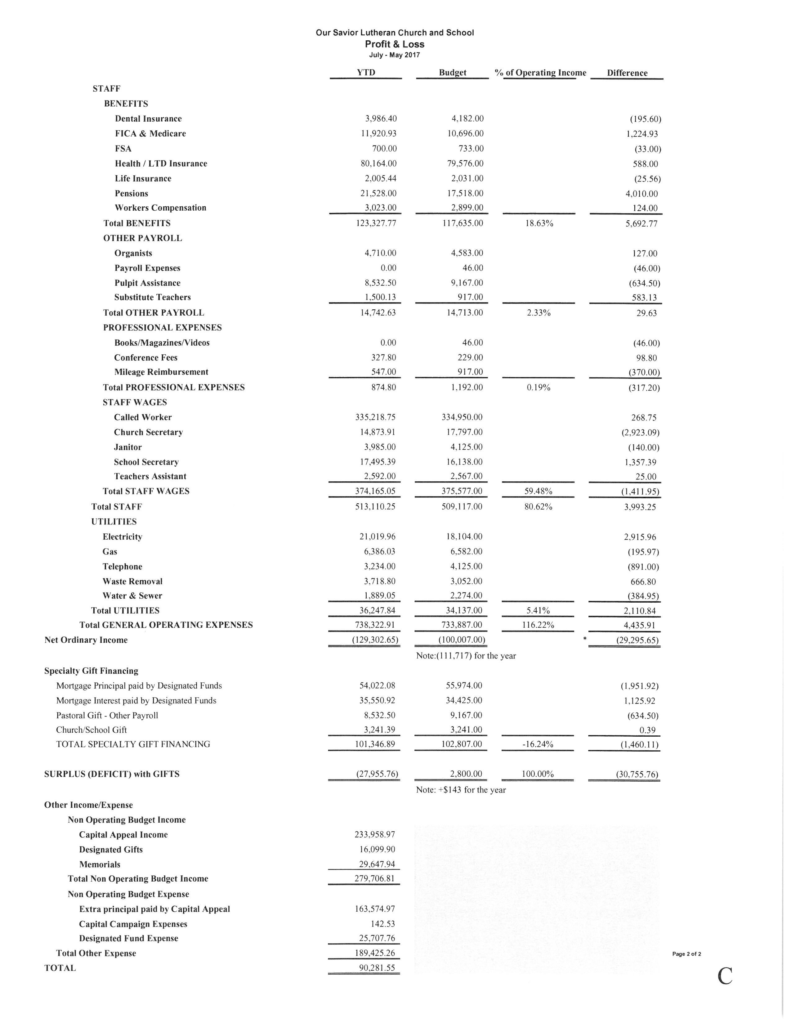

2017 Annual Report
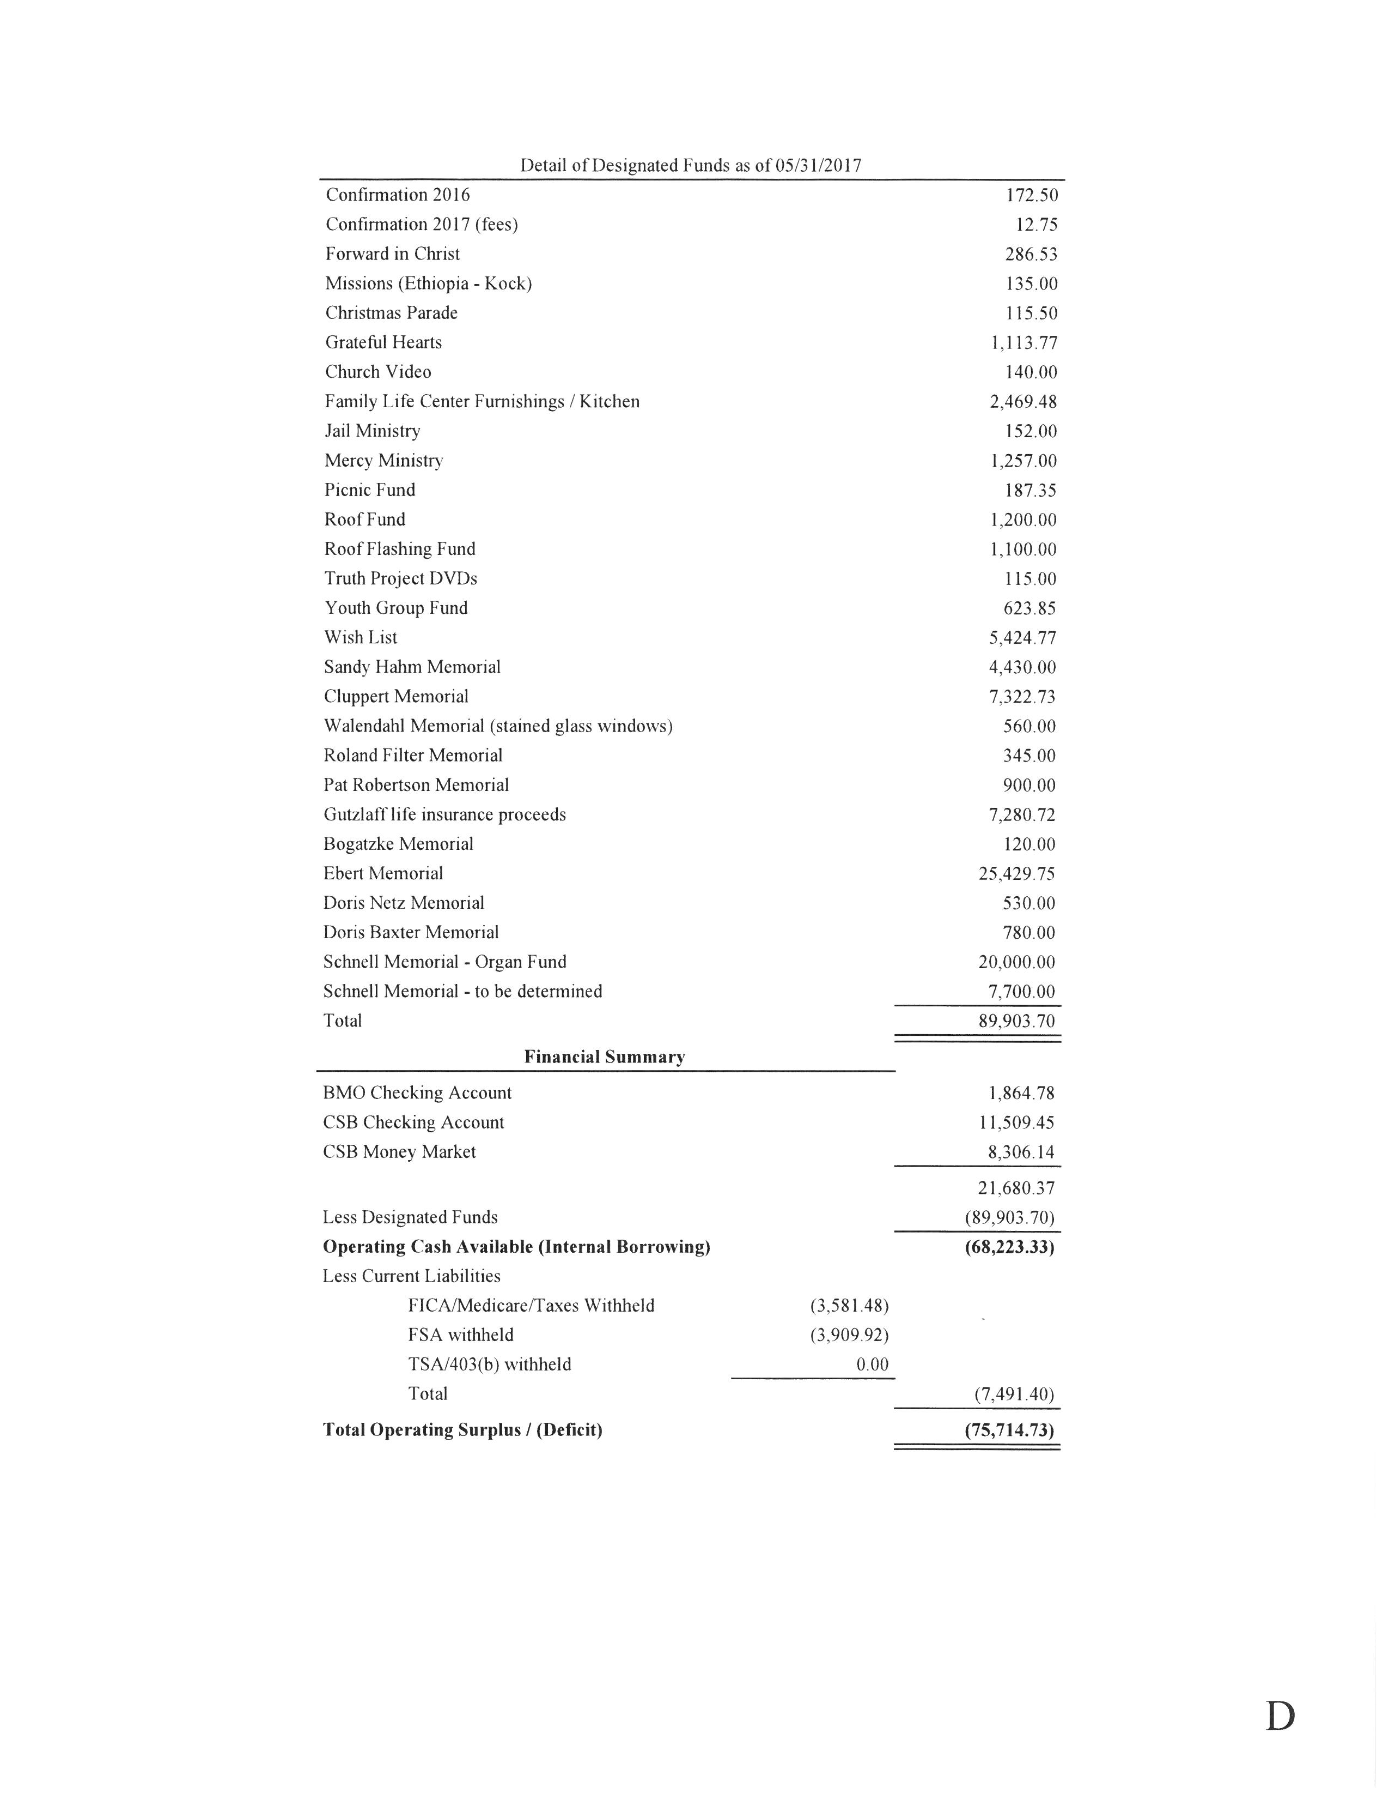

2017 Annual Report
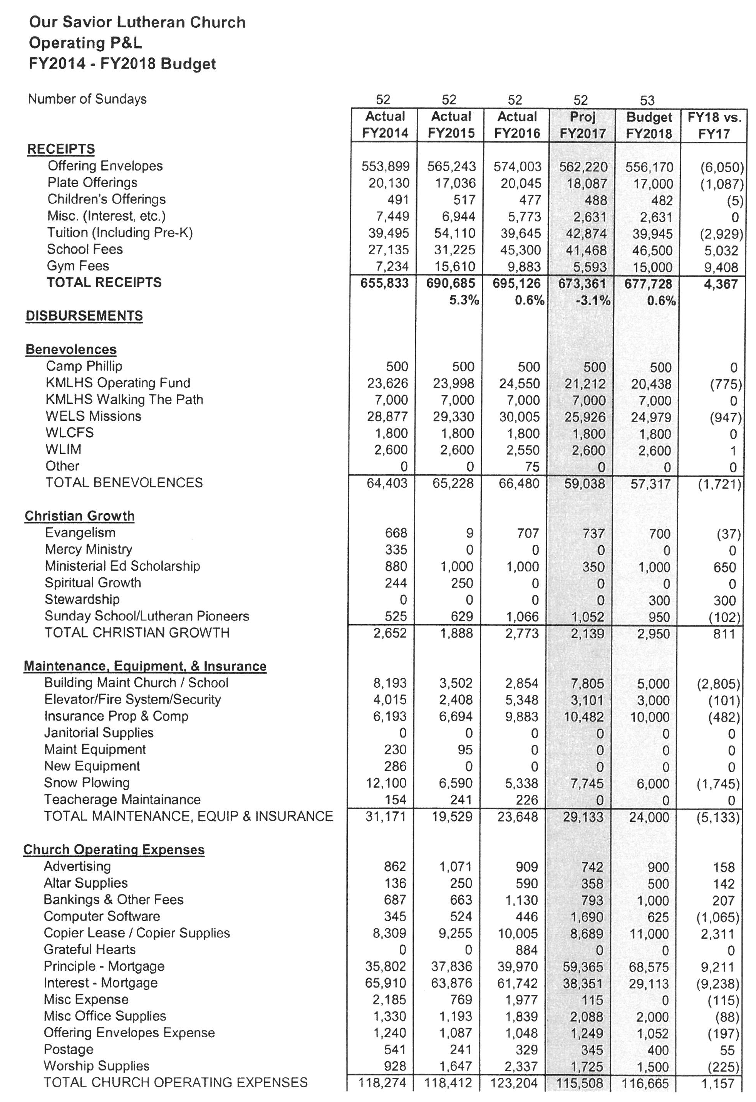

2017 Annual Report
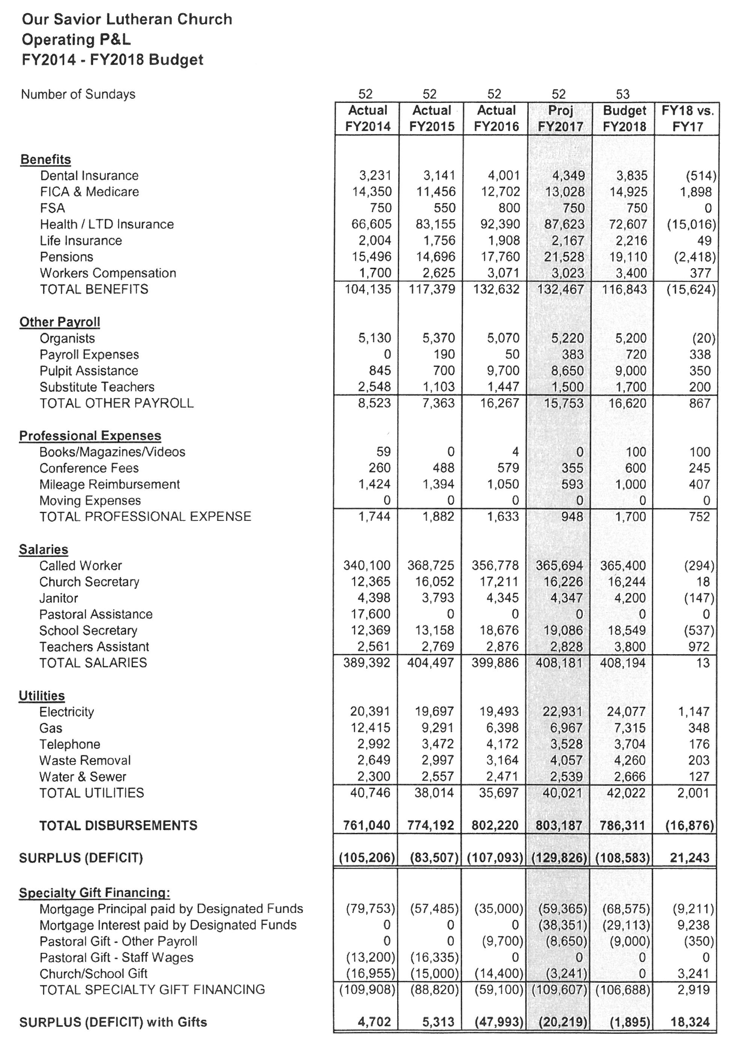

2017 Annual Report

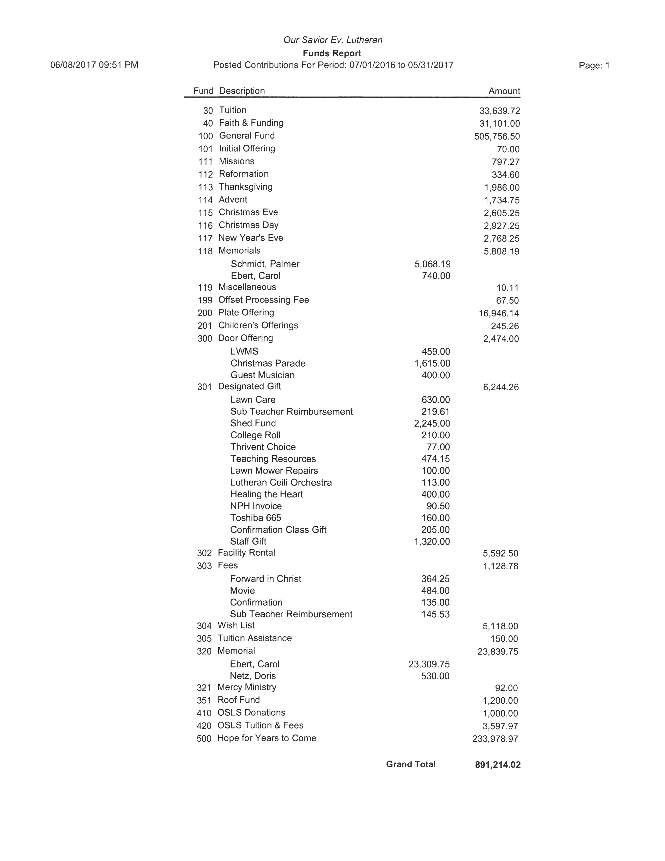

2017 Annual Report

Board, Committee or Group Reporting | Altar Guild
Trends affecting our ministry: | - Members busy with other obligations.  - Members leaving the group
Accomplishments in 2016/2017 | - Poinsettia sale for Christmas and Spring Flower sale for Easter.  - Repair and polish communion ware at annual meeting  - Annual meeting on June 10th .  - attempt to recruit new members to Altar Guild  - New schedule created for year
Asking the Lord to bless our efforts, we have made the following goals for 2017 | - Encourage new members.  - Have a meeting to discuss changes and questions  - communicate with ushers/altar assistants regarding responsibilities of Altar Guild
The congregation can aid us in achieving our goals by: | - Praying for our members.  - Volunteering to join our group.  - encourage other members of the congregation to join the group  - updated new phone numbers/address/e-mail for better communication
Reporter Name or any other person to be acknowledged for this area of ministry: | Becky Baughman, President

2017 Annual Report
Board, Committee or Group Reporting | Missions
Trends affecting our ministry: | We continue to have long-term interest in world fields our members are associated with: Africa, Nepal & Pakistan. Our latest emphasis has been through Pastor Wagner on Home Missions, as he continues to serve as District Mission Board Chairman. We intend to alternate or include home missions as part of our emphasis each year.  Synod: flat financials this past year, though we were able to open 7 new ministries during the last fiscal year (2 in our district) and 8 the previous year. We need to consider our level of continued support of synod through our regular CMO (Congregational Mission Offering).
Areas We Serve | WELS  By supporting synod we support:  - Doctrinal supervision & administration of our international ministry through the conference of District Presidents.  - Worker training to prepare candidates for ministry;  - Home & World missions, including nearly 250 home missions and 60 foreign mission fields, leading and aligning our church body with other church bodies of the same confession  - Institutional Ministries & Special Needs Ministries  - Parish Services which include Evangelism, Adult Discipleship, Worship, Youth Discipleship, Stewardship, etc.  - Planned Giving Counselors & Parish Consultants  Plus a host of other activities, including para-church organizations like Lutherans for Life, WLCFS, VEBA etc.  WLCC  As part of the Milwaukee Federation we support the work of our church body in particular through the Wisconsin Lutheran Care Center. They feature:  - Counseling services;  - Nursing homes; Retirement communities;  - Adoption  KMLHS  As part of the Kettle Moraine Federation we support the area Lutheran high school in its mission and ministry. Their mission: Empowered by God’s Word, KMLHS educates, encourages and equips God’s people for life and eternity. Many of our own high school age students attend and benefit from this educational ministry. As Secretary of the Federation, Pastor Wagner completed 9 years of service on the Board of Directors; Mr. Hering still serves on the Executive Committee. We have four congregational delegates.  WLIM  Wisconsin Lutheran Institutional Ministries serve our area directly by organizing, recruiting and training laymen along with the called chaplains for ministry to area prisons. I regularly refer inmates who have been transferred from Ozaukee County to the state system.
2017 Annual Report
Board, Committee or Group Reporting | Visitation Ministry
Trends affecting our ministry: | - Our Visitation Team has had fairly good success in connecting with the straying families of our congregation for the past three years. With Dale’s help we’re tracking those who are absent from worship much more closely.  - A unique craving for friendship, visitation and witness to the truth among this group of people. Tremendous potential for outreach, and loving, compassionate service.  - America’s aging “boomer” generation are facing uncertain times.  - A growing population of special needs and shut-ins, collective housing projects like assisted care, villages for elderly especially in this area (cf. downtown Grafton, expanding rehab facilities, new hospital)
Accomplishments in 2016/2017 | - Continued contact of straying – several members activated in attendance, yet some who showed no response and were released  - Pastor, Staff Minister and Visitation Elder currently share this responsibility of regular visits and communion for our shut-ins  - Christmas visits included caroling for all our shut-ins and some visits from our members, promoted through the Advent materials.  - Visitations list has reduced due to either improvement of health or the call home to heaven.  - Ozaukee County Jail ministry supervision was handed over from Pastor Wagner to Pastor Wildauer late in 2014. He and Tom Hering regularly visit, conduct services and bible studies, coordinate services, speakers, studies and served on the Oz. Co. Chaplaincy Board.
Asking the Lord to bless our efforts, we have made the following goals for 2017-18 | - Pray for, seek the Spirit’s guidance and encourage family members who function as caretakers for their loved ones and continue to seek new avenues for outreach and witness.  - Recruit new team members for the Outreach part of this ministry.  - Continue involving congregational members in holiday visits, letters, gifts etc.
The congregation can aid us in achieving our goals by: | - Praying for those who are sick, suffering, becoming inactive or in jail.  - Offering to serve as visitors, short or long term.  - Supporting and encouraging those who are already involved in this work.  - Special gifts, either directly to the sick and shut-ins or financial support for materials.
Reporter Name or any other person to be acknowledged for this area of ministry: | Pastor Wagner, Staff Minister Hering, Visitation Elder Gary Suckow  Coordinator for the Visitation Team – Dale Meyer, Visitation Team

