September USHERS’ SCHEDULE
8:00 am, Sunday Team 1E Dave Schlegel, Curt Bobholz, Steve Semmann,
Seth Seyfert, Dave Spietz, Lee Bladow, Dan Olson
10:30 am, Sunday Team 2L: George Edwards, Cliff Anderson, Billy Griffin,
Matt Schiller, Bill Tschanz, Ben Polheber
Thursday, 7:00 pm Team 2: Dick Blank & Bill Wessel

Septmeber ALTAR GUILD
Becky Baughman

GREETERS FOR September 16th
8:00 am William Mathiak
10:30 am Sharon Whitford/LeAnn Abts

CHURCH CLEANERS FOR SEPTEMBER 16th
Whitford Family

ALTAR ASSISTANTS FOR SEPTEMBER 13tH & September 16th
7:00 pm Stu Stein
8:00 am Joel Grulke & Marty Dierker
10:30 am Fred Kolkmann & Jim Brich

 | Last Week | Last Year
Thursday | 60 | 53
Sunday Early | 109 | 133
Sunday Late | 126 | 128
Total | 295 | 314

40

OUR SAVIOR EV. LUTHERAN CHURCH
(Wisconsin Synod)
1332 Arrowhead Drive, Grafton, WI 53024
Church: 262-377-6363 School: 262-377-7780
e-mail: oslcoffice@wi.rr.com e-mail: osls@wi.rr.com
Website: www.OurSaviorGrafton.org

Pastor Mark C. Wagner
Thomas P. Hering, Staff Minister
Joel A. Grulke, Principal

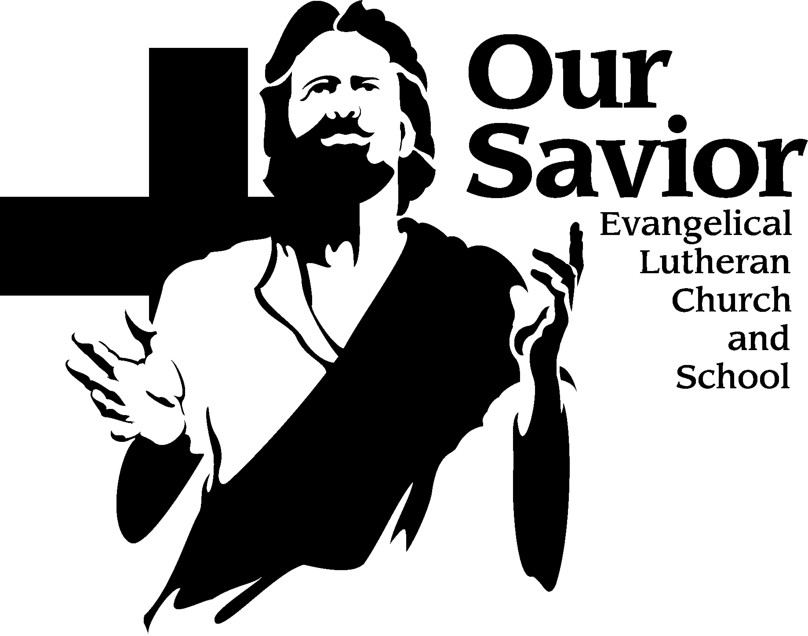
News & Notes
September 9, 2018

SPECIAL VOTERS’ MEETING – There will be a special voters’ meeting held on Monday, September 17th at 6:30pm. This meeting will be an update on the flood damage and financial decisions.

FALL ADULT BIBLE STUDY – Beginning of the End. September 9 – November 25. Does it feel like we’re living in crazy times? Is the world coming to an end soon? Almost every day people comment about how troubled they are about trends in our country: increased violence, immorality and selfishness. Seniors sit in front of the evening news shaking their heads. Parents fret over the safety of their babies, big and small. Children are exposed to images and content that once was hidden from public. What answers do we have in Scripture? What does God tell us about the end times? For the first time in a decade we’re back into the book of Revelation to hear what the Spirit shared with the Apostle John. We’ll watch the Lamb open the seals of judgment and call for the trumpets to sound forth. We’ll also see how the Lion of Judah (Jesus) is woven into every theme and every victory described in Revelation 6-9. This study will be taught by our Pastoral Team in the Sanctuary. Child care is available.
MARRIAGE BIBLE STUDY - Attention! An 8-week class led by Tom Hering that runs from September 9 through November 4. This series will encourage discussion while exploring a variety of topics for husbands and wives. The class will meet in Mr. Grulke’s classroom off the Family Life Center upper lobby during the regular Sunday morning Bible class hour. Child care is provided.

Sunday School Visitation Day - Our Sunday School begins TODAY Sept. 9. All S.S. parents are invited to greet their child’s teacher during the last portion of our first SS day by stopping at the classroom at 10 o’clock. This will also give you a few moments to complete some brief paper work and meet other parents. We hope all our SS parents can make it.

There’s a Prayer for that BOOKS - The Word encourages you to pray in every circumstance. Whether life leads you to bring thanks, praise, or troubles before God, he will listen. There's a Prayer for That guides you in this continual conversation with God. This collection contains over 450 prayers including some from Meditations Daily Devotional, for the people and situations in your life. These books will be available for purchase through the church office for $8.00 each. Please use the sign-up sheet on the table in the back if you would like to purchase one. There will be a copy on the table for you look at. Checks can be made out to Our Savior.

SENIOR ADULT BIBLE STUDY – Gospel of John In our study of John’s gospel, we will take a journey through the life of Jesus. John offers perhaps the clearest reason why the Holy Spirit has given us these inspired writings: “…these are written that you may believe that Jesus is the Christ, the Son of God, and that by believing you may have life in his name” (John 20:31). We'll apply our Savior’s teachings to our own lives throughout the study. The class will be taught by Staff Minister Hering in the Church Office Classroom on Tuesdays at 10:30 am, beginning September18th and continuing through November 20th.

Why does a Christian give? - Giving is a very poignant, personal, individual expression of faith; not a response to needs of the church. It is a direct result of the Holy Spirit's work in our hearts, an internal demonstration of our trust in God, and has profound meaning for both the individual doing the giving and the group receiving the gift. Giving is a response to the grace that the Lord has given to us, not a motivation for his grace. When we are connected to the vine, the fruit comes naturally. Don’t miss Pastor Mark Jeske’s (Time of Grace) when he joins us on October 4th and 7th here at Our Savior.
Our Savior School PTF meeting RESCHEDULED DATE – All parents, grandparents, teachers, and friends of Our Savior are invited to the PTF meeting Come and learn about the PTF, discuss what things are coming up, offer any new ideas, and meet everyone. The meeting will be held on Friday, September 14th @ 5:30pm pm in the FLC. Childcare is available!

ADULT BIBLE STUDY - Romans - A Bible study on Tuesday evenings will begin on September 11th at 7:00 pm in the church office classroom which is located in the white building. We will meet from 7:00 – 8:30 each Tuesday evening. Bring your point of view because you will be able to give it during our discussions.

ADVENT BY CANDLE LIGHT PLANNING MEETING – Attention ladies of the congregation, there will be an ABC (Advent By Candlelight) planning meeting TODAY Sunday, September 9th at 11:45am in the Church office classroom. We are looking to do some brainstorming about this year’s event, we should be done within an hour. All are invited.

From the Board of Stewardship - In 1 John 4:16 we read, “God is love.” God’s love is evident in His giving. “For God so loved the world that He gave His one and only Son that whoever believes in Him shall not perish but have eternal life” (John 3:16). Because of His love, God gave us the gift that we needed the most - our Savior. Out of love and gratitude for who God is and what He has done for us, we strive to live as Christ did, to be more like Him. Dear Lord, help us to treasure your perfect love for us. Help us to live for you, who died for us. Help us to overflow with your love to others. Amen.

Hearts-to-Hands - Grab your hooks and needles and join Hearts to Hands for an evening of crafting/crocheting/knitting, Monday, September 10th at 6:30pm in the mezzanine of the school building. If you're not a knitter/crocheter drop in to see what we're all about. We have needles, hooks and yarn to spare and would love to have you join us. We start at 6:30pm but come any time you want. With questions, call Laurel Polheber @ 262-483-2102.
Other Area News…

Friends of the Seminary - Day will be held Saturday, October 6, 2018. Sponsored by the WLS Auxiliary, this annual event highlights the way your gifts help WLS support the worldwide mission of WELS. Professor Kenneth Cherney, who joined the faculty in 2006, will share how valuable it is for our students to learn and use the original language of the Bible so they can take God’s timeless message to people today. Samuel Jeske is returning to the seminary for his senior year after his vicar year at Faith, Sharpsburg, Georgia. As part of the seminary’s Vicar in a Mission Setting program, Jeske spent a year learning and serving in this mission-minded congregation. Registration and coffee hour begins at 8 a.m. in the auditorium. Worship begins at 9 a.m. After the presentations, a light lunch, included in the $10 registration fee, will be served. Guided tours of the campus will follow. Please send your name, address, telephone number, and home congregation along with your registration fee to the attention of Lori Guse at 11831 N Seminary Drive, Mequon WI 53092, no later than September 14. For more information, contact Lori at 262.242.8104 or lori.guse@wls.wels.net.

