October USHERS’ SCHEDULE
8:00 am, Sunday Team 2E Dean Jacoby, Jeff & Jordon Abts, Tadd Hilgendorf,
Tate Plath, Craig Shanks, Bruce Voss, Josh Wimmer, Scott & Paul Zimmermann
10:30 am, Sunday Team 3L: Ken Lemke, Nathan Baughman, Norm Baughman, Matthew Baughman, Daniel Henning, Mike Krenke.
Thursday, 7:00 pm Team 3: Pat Wetzel, Travis Whitford.

October ALTAR GUILD
Carol Campbell, Casey, Rachel, & Naomi Gahan, Linda Hering

GREETERS FOR September 23rd
8:00 am Mike & Lora Sauer
10:30 am Schiller Family

CHURCH CLEANERS FOR SEPTEMBER 23rd
Luehring Family

ALTAR ASSISTANTS FOR October 4th & 7th
7:00 pm Stu Stein
8:00 am Joel Grulke & Bob Duckart
10:30 am Gary Suckow & Ken Lemke

 | Last Week | Last Year
Thursday | 46 | 32
Sunday Early | 183 | 201
Sunday Late | 109 | 93
Total | 338 | 332

40

OUR SAVIOR EV. LUTHERAN CHURCH
(Wisconsin Synod)
1332 Arrowhead Drive, Grafton, WI 53024
Church: 262-377-6363 School: 262-377-7780
e-mail: oslcoffice@wi.rr.com e-mail: osls@wi.rr.com
Website: www.OurSaviorGrafton.org

Pastor Mark C. Wagner
Thomas P. Hering, Staff Minister
Joel A. Grulke, Principal

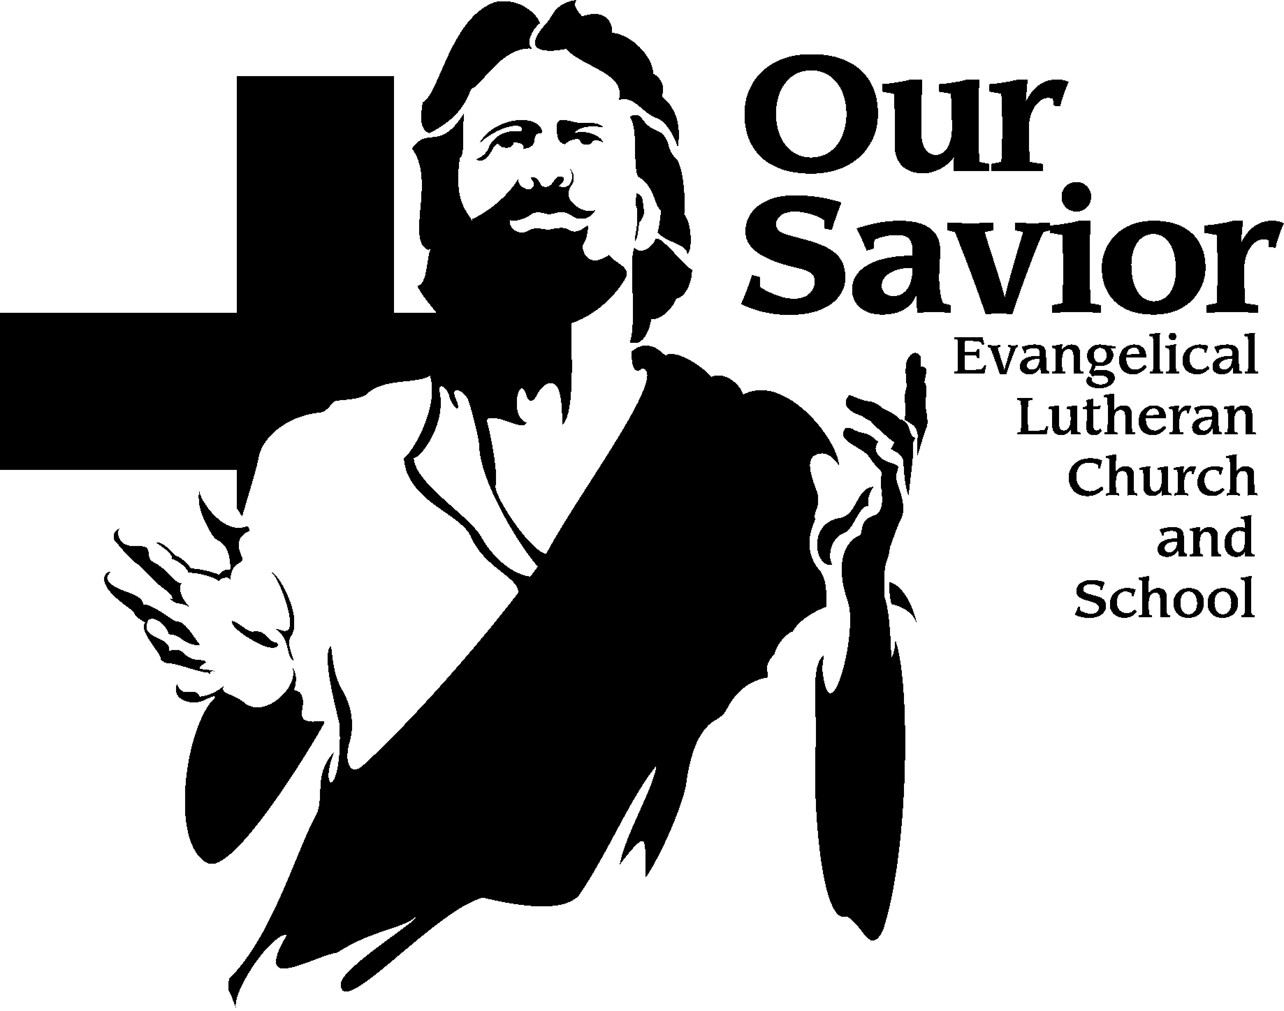
News & Notes
September 23, 2018

Why does a Christian give? - Giving is a very poignant, personal, individual expression of faith; not a response to needs of the church. It is a direct result of the Holy Spirit's work in our hearts, an internal demonstration of our trust in God, and has profound meaning for both the individual doing the giving and the group receiving the gift. Giving is a response to the grace that the Lord has given to us, not a motivation for his grace. When we are connected to the vine, the fruit comes naturally. Don’t miss Pastor Mark Jeske’s (Time of Grace) when he joins us on October 4th and 7th here at Our Savior.
FALL ADULT BIBLE STUDY – Beginning of the End. September 9 – November 25. Does it feel like we’re living in crazy times? Is the world coming to an end soon? Almost every day people comment about how troubled they are about trends in our country: increased violence, immorality and selfishness. Seniors sit in front of the evening news shaking their heads. Parents fret over the safety of their babies, big and small. Children are exposed to images and content that once was hidden from public. What answers do we have in Scripture? What does God tell us about the end times? For the first time in a decade we’re back into the book of Revelation to hear what the Spirit shared with the Apostle John. We’ll watch the Lamb open the seals of judgment and call for the trumpets to sound forth. We’ll also see how the Lion of Judah (Jesus) is woven into every theme and every victory described in Revelation 6-9. This study will be taught by our Pastoral Team in the Sanctuary. Child care is available.
DOOR OFFERING – the door collection for this month will be for the LWMS fall rally. The monies will go to two WLC women who will be traveling to volunteer in the Zambia, Africa Mission.

Our Mission Fest - held on October 18 & 21 at Our Savior, will emphasize Home Missions this fall – Jim Buske, Executive Director of Lighthouse Youth Center will be our preacher and presenter. Pastor Buske will share how relational ministry can bridge the gap with latch key kids in the inner city. Lighthouse has served over 20,000 Milwaukee kids during the past decade, giving them a safe place after school. Their time there includes tutoring, Bible Studies, and discussion on how Christ changes everything for us.

MARRIAGE BIBLE STUDY - Attention! An 8-week class led by Tom Hering that runs through November 4. This series will encourage discussion while exploring a variety of topics for husbands and wives. The class will meet in Mr. Grulke’s classroom off the Family Life Center upper lobby during the regular Sunday morning Bible class hour. Child care is provided.

“There’s a Prayer for that” BOOKS - The Word encourages you to pray in every circumstance. Whether life leads you to bring thanks, praise, or troubles before God, he will listen. There's a Prayer for That guides you in this continual conversation with God. This collection contains over 450 prayers including some from Meditations Daily Devotional, for the people and situations in your life. These books will be available for purchase through the church office for $8.00 each. Please use the sign-up sheet on the table in the back if you would like to purchase one. There will be a copy on the table for you look at. Checks can be made out to Our Savior. The order will be placed On October 1st. These books make great gifts.

ADULT BIBLE STUDY - Romans - A Bible study on Tuesday evenings will begin on September 11th at 7:00 pm in the church office classroom which is located in the white building. We will meet from 7:00 – 8:30 each Tuesday evening. Bring your point of view because you will be able to give it during our discussions.

SENIOR ADULT BIBLE STUDY – Gospel of John In our study of John’s gospel, we will take a journey through the life of Jesus. John offers perhaps the clearest reason why the Holy Spirit has given us these inspired writings: “…these are written that you may believe that Jesus is the Christ, the Son of God, and that by believing you may have life in his name” (John 20:31). We'll apply our Savior’s teachings to our own lives throughout the study. The class will be taught by Staff Minister Hering in the Church Office Classroom on Tuesdays at 10:30 am, continuing through November 20th.

MEAL TRAIN - Mom’s Circle is starting a meal train! This will be a wonderful opportunity for our church family here at Our Savior to serve families who are welcoming new babies. By bringing these families meals, we can show them they are supported and help keep their families fed during a time of transition and shifting priorities. Meal train sign-up will be coordinated online as families are blessed with new arrivals. To be notified when a new meal train is starting, join the Our Savior Mom’s Circle Facebook Group or leave your name and email address on the sign-up sheet in the back of church. We will let you know when the opportunity to share a meal arises. Questions? Please contact Stephanie Boeckman (stephanie.boeckman@gmail.com or 414-526-8709) or Alyssa Pautz (1-920-710-2377 or alyssa@jimmypautz.com)

Our Savior School PTF meeting – All parents, grandparents, teachers, and friends of Our Savior are invited to the PTF meeting Come and learn about the PTF, discuss what things are coming up, offer any new ideas, and meet everyone. The meeting will be held on Monday, September 24th @ 6:00pm pm in the FLC. Childcare is available!

Youth Group Packer Party - ATTENTION all 8th grade through high school seniors of Our Savior! You are invited to gather on Sunday, October 7, right after the 10:30 service (around 11:45 am) for pizza and a Youth Group Game Party – Packers and Board Games! We’ll gather in the white office building classroom. Nothing to bring but an appetite. There is no cost. Come and enjoy great fun, food and friends! Invite a friend. And be sure to watch for future Youth Group Activities!

SAVE THE DATE - The Our Savior Parents Teachers & Friends (PTF) organization will be hosting a Fall Family Fun night on Friday, October 19th at 6:00pm. More details to follow.

CLERGY APPRECIATION MONTH - October is Clergy Appreciation Month. Please take this opportunity to thank and encourage Pastor Wagner, Staff Minister Hering, Pastor Kelm, and Jeremiah Backhaus for their faithful service at Our Savior.

HEARTS TO HANDS - What better way to stay cool this summer than knitting/crocheting a beautiful scarf to keep you warm in the cold winter. Join Hearts to Hands Monday September 24th at 6:30 pm in the mezzanine of the school building. All are welcome, beginners and experienced alike. We have hooks. needles, and yarn to share. Hope to see you there. Contact with questions: Laurel Polheber 262-483-2102.

