21st Sunday of Pentecost

October 14 & 17, 2021
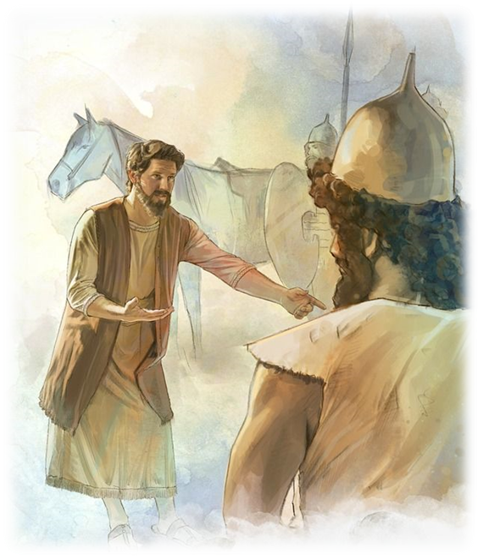
How Rich We
Already Are

Our Savior Ev. Lutheran Church
(Wisconsin Synod)
1332 Arrowhead Rd.
Grafton, Wisconsin 53024
Church: 262-377-6363 School: 262-377-7780

Versicle: I will proclaim your name to my people; in the midst of the congregation I will praise you. Hebrews 2:12

PRAYER OF THE DAY Grant, O merciful Lord, to your faithful people pardon and peace that they may be cleansed from all their sins and serve you with a quiet mind; through Jesus Christ, your Son, our Lord, who lives and reigns with you and the Holy Spirit, one God, now and forever. Amen.
HOLY COMMUNION As we celebrate the Lord's Supper today, we observe the practice of close communion just as Jesus did. Members of Our Savior and of other WELS or ELS churches are invited to commune with us. Other guests are asked to speak with our pastor if they wish to commune.
WORSHIP NOTES Sometimes our desires don’t correlate with God’s gifts. When greedy Gehazi concocted a lie to gain earthly wealth, the Lord disciplined him. As Paul wrote, “People who want to get rich fall into temptation and a trap and into many foolish and harmful desires that plunge men into ruin and destruction” (1 Tim 6:9). A review of our place with God will quickly remind us just how rich we really are and allow us to hold to the highest standards on the basis of our relationship with God.

GUESTS Welcome to our visitors!
Restrooms: At the far (south) side of the entry area.
Parents’ Room: Also at the far (south) side of the entry area.
Hearing Help: Enhanced hearing units are available. Contact an usher.
Large Print Hymnal: Contact an usher.

___________________________________________________________________

OPENING HYMN “My Soul, Now Bless Your Maker” CW, #257
My soul, now bless your Maker!
Let all within me bless his name
Who makes me a partaker
Of mercies more than I dare claim.
Forget him not whose meekness
Still bears with all your sin,
Who heals your ev'ry weakness,
Renews your life within,
Whose grace and care are endless
And saved you through the past,
Who leaves no suff'rer friendless
But rights the wronged at last.
For as a tender father
Has pity on his children here,
He in his arms will gather
All who are his in childlike fear.
He knows how frail our powers
Who but from dust are made.
We flourish like the flowers,
And even so we fade.
The wind but through them passes,
And all their bloom is o'er.
We wither like the grasses;
Our place knows us no more.

God's grace stands fast, enduring,
And children's children yet shall prove
His strength abides, assuring
The hearts of all who seek his love.
In heav'n is fixed his dwelling;
His rule is over all.
Angels, in might excelling,
Bright hosts, before him fall.
Praise him in song forever,
All you who hear his Word.
He hears our hymns with favor --
My soul, oh, bless the Lord!
GREETING
P: The grace of the Lord Jesus Christ, the love of God, and the fellowship of the Holy Spirit be with you.
C: And also with you.

CONFESSION AND ABSOLUTION
P: We come before you, Holy God, ashamed of our weakness and sorry for our sins. And yet, we come before you, Our Father, as dearly loved children for Jesus’ sake. Forgive us our wrongs and failures. Restore our joy. Renew our desire to serve you
C: We have sinned, Father, in unkind words and selfish acts. We have failed to represent you to those around us as we ought. We have not served you as we promised we would. We have too often loved the things you’ve entrusted to us and taken for granted the greater blessings of your presence and promise. At your invitation and for the sake of Jesus, we ask you to take away our sin and remove our guilt.

P: Your Heavenly Father sees the price Jesus paid to redeem you. He remembers His promise to reconcile you to Himself. You are forgiven. You are loved. You are His people, “called out of darkness into His wonderful light, that you may declare his praises.”

OUR SONG OF PRAISE “From All that Dwell below the Skies” CW, # 250:1
From all that dwell below the skies
Let the Creator's praise arise.
Alleluia! Alleluia!
Let the Redeemer's name be sung
Through ev'ry land, by ev'ry tongue.
Alleluia! Alleluia! Alleluia! Alleluia! Alleluia!

THE OLD TESTAMENT LESSON 2 Kings 5:14-27
When greedy Gehazi concocted a lie to gain earthly wealth, the Lord disciplined him severely. As St. Paul wrote, “People who want to get rich fall into temptation and a trap and into many foolish and harmful desires that plunge men into ruin and destruction” (1 Tim 6:9).
So he went down and dipped himself in the Jordan seven times, as the man of God had told him, and his flesh was restored and became clean like that of a young boy. Then Naaman and all his attendants went back to the man of God. He stood before him and said, “Now I know that there is no God in all the world except in Israel. Please accept now a gift from your servant.” The prophet answered, “As surely as the LORD lives, whom I serve, I will not accept a thing.” And even though Naaman urged him, he refused. “If you will not,” said Naaman, “please let me, your servant, be given as much earth as a pair of mules can carry, for your servant will never again make burnt offerings and sacrifices to any other god but the LORD. But may the LORD forgive your servant for this one thing: When my master enters the temple of Rimmon to bow down and he is leaning on my arm and I bow there also—when I bow down in the temple of Rimmon, may the LORD forgive your servant for this.” “Go in peace,” Elisha said. After Naaman had traveled some distance, Gehazi, the servant of Elisha the man of God, said to himself, “My master was too easy on Naaman, this Aramean, by not accepting from him what he brought. As surely as the LORD lives, I will run after him and get something from him.” So Gehazi hurried after Naaman. When Naaman saw him running toward him, he got down from the chariot to meet him. “Is everything all right?” he asked. “Everything is all right,” Gehazi answered. “My master sent me to say, ‘Two young men from the company of the prophets have just come to me from the hill country of Ephraim. Please give them a talent of silver and two sets of clothing.’” “By all means, take two talents,” said Naaman. He urged Gehazi to accept them, and then tied up the two talents of silver in two bags, with two sets of clothing. He gave them to two of his servants, and they carried them ahead of Gehazi. When Gehazi came to the hill, he took the things from the servants and put them away in the house. He sent the men away and they left. Then he went in and stood before his master Elisha. “Where have you been, Gehazi?” Elisha asked. “Your servant didn’t go anywhere,” Gehazi answered. But Elisha said to him, “Was not my spirit with you when the man got down from his chariot to meet you? Is this the time to take money, or to accept clothes, olive groves, vineyards, flocks, herds, or menservants and maidservants? Naaman’s leprosy will cling to you and to your descendants forever.” Then Gehazi went from Elisha’s presence and he was leprous, as white as snow.

PSALM OF THE DAY Psalm 90 (p. 11) (in Unison) CW, p. 99

How foolish to live only for this life. It flies away in an instant, but eternity is forever.

THE EPISTLE LESSON Hebrews 13:1-6

God’s command: “Keep your lives free from the love of money and be content with what you have.” God’s promise: “Never will I leave you; never will I forsake you.’”
Keep on loving each other as brothers. Do not forget to entertain strangers, for by so doing some people have entertained angels without knowing it. Remember those in prison as if you were their fellow prisoners, and those who are mistreated as if you yourselves were suffering. Marriage should be honored by all, and the marriage bed kept pure, for God will judge the adulterer and all the sexually immoral. Keep your lives free from the love of money and be content with what you have, because God has said, “Never will I leave you; never will I forsake you.” So we say with confidence, “The Lord is my helper; I will not be afraid. What can man do to me?”

VERSE OF THE DAY

P: Alleluia. This is the Lord, we trusted in him.
C: Let us rejoice and be glad in his salvation. Alleluia. (Isaiah 25:9)

THE HOLY GOSPEL Mark 10:17-27

A rich young man came to Jesus full of confidence in his own goodness. But when Jesus showed him he was unable to obey all of God’s holy commandments, he went away sad. Must you go away sad too? Not at all. Put your trust in the God who can fit a camel through the eye of a needle!
As Jesus started on his way, a man ran up to him and fell on his knees before him. “Good teacher,” he asked, “what must I do to inherit eternal life?” “Why do you call me good?” Jesus answered. “No one is good—except God alone. You know the commandments: ‘Do not murder, do not commit adultery, do not steal, do not give false testimony, do not defraud, honor your father and mother.’ “Teacher,” he declared, “all these I have kept since I was a boy.” Jesus looked at him and loved him. “One thing you lack,” he said. “Go, sell everything you have and give to the poor, and you will have treasure in heaven. Then come, follow me.” At this the man’s face fell. He went away sad, because he had great wealth. Jesus looked around and said to his disciples, “How hard it is for the rich to enter the kingdom of God!” The disciples were amazed at his words. But Jesus said again, “Children, how hard it is to enter the kingdom of God! It is easier for a camel to go through the eye of a needle than for a rich man to enter the kingdom of God.” The disciples were even more amazed, and said to each other, “Who then can be saved?” Jesus looked at them and said, “With man this is impossible, but not with God; all things are possible with God.”

HYMN OF THE DAY “Oh, Blessed Home, Where Man and Wife” CW, #503
Oh, blessed home, where man and wife
Together lead a godly life,
By love their faith confessing!
There many a happy day is spent;
There Jesus gladly will consent
To tarry with his blessing,
To tarry with his blessing.

If they have given him their heart,
The place of honor set apart
For him each night and morrow,
Then he the storms of life will calm,
Will bring for ev'ry wound a balm,
And change to joy their sorrow,
And change to joy their sorrow.

Oh, Lord, we come before your face,
In ev'ry home bestow your grace
On children, father, mother.
Relieve their wants; their burdens ease.
Let them together dwell in peace
And love for one another,
And love for one another.

SERMON 2 Kings 5:14-27
Swearing by the Living LORD …
- Not to accept a thing?
- Or to get a quick profit?

THE CONFESSION OF FAITH — The Apostles Creed
I believe in God, the Father almighty,
maker of heaven and earth.

I believe in Jesus Christ, his only son, our Lord,
who was conceived by the Holy Spirit,
born of the virgin Mary,
suffered under Pontius Pilate,
was crucified, died, and was buried.
He descended into hell.
The third day he rose again from the dead.
He ascended into heaven
and is seated at the right hand of God the Father almighty.
From there he will come to judge the living and the dead.

I believe in the Holy Spirit,
the holy Christian Church
the communion of saints,
the forgiveness of sins,
the resurrection of the body,
and the life everlasting. Amen

THE GATHERING OF THE OFFERING
Online or in the entryway. Guests please do not feel any obligation to participate in the offering (though you are always welcome to do so). Please fill out a Guest Card located in the entryway, and drop it in the box on the Welcome Center so we can connect with you – thanks!

A STEWARD’S LITANY
P: For humble hearts that acknowledge everything we have as a gift of your goodness and for wisdom to use your blessings to us as you desire,
C: We pray to you, O Lord.
P: For the faith to trust you to take care of us, and for the courage to act on that faith.
C: We seek your help, O Lord.
P: For the joy there is in giving, for the contentment that lies in your promises, for the love to see beyond ourselves to needs and opportunities in the lives of others.
C: We ask your presence in our lives, dear Lord.
P: Heavenly Father, your Son became poor that we might be rich, that we would enjoy the treasures of your grace forever. Keep us from settling for far less in covetous pursuit of things. Grow us in godliness as we manage the resources entrusted to us. Make us generous in our giving and eager to show you how much we love you with our offerings. Fill our hearts with the contentment there is in the assurance of your love and in the wisdom that understands life as you do. Let the world see your love and hear your truth in our lives, through Jesus Christ, your Son, our Lord, who lives and rules with you and the Holy Spirit, one God, now and forever.
C: Amen.
OUR PRAYERS & THE LORD’S PRAYER
Our Father, who art in heaven, hallowed be thy name, thy kingdom come, thy will be done on earth as it is in heaven. Give us this day our daily bread; and forgive us our trespasses, as we forgive those who trespass against us; and lead us not into temptation, but deliver us from evil. For thine is the kingdom and the power and the glory forever and ever. Amen

LITURGY OF HOLY COMMUNION

P: The Lord be with you.
C: And also with you.

P: Lift up your hearts.
C: We lift them up to the Lord.

P: Let us give thanks to the Lord our God.
C: It is right to give Him thanks and praise.
P: Therefore we praise you, almighty, everlasting, and merciful God. We join our voices with the angels and archangels and all the company of heaven, who forever sing this hymn to proclaim the glory of your name:
THE SANCTUS (Tune of Hymn #195)

Holy, holy, holy! Lord God Almighty!
Early in the morning [evening]
our song shall rise to thee;
Holy, holy, holy, merciful and mighty,
God in three persons, blessed Trinity!

WORDS OF INSTITUTION

THE AGNUS DEI (Tune of Hymn #268)
Lamb of God, pure and holy,
Who on the cross did suffer,
Ever patient and lowly,
Yourself to scorn didst offer.
All sins you carried for us,
Else had despair reigned o’er us:
Your peace be with us, O Jesus!

DISTRIBUTION OF THE LORD’S SUPPER

DISTRIBUTION HYMNS
“Bless Our Loved Ones, Holy Father” CW, #504
Bless our loved ones, Holy Father;
Hear our anxious prayer;
By your mercy keep them always
In your care.
Jesus, Savior, let your presence
Be their light and guide;
Keep, oh, keep them in their weakness
At your side.
When in sorrow, when in danger,
When in loneliness,
In your love look down and comfort
Their distress.
May the joy of your salvation
Be their strength and stay!
May they love and may they praise you
Day by day!
Holy Spirit, let your teaching
Sanctify their life;
Send your grace that they may conquer
In the strife.
Father, Son, and Holy Spirit,
God forever true,
Bless them, guide them, save them, keep them
Close to you.

HYMN RESPONSE (Tune of Hymn #5)
He comes to us in bread and wine
To give himself—and gifts divine
Oh, praise him for this sacrament,
Redeeming love’s great testament!

PRAYER
P: God of life, we thank You for feeding us today with the spiritual food of Your precious Word and the body and blood of Your Son, our Savior, Jesus Christ. Through these means of grace, You have assured us that we are living members of the body of Christ and heirs of Your eternal kingdom. And now, Father, send us out to do the work that You have given us to do, to love and serve You as faithful witnesses of Christ our Lord. To Him, to You, and to the Holy Spirit, be honor and glory, now and forever. Amen.

BLESSING

CLOSING HYMN “Oh, Blest the House, Whate’er Befall” CW, #506:1-2
Oh, blest the house, whate'er befall,
Where Jesus Christ is all in all!
A home that is not wholly his --
How sad and poor and dark it is!
Oh, blest that house where faith you find
And all within have set their mind
To trust their God and serve him still
And do in all his holy will.

SILENT PRAYER

ANNOUNCEMENTS
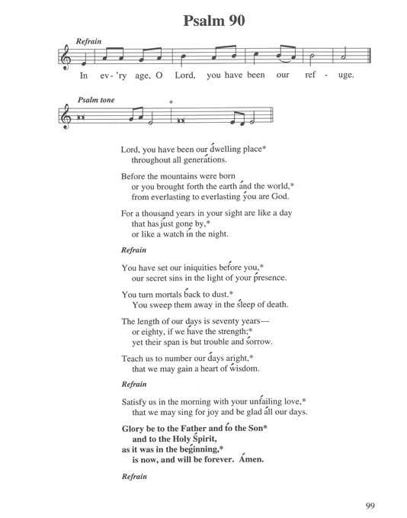

THIS WEEK AT OUR SAVIOR

Sunday (10/17) 8:00 AM Worship Service w/Communion
9:15 AM Adult Bible Class
9:15 AM Teen Bible Study
9:15 AM Sunday School
10:30 AM Worship Service w/Communion
Tuesday 10:30 AM Senior Bible Study
Wednesday 8:30 AM Children’s Church
4:00 PM Public School Confirmation Class
Thursday 7:00 PM Worship Service
Sunday (10/25) 8:00 AM Worship Service
9:15 AM Adult Bible Class
9:15 AM Teen Bible Study
9:15 AM Sunday School
10:30 AM Worship Service

LiveStream on Youtube Channel at 10:30am every Sunday
This service is also recorded for review after livestream.
Link on our website (see below).
Art https://www.pinterest.com/pin/367113807104996827/

THIS WEEK’S
WORSHIP SERVICE

Rich in Every Way
Service Theme

Preaching: Robert Read

Organist: Ann Petermann

Hymns: 257, 250:1, 503,
504, 506:1-2

FIRST LESSON:
2 Kings 5:14-27

SECOND LESSON:
Hebrews 13:1-6

GOSPEL LESSON:
Mark 10:17-27

THE SERMON:
2 Kings 5:14-27

“Swearing by the
Living Lord”

_______________

Altar Flowers
The flowers this week are from
Bill & Annette Favorite in Loving memory of David Mark Favorite

NEXT WEEK’S BIBLE READINGS

1st Lesson 2 Chronicles 26:16-23
2nd Lesson 1 Corinthians 9:7-12, 19-23
Gospel Mark 10:35-45
Psalm Psalm 22

Our Savior Ev. Lutheran Church & School
(Wisconsin Synod)
1332 Arrowhead Rd., Grafton, Wisconsin 53024
Church: 262-377-6363 oslcoffice@wi.rr.com
School: 262-377-7780 osls@wi.rr.com
Mark C. Wagner |  | Nathan Schultz
Pastor |  | Principal
oslc@wi.rr.com |  | nschultz@oursaviorgrafton.org

