16th Sunday after Pentecost
September 14th & 17th 2023

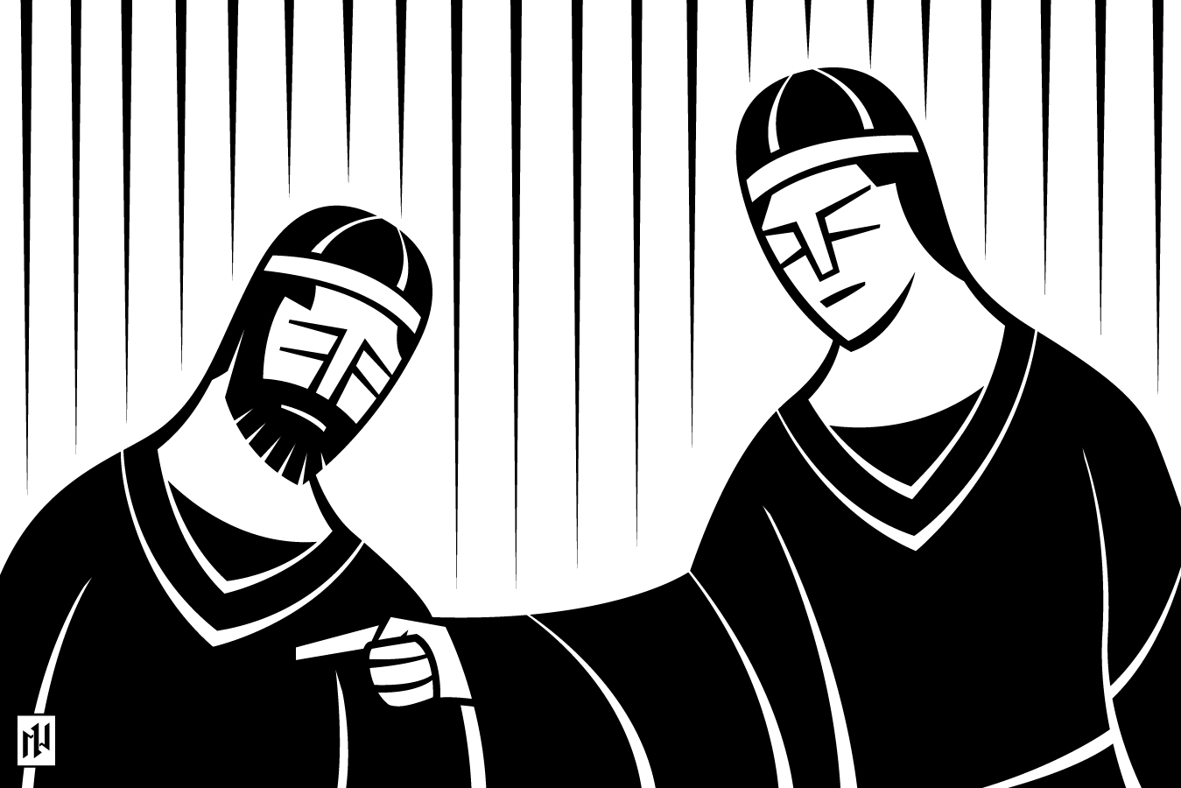

Our Savior Ev. Lutheran Church
748 Brothers, Sisters, Let Us Gladly CW 748
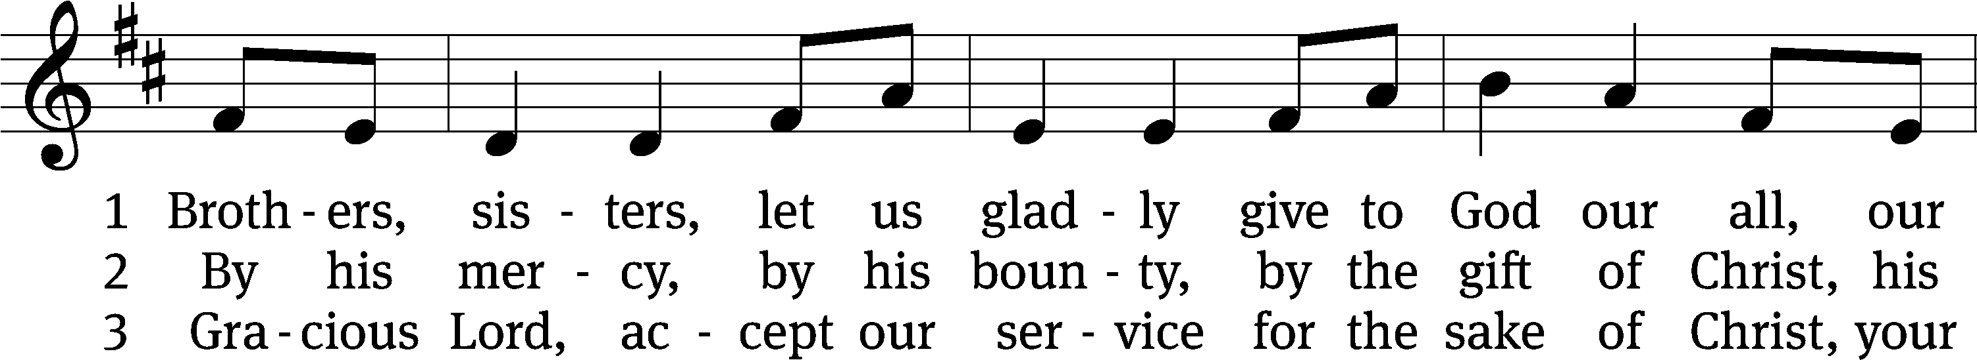
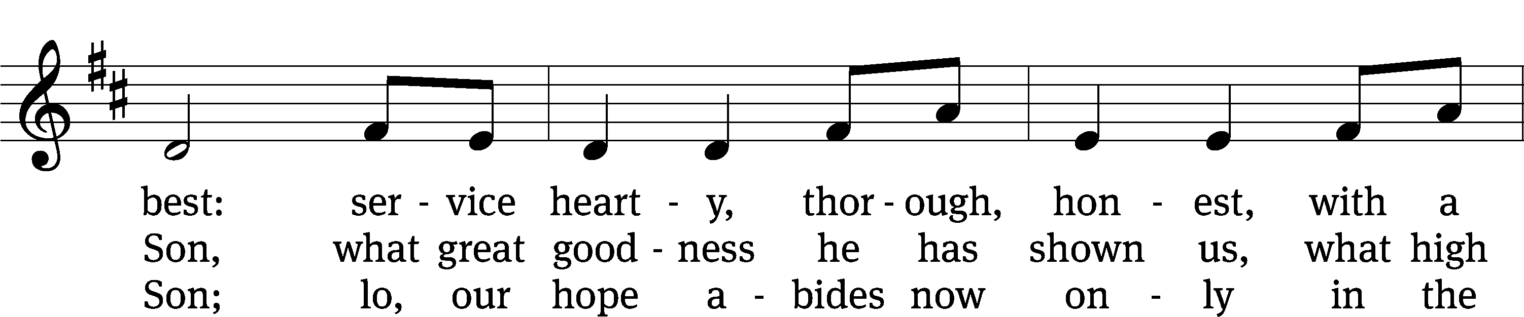
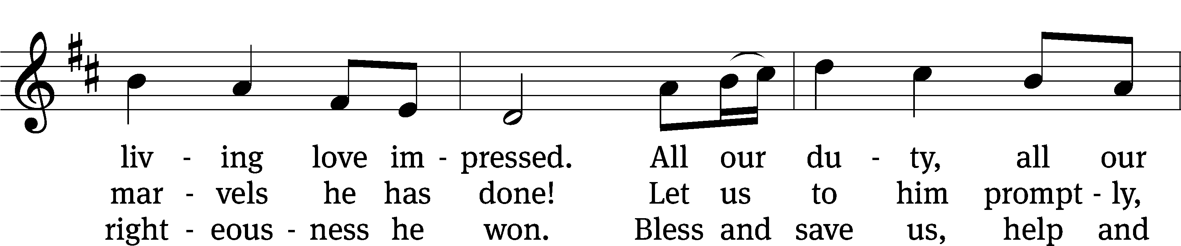
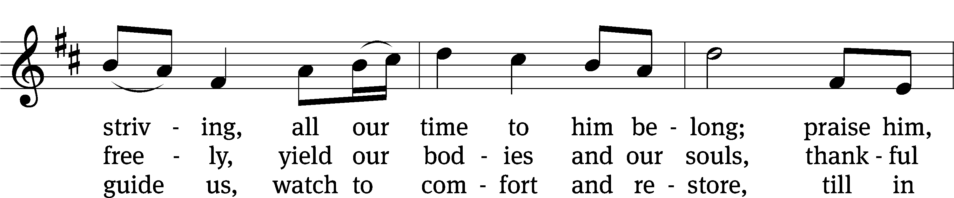
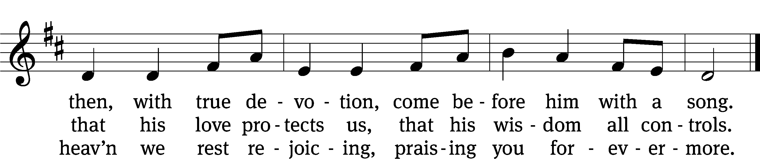
Text: Henry Bateman, 1802–1872
Tune: adapt. William Bradbury, 1816–1868; Repository of Sacred Music, Part Second, Harrisburg, 1813, ed. John Wyeth
Text and tune: Public domain

Stand

In the name of the Father and of the T Son and of the Holy Spirit.
Amen.

Confession CW 155
Blessed are they whose transgressions are forgiven, whose sins are covered.
Blessed are they whose sin the Lord does not count against them.

Let us confess our sins to the Lord.
Almighty and merciful Father,
we have strayed from your ways like lost sheep.
We have followed what we have devised and desired in our hearts.
We have offended you and sinned against your holy law.
We have done those things that we should not have done,
and we have not done those things that we should have done.
Have mercy on us, Lord!
Spare us, forgive us, and restore us,
according to your promises in Christ Jesus.

Silence for meditation and reflection

God, our merciful Father, has forgiven all our sins. He sent his Son, Jesus Christ, to be our Redeemer and Savior. Jesus paid the penalty for our guilt by his death on the cross and freed us from death by his resurrection from the grave. We have peace with God now and forever.
Amen.
Lord, Have Mercy
In peace let us pray to the Lord.
Lord, have mercy.

For the peace from above and for our salvation, let us pray to the Lord.
Lord, have mercy.

For the peace of the whole world, for the well-being of the Church of God, and for the unity of all, let us pray to the Lord.
Lord, have mercy.
For this holy house and for all who offer here their worship and praise, let us pray to the Lord.
Lord, have mercy.

Help, save, comfort, and defend us, gracious Lord.
Amen.
Glory Be to God on High CW 157
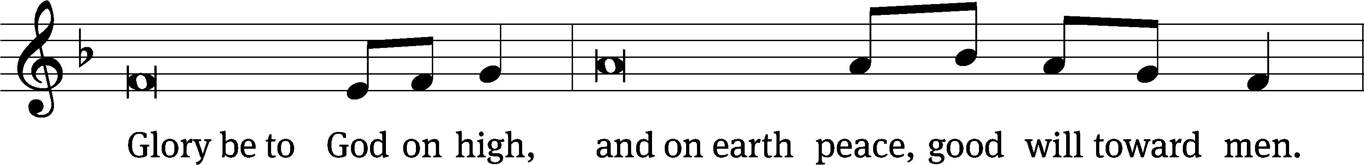
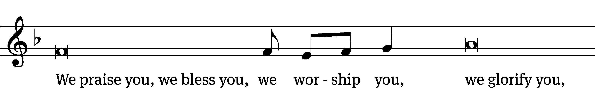
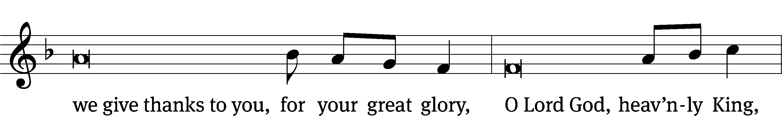
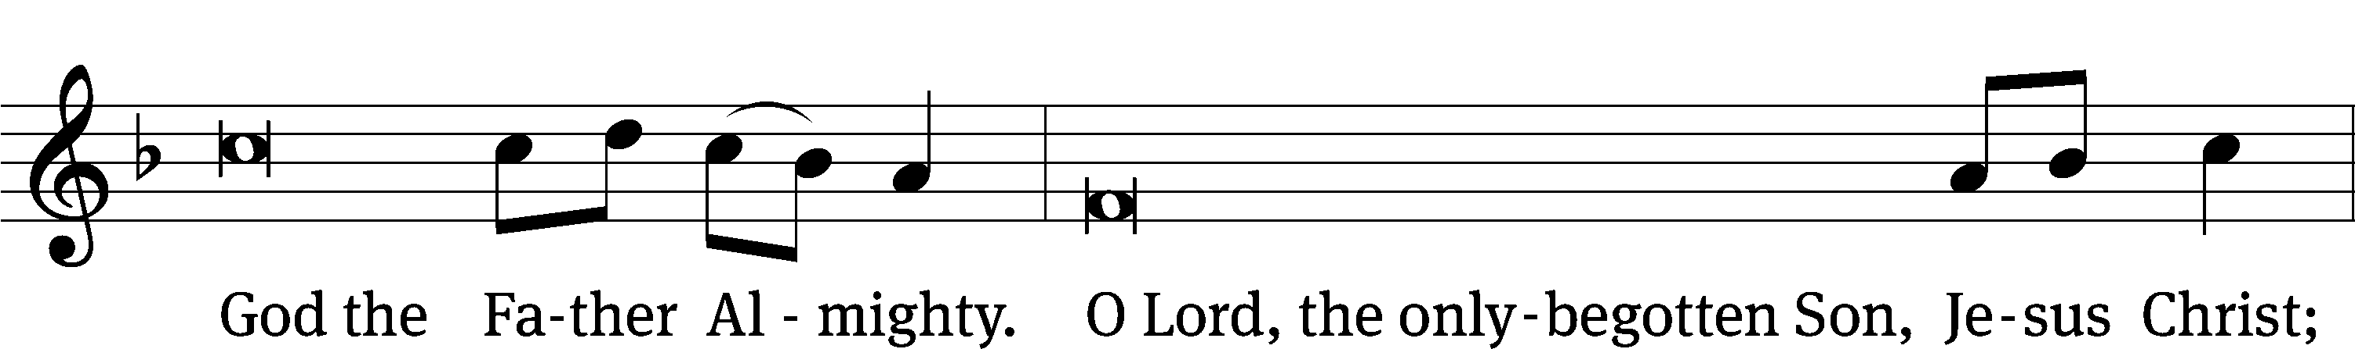
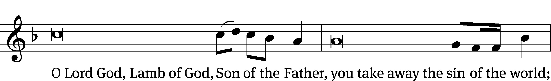
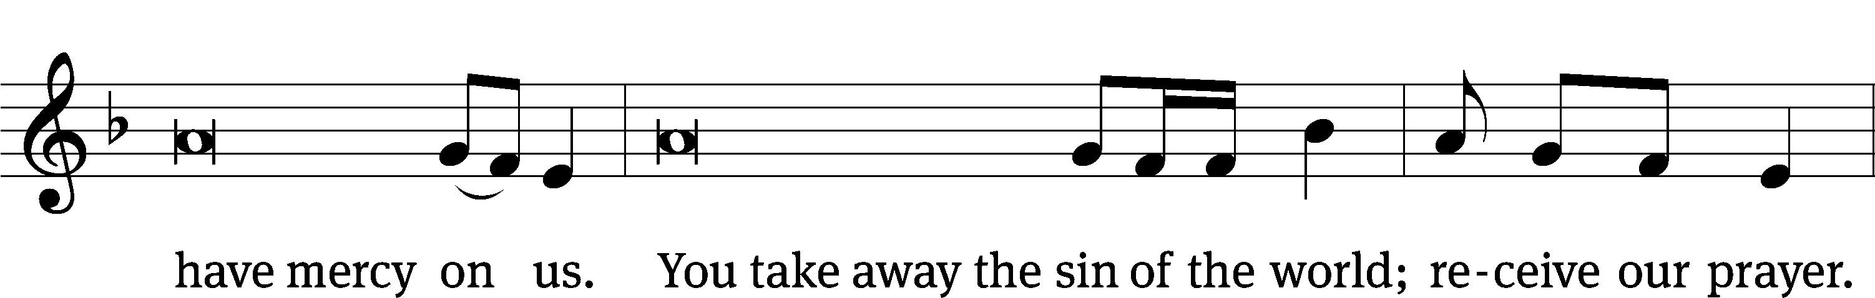
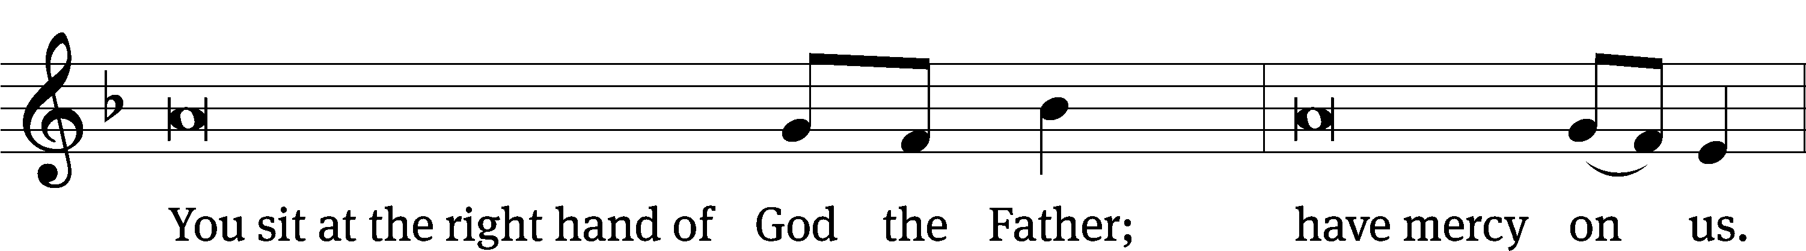
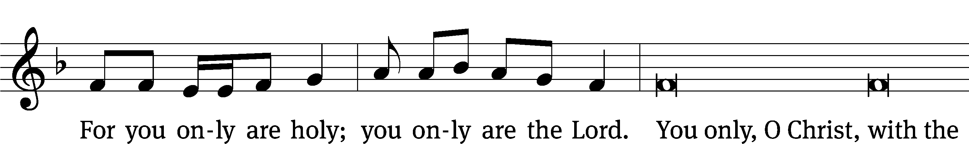
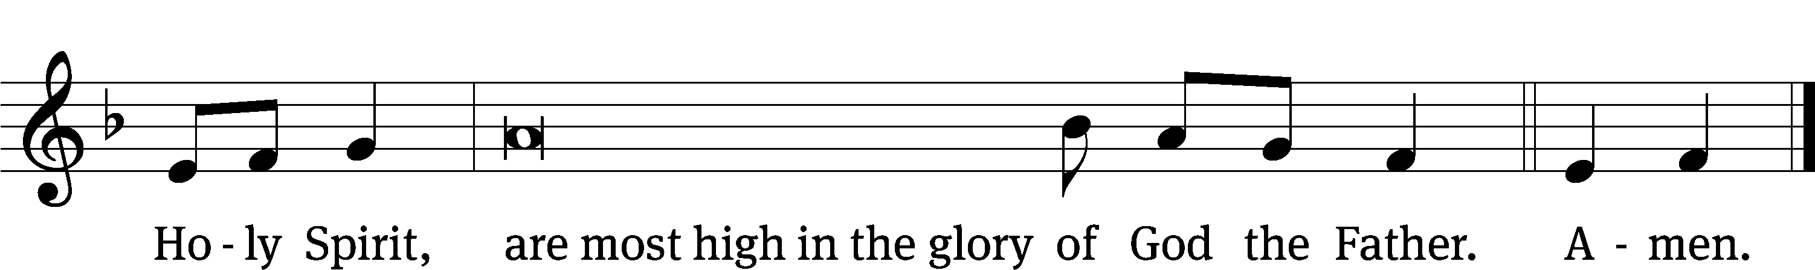

The Word

The Lord be with you.
And also with you.
Prayer of the Day
Let us pray.

Lord God, heavenly Father, you graciously forgive us all our sins and abundantly provide for all our needs of body and soul. Give us confidence in your mercy, and teach us also to be merciful to our neighbor, that we willingly forgive all people, and judging only ourselves, lead blessed lives to your glory; through your Son, Jesus Christ our Lord, who lives and reigns with you and the Holy Spirit, one God, now and forever.
Amen.

Be seated
First Reading 1 Chronicles 29:1–2, 10–18
1Then King David said to the whole assembly: “My son Solomon, the one whom God has chosen, is young and inexperienced. The task is great, because this palatial structure is not for man but for the Lord God. 2With all my resources I have provided for the temple of my God—gold for the gold work, silver for the silver, bronze for the bronze, iron for the iron and wood for the wood, as well as onyx for the settings, turquoise, stones of various colors, and all kinds of fine stone and marble—all of these in large quantities.
10David praised the Lord in the presence of the whole assembly, saying,
“Praise be to you, Lord,
the God of our father Israel,
from everlasting to everlasting.
11Yours, Lord, is the greatness and the power
and the glory and the majesty and the splendor,
for everything in heaven and earth is yours.
Yours, Lord, is the kingdom;
you are exalted as head over all.
12Wealth and honor come from you;
you are the ruler of all things.
In your hands are strength and power
to exalt and give strength to all.
13Now, our God, we give you thanks,
and praise your glorious name.
14“But who am I, and who are my people, that we should be able to give as generously as this? Everything comes from you, and we have given you only what comes from your hand. 15We are foreigners and strangers in your sight, as were all our ancestors. Our days on earth are like a shadow, without hope. 16Lord our God, all this abundance that we have provided for building you a temple for your Holy Name comes from your hand, and all of it belongs to you. 17I know, my God, that you test the heart and are pleased with integrity. All these things I have given willingly and with honest intent. And now I have seen with joy how willingly your people who are here have given to you. 18Lord, the God of our fathers Abraham, Isaac and Israel, keep these desires and thoughts in the hearts of your people forever, and keep their hearts loyal to you.

The Word of the Lord.
Thanks be to God.

62A In God Alone My Soul Can Find Rest and Peace Psalm 62A
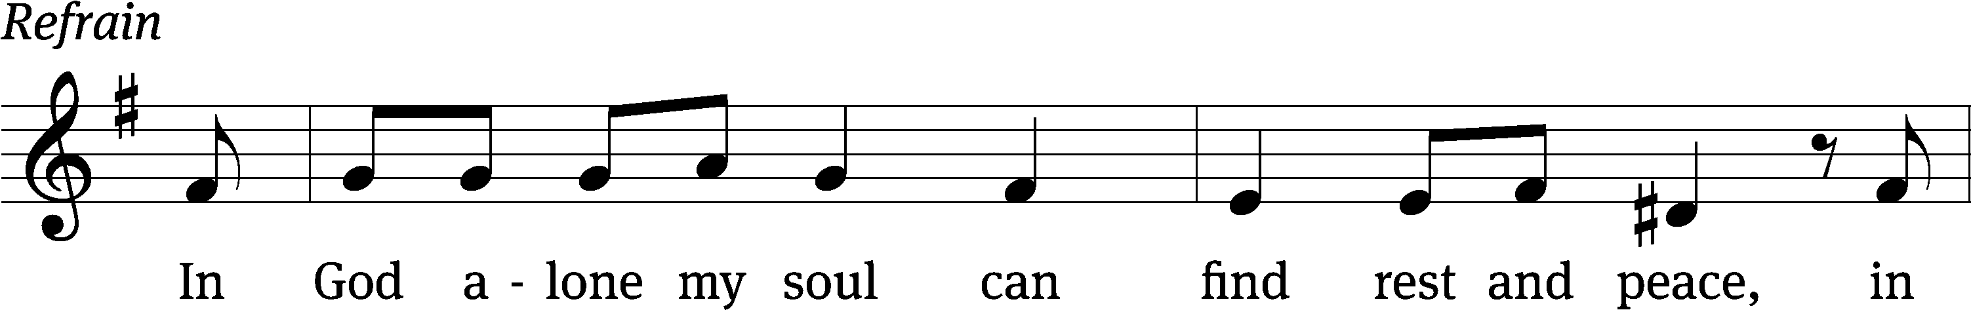
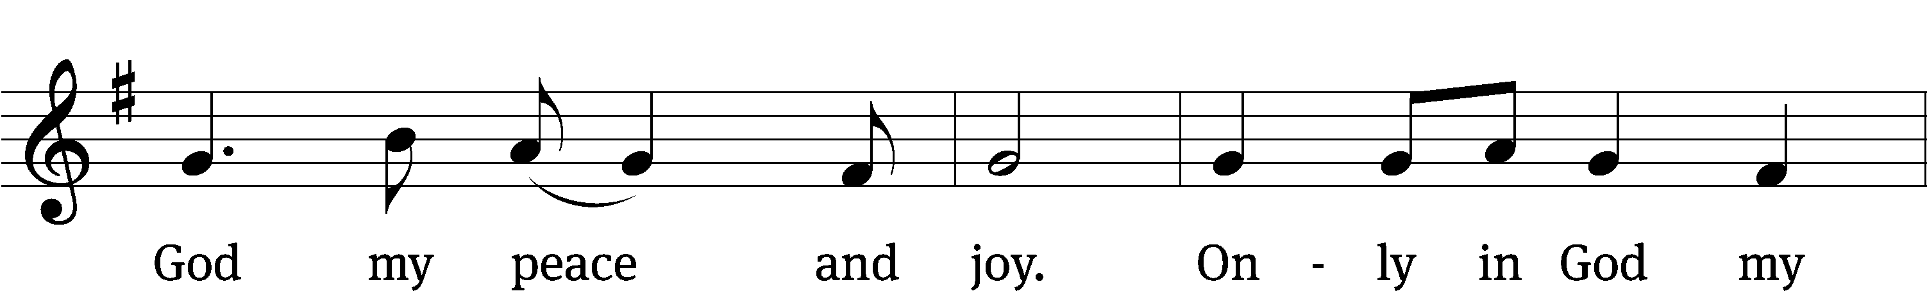
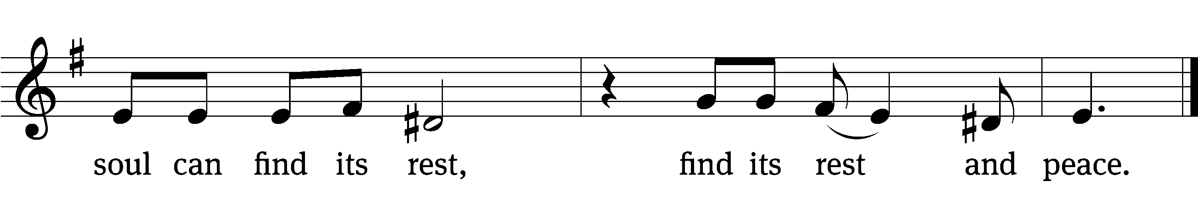
Truly my soul finds / rest in God;
my salvation / comes from him.
Truly he is my rock and my sal- / vation;
he is my fortress, I will never be / shaken.
Yes, my soul, find / rest in God;
my hope / comes from him. Refrain

Though your rich- / es increase,
do not set your / heart on them.
My salvation and my honor de- / pend on God;
he is my mighty rock, my / refuge.
Trust in him at all times, you / people;
pour out your hearts to him, for God is our / refuge.
Glory be to the Father and / to the Son
and to the Holy / Spirit, as it was in the be- / ginning,
is now, and will be forever. / Amen. Refrain
Second Reading 2 Thessalonians 1:1–5, 11, 12
1Paul, Silas and Timothy,
To the church of the Thessalonians in God our Father and the Lord Jesus Christ:
2Grace and peace to you from God the Father and the Lord Jesus Christ.
3We ought always to thank God for you, brothers and sisters, and rightly so, because your faith is growing more and more, and the love all of you have for one another is increasing. 4Therefore, among God’s churches we boast about your perseverance and faith in all the persecutions and trials you are enduring.
5All this is evidence that God’s judgment is right, and as a result you will be counted worthy of the kingdom of God, for which you are suffering.
11With this in mind, we constantly pray for you, that our God may make you worthy of his calling, and that by his power he may bring to fruition your every desire for goodness and your every deed prompted by faith.
12We pray this so that the name of our Lord Jesus may be glorified in you, and you in him, according to the grace of our God and the Lord Jesus Christ.

The Word of the Lord.
Thanks be to God.

Stand

Gospel Acclamation CW 161
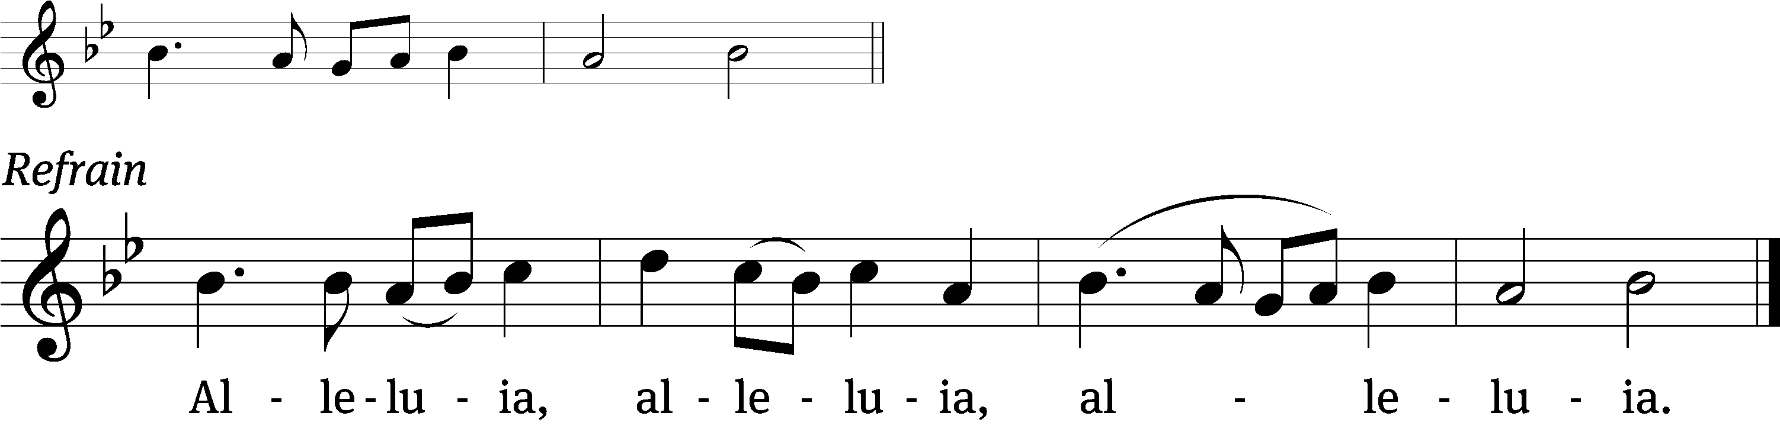
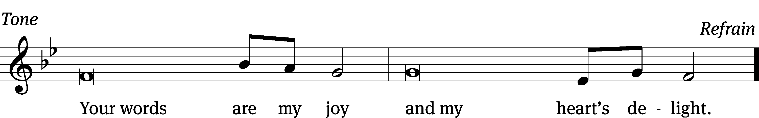
Tune: © 2021 Northwestern Publishing House. Used by permission: OneLicense no. 714932
Gospel Luke 17:1–10
1Jesus said to his disciples: “Things that cause people to stumble are bound to come, but woe to anyone through whom they come. 2It would be better for them to be thrown into the sea with a millstone tied around their neck than to cause one of these little ones to stumble. 3So watch yourselves.
“If your brother or sister sins against you, rebuke them; and if they repent, forgive them. 4Even if they sin against you seven times in a day and seven times come back to you saying ‘I repent,’ you must forgive them.”
5The apostles said to the Lord, “Increase our faith!”
6He replied, “If you have faith as small as a mustard seed, you can say to this mulberry tree, ‘Be uprooted and planted in the sea,’ and it will obey you.
7“Suppose one of you has a servant plowing or looking after the sheep. Will he say to the servant when he comes in from the field, ‘Come along now and sit down to eat’? 8Won’t he rather say, ‘Prepare my supper, get yourself ready and wait on me while I eat and drink; after that you may eat and drink’? 9Will he thank the servant because he did what he was told to do? 10So you also, when you have done everything you were told to do, should say, ‘We are unworthy servants; we have only done our duty.’ ”

The Gospel of the Lord.
Praise be to you, O Christ!

Be seated

767 Lord of Glory, You Have Bought Us CW 767
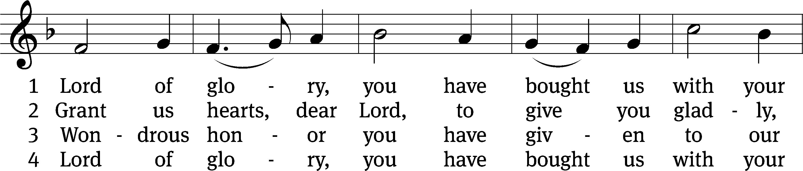
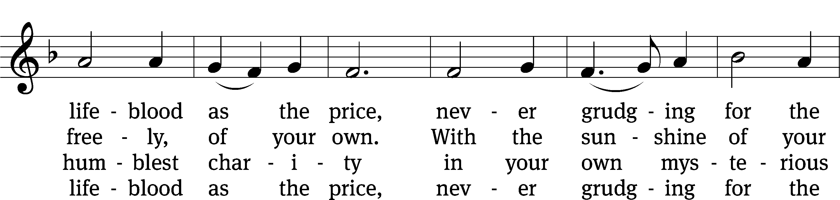
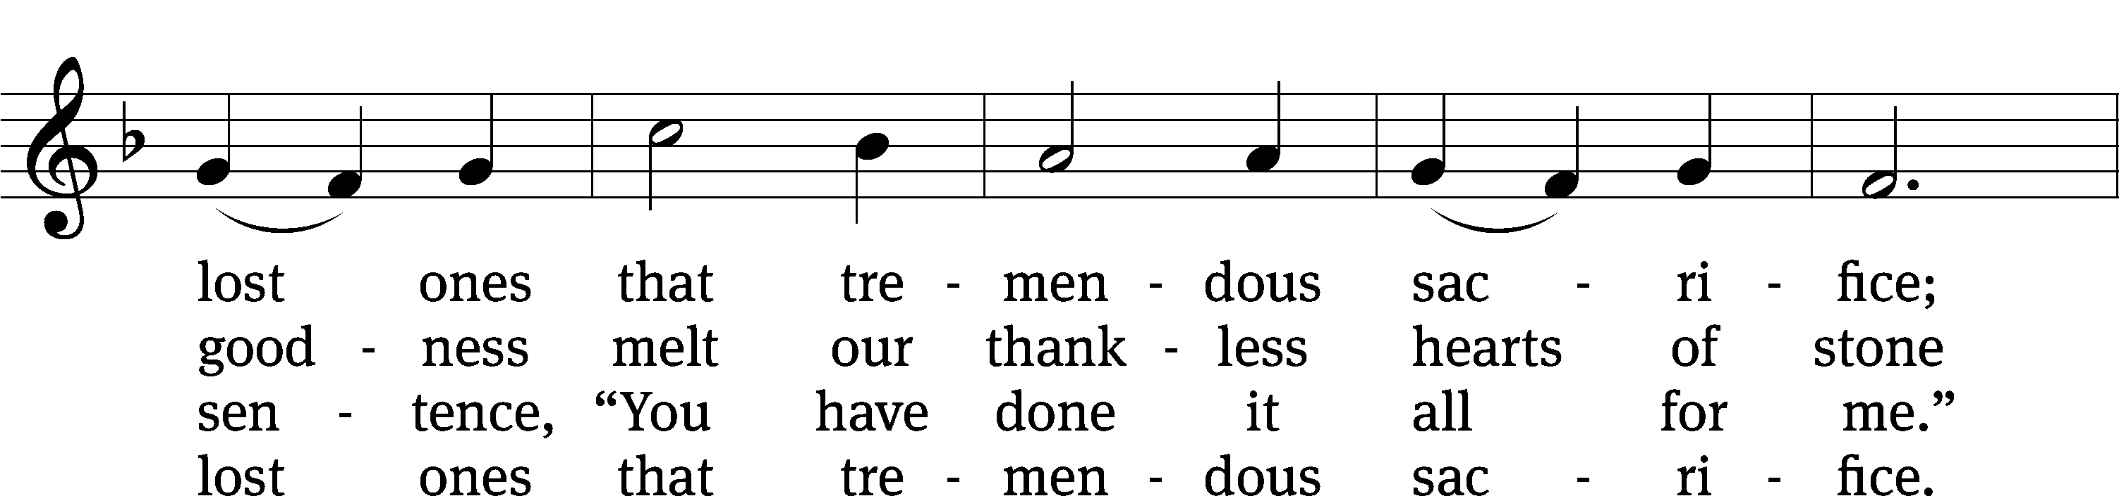
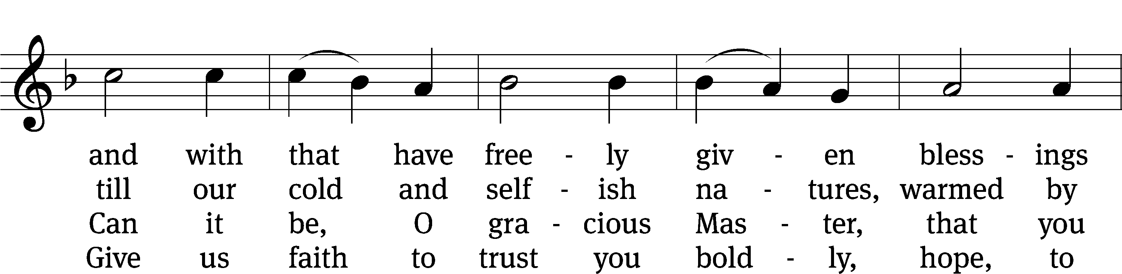
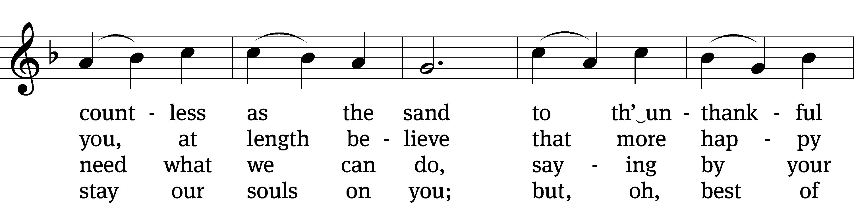
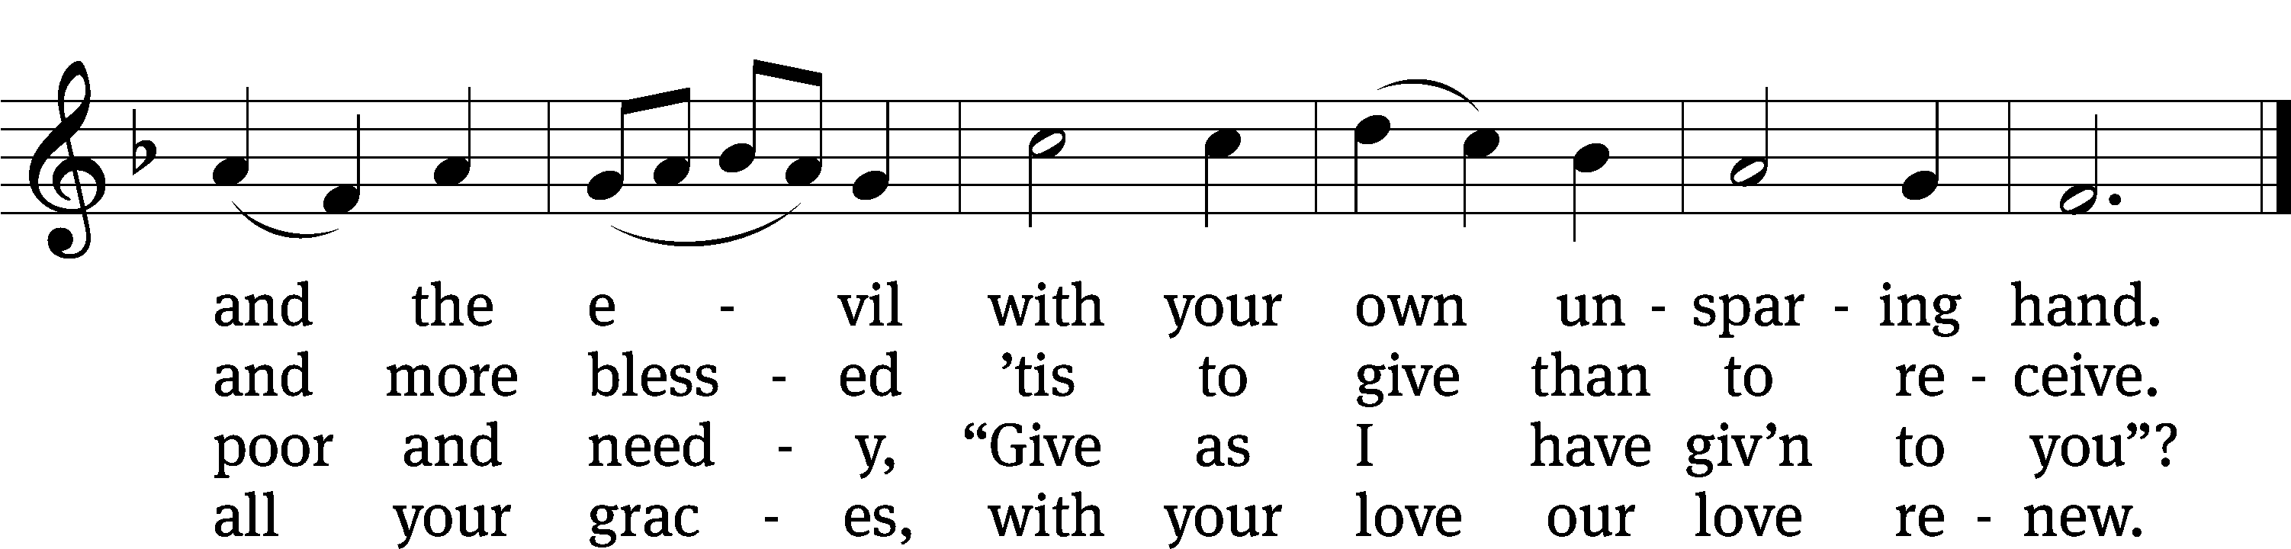

Sermon 1 Chronicles 29:1-2,10-18 "The best gift comes from a full heart."
Space is included for you to take notes during the sermon.

Stand

Nicene Creed
We believe in one God, the Father, the Almighty,
maker of heaven and earth,
of all that is,
seen and unseen.

We believe in one Lord, Jesus Christ, the only Son of God,
eternally begotten of the Father,
God from God, Light from Light, true God from true God,
begotten, not made,
of one being with the Father.
Through him all things were made.
For us and for our salvation, he came down from heaven,
was incarnate of the Holy Spirit and the Virgin Mary,
and became truly human.
For our sake he was crucified under Pontius Pilate.
He suffered death and was buried.
On the third day he rose again in accordance with the Scriptures.
He ascended into heaven
and is seated at the right hand of the Father.
He will come again in glory to judge the living and the dead,
and his kingdom will have no end.
We believe in the Holy Spirit,
the Lord, the giver of life,
who proceeds from the Father and the Son,
who in unity with the Father and the Son
is worshiped and glorified,
who has spoken through the prophets.
We believe in one holy Christian and apostolic Church.
We acknowledge one baptism for the forgiveness of sins.
We look for the resurrection of the dead
and the life of the world to come. Amen.

Be seated
Prayer of the Church
Offering
Our Savior's ministries are supported by the joyful gifts of her members. If you are not a member of Our Savior, please do not feel obligated to give an offering. It is our privilege and pleasure to serve you with God's Word today.

Please sign the friendship register and pass it down the pew.

The Sacrament

Stand
Preface CW 165
The Lord be with you.
And also with you.

Lift up your hearts.
We lift them up to the Lord.

Let us give thanks to the Lord our God.
It is right to give him thanks and praise.

It is truly good and right that we should at all times and in all places give you thanks, O Lord, holy Father, almighty and everlasting God, through Jesus Christ our Lord, who promised that wherever two or three come together in his name, there he is with them to shepherd his flock until he comes again in glory. Therefore, with all the saints on earth and hosts of heaven, we praise your holy name and join their glorious song:
Holy, Holy, Holy CW 167
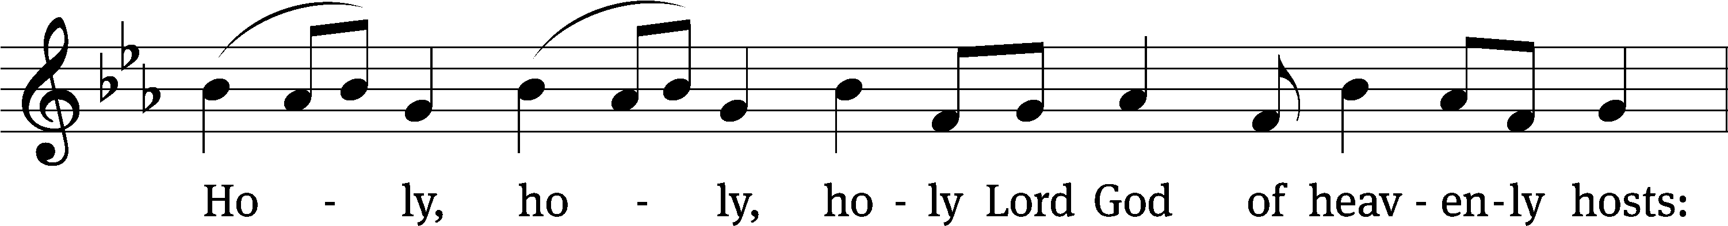
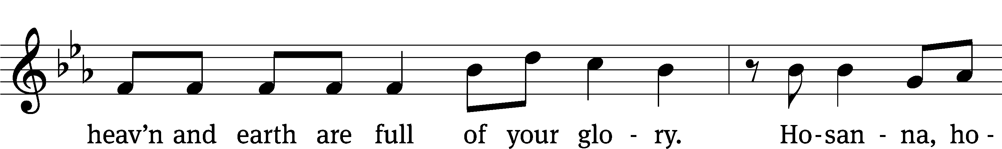
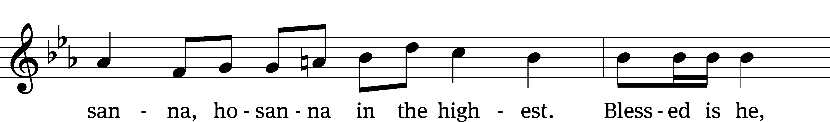
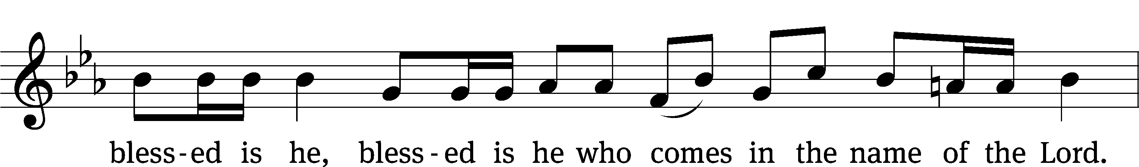
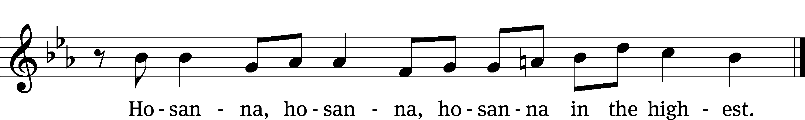

Prayer of Thanksgiving
We give thanks to you, O God, through your dear Son, Jesus Christ, whom you sent to be our Savior, our Redeemer, and the messenger of your grace. Through him you made all things; in him you are well pleased. He is the incarnate Word, conceived by the Holy Spirit and born of the Virgin Mary. To fulfill your promises, he stretched out his hands on the cross and released from eternal death all who believe in you.

As we remember Jesus’ death and resurrection, we thank you that you have gathered us together to receive your Son’s body and blood. Send us your Spirit, unite us as one, and strengthen our faith so that we may praise you in your Son, Jesus Christ. Through him, we glorify and honor you, O God our Father, with the Holy Spirit, one God, now and forever.
Amen.

Lord’s Prayer
Our Father, who art in heaven, hallowed be thy name, thy kingdom come, thy will be done on earth as it is in heaven. Give us this day our daily bread; and forgive us our trespasses, as we forgive those who trespass against us; and lead us not into temptation, but deliver us from evil. For thine is the kingdom and the power and the glory forever and ever. Amen.
Words of Institution
Our Lord Jesus Christ, on the night he was betrayed, took bread; and when he had given thanks, he broke it and gave it to his disciples, saying, “Take and eat; this is my T body, which is given for you. Do this in remembrance of me.”

Then he took the cup, gave thanks, and gave it to them, saying, “Drink from it, all of you; this is my T blood of the new covenant, which is poured out for you for the forgiveness of sins. Do this, whenever you drink it, in remembrance of me.”

The peace of the Lord be with you always.
Amen.
O Christ, Lamb of God CW 169
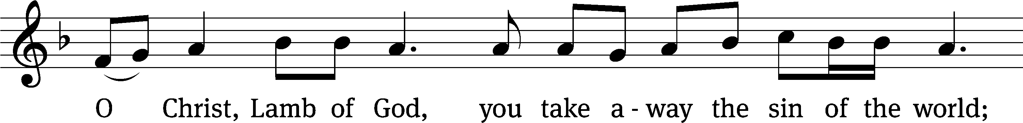
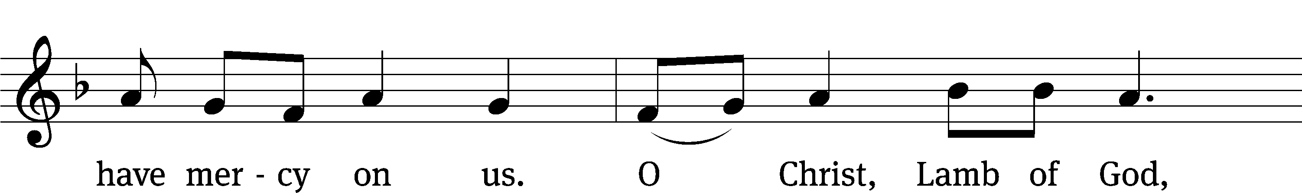
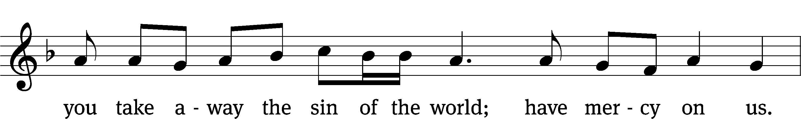
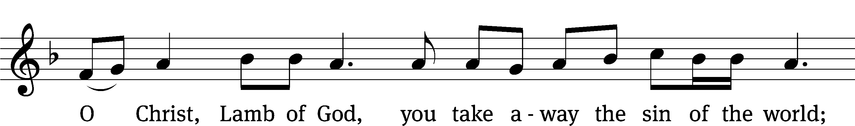
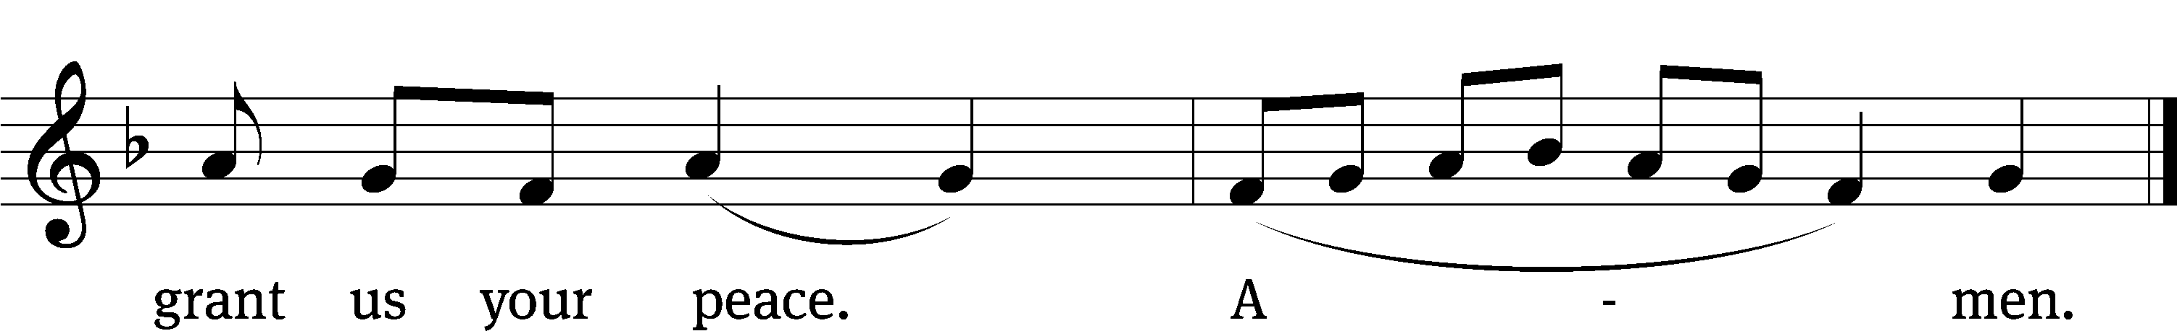

Be seated

Distribution
Out of sincere love for the truth of God's Word and precious souls, we practice closed Communion in our congregation. This has been the practice of Christians for centuries and is thoroughly scriptural. It neither questions the faith nor judges the heart of any individual, yet expects that there be full doctrinal agreement among those who commune. For this reason, we ask that only members of the Wisconsin Evangelical Lutheran Synod (WELS) join us for the Lord's Supper today. If you have any questions please speak with Pastor Fischer after the service.
668 Jesus Comes Today with Healing CW 668
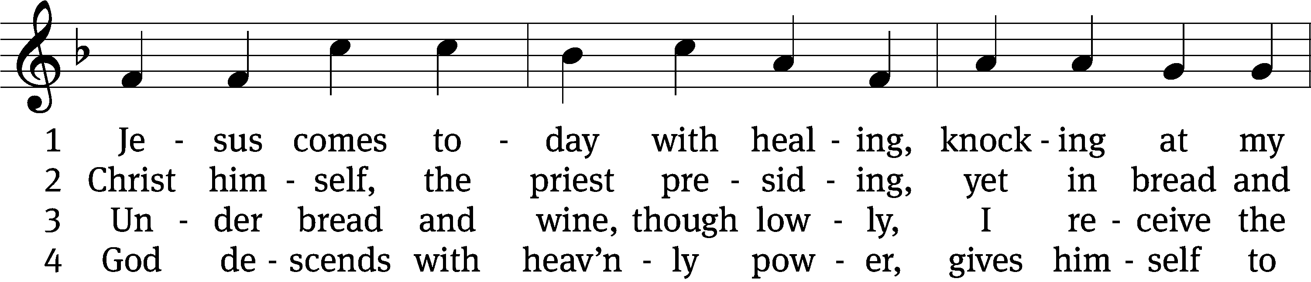
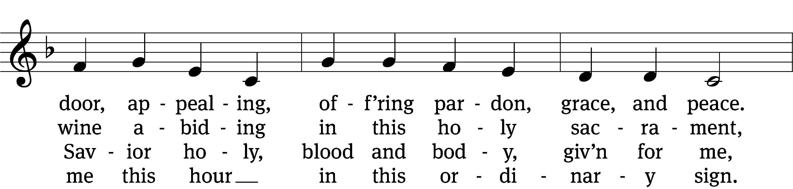
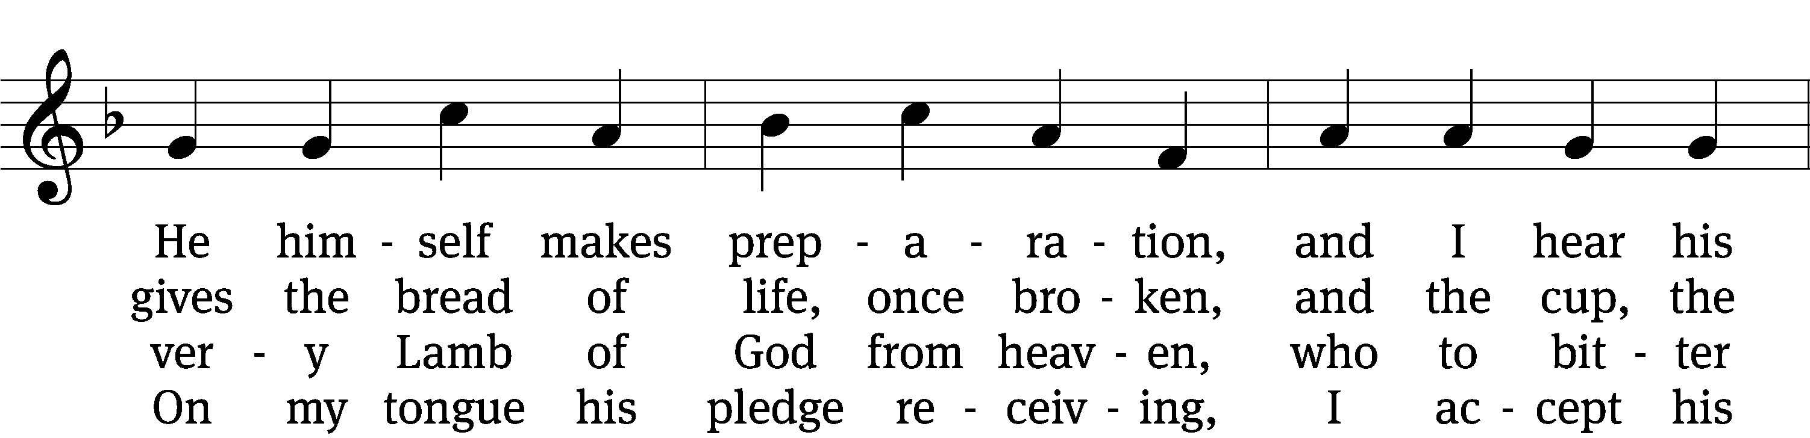
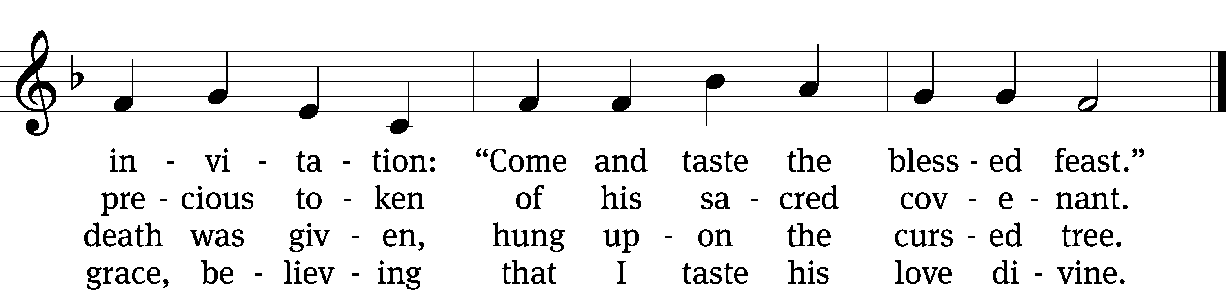

5 Let me praise God’s boundless favor,  whose own feast of love I savor,  bidden by his gracious call.  Wedding garments he provides me,  with a robe of white he hides me,  fits me for the royal hall. | 6 Now have I found consolation,  comfort in my tribulation,  balm to heal the troubled soul.  God, my shield from ev’ry terror,  cleanses me from sin and error,  makes my wounded spirit whole
Text: tr. David W. Rogner, b. 1960; Heinrich Puchta, 1808–1858
Tune: adapt. Johann Balthasar König, 1691–1758; Johann Löhner, 1645–1705
Text: © 2003 David W. Rogner. Used by permission: OneLicense no. 714932
Tune: Public domain

Stand

Give thanks to the Lord, for he is good;
his mercy endures forever.

Whenever we eat this bread and drink this cup,
we proclaim the Lord’s death until he comes.

We give thanks, almighty God, that you have refreshed us with this saving gift. We pray that through it you will strengthen our faith in you and increase our love for one another. We ask this in the name of Jesus Christ our Lord, who lives and reigns with you and the Holy Spirit, one God, now and forever.
Amen.
Blessing
The Lord bless you and keep you.
The Lord make his face shine on you and be gracious to you.
The Lord look on you with favor and T give you peace.
Amen.

Be seated

695 Take My Life and Let It Be CW 695
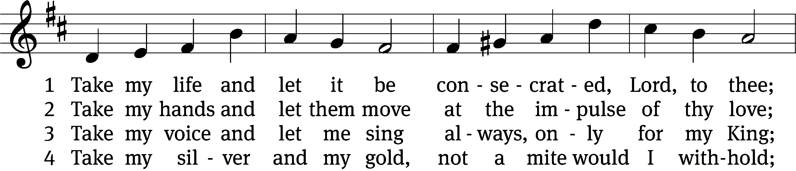
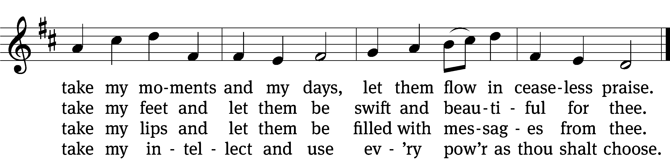

5 Take my will and make it thine,  it shall be no longer mine;  take my heart, it is thine own,  it shall be thy royal throne. | 6 Take my love, my Lord, I pour  at thy feet its treasure store;  take myself, and I will be  ever, only, all for thee.
Text: Frances R. Havergal, 1836–1879
Tune: William H. Havergal, 1793–1870
Text and tune: Public domain

Acknowledgments
Setting One from Christian Worship
Unless otherwise indicated, Scripture quotations are from The Holy Bible, New International Version®, NIV®. Copyright © 1973, 1978, 1984, 2011 by Biblica, Inc.TM Used by permission of Zondervan. All rights reserved worldwide.
Software distributed in partnership with Northwestern Publishing House. Created by Christian Worship: Service Builder © 2023 Concordia Publishing House.

THIS WEEK’S
WORSHIP SERVICE

Presiding Minister:
Jonathan Fischer

Preacher:
Isaiah Duff

Organist: Jon Hahm

FIRST LESSON:
1 Chronicles 29:1-5, 11. 12

SECOND LESSON:
2 Thessalonians 29:1-2, 10-18

GOSPEL LESSON:
Luke 17:1-10

THE SERMON:
1 Chronicles 29:1-5, 11. 12

THIS WEEK AT OUR SAVIOR

Sunday (9/17) | 8:00 | AM | Worship Service w/communion
 | 9:15 | AM | Sunday School
 | 9:15 | AM | Teen Bible Study
 | 9:15 | AM | Adult Bible Study
 | 10:30 | AM | Worship Service w/communion
Tuesday | 10:30 | AM | Bible Study
Wednesday | 4:00 | PM | Confirmation Class
 | 7:00 | PM | Life with Our Savior Bible Study
 | 7:00 | PM | Ephesians Bible Study
Thursday | 7:00 | PM | Worship Service
Sunday (9/24) | 8:00 | AM | Worship Service
 | 9:15 | AM | Sunday School
 | 9:15 | AM | Teen Bible Study
 | 9:15 | AM | Adult Bible Study
 | 10:30 | AM | Worship Service

LiveStream on Youtube Channel at 10:30am every Sunday
This service is also recorded for review after livestream.
Link on our website (see below).

Our Savior Ev. Lutheran Church & School
(Wisconsin Synod)
1332 Arrowhead Rd., Grafton, Wisconsin 53024
Website: www.OurSaviorGrafton.org
Church: 262-377-6363 School: 262-377-7780

Pastor Jonathan Fischer | Jeremiah Backhaus | Nate Schultz
Pastor | Pastoral Assistant | Principal
pastorfischer@oursaviorgrafton.org | oslcpa@oursaviorgrafton.org | nschultz@oursaviorgrafton.org

